The ICAHAN STADIUM
CALLING ALL 100 METERS SPRINTERS
Welcome to the Icahn Stadium, located along Randall’s Island Park’s northwestern shoreline; this Stadium is visible from the East Side of Manhattan and the FDR Drive. The Icahn Stadium host many meets such as: “International Amateur Athletic Federation (IAAF) specifications for accommodating local, national and international track and field events, including Olympic training and trials. It offers a standard 400-meter Mondo surface running track, flanked by covered spectator seating. The Icahn Stadium is the seventh pit stop on the IAAF diamond league calendar, which is spread over three continents (13 countries). The diamond league is a point award system of first, second, and third (3,2,1); where athletes competes against each other from May to August; at the end of the Diamond league the athlete that accumulated the most points in their respective event are rewarded with trophy and cash. I will be focusing on the 100 meters sprinting aspect of the Diamond league at the Icahn Stadium. Over the decades, the 100 meters sprints are traditionally dominated by the United States and Jamaica.
Getting to the Icahn Stadium: 20 Randall’s Island Park, New York, NY 10035 subway/ bus Take the Lexington Avenue 4, 5 or 6 trains to 125 Street; transfer at the NW corner of 125 Street and Lexington Ave. to the M35 to Icahn Stadium. 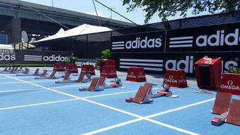 HOW TO RUN THE 100M
To run the 100m dash athletes are usually powerful, explosive, and strong; this helps them to finish ahead of their competitors. In the 100m race, one has to train extremely hard, using of raw power, lightning speed, and flawless sprinting technique along with your running spikes. 100 meters athletes usually go through 12 weeks of 100m/200m/400m training program before they start competing. There is three parts in a 100m dash (heats, semi-finals, and final). Start- at the beginning of each race athletes is place on their mark; they then place their leg in equipment that is called the starting blocks. Their stronger leg usually goes in the front block and your faster leg goes into the rear block. It’s important that athletes are properly warmed up prior to their races.

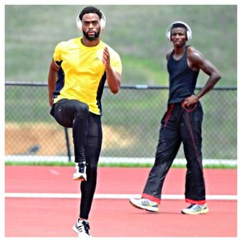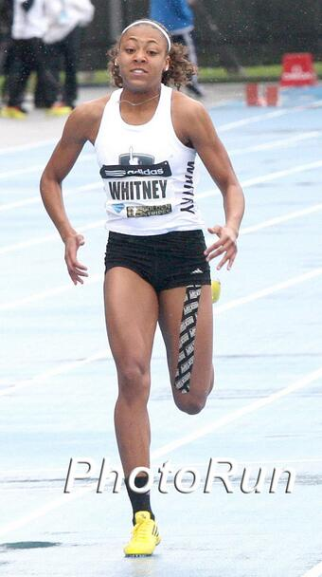
Track and field is said to be around since the year 776 BC, but other archaeological evidence suggest it could be earlier than this date. The 100m is a sprint race and one of the shortest in track and field. The men 100m dash is one of the most exciting athletics events, which have been dominate for the past 10 years by world record holder Usain Bolt. It was at Randall’s Island Icahn Stadium, at the Adidas Diamond league meet that Usain Bolt dominated from start to finished; this propelled him into setting his first 100m world record of “9.72. On 31 May 2008.” He’s still the world record holder of 9.58 seconds. When a sprint event is running, if you blink too much then you sure will missed this event; because, it ends in a flash. In fact, no one believe, this boundary of running with such top end speed for the 100 meters, was achievable in history by human.
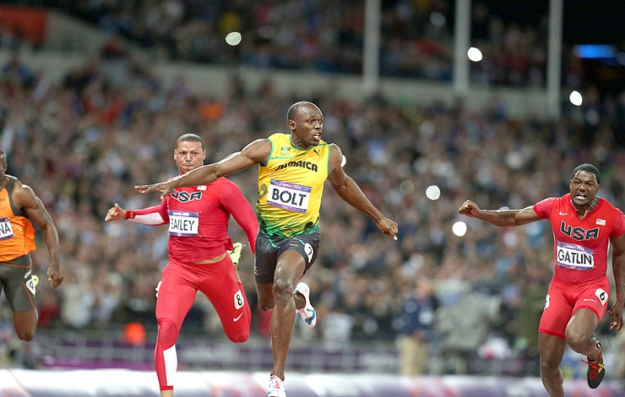 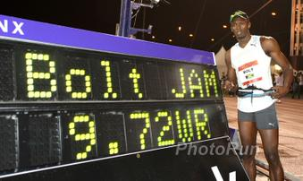 The female 100m sprint is just as exciting as their male counterpart. They also have to be physically and mentally prepared for their events as well. The women's world record of 10.49 seconds was set by the late American Florence Griffith-Joyner in 1988. The woman 100m Diamond league race, it’s a point award system, similar to that of the men.
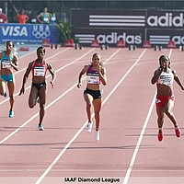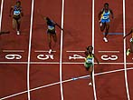
Rules about the 100 meters sprints
- Once on your mark, the runner must remain still
- It’s always good to get a head start, but if you false start, then you’re out of the race.
- A false start is the reaction time of a runner less than 0.12 seconds after the gun.
- When the race begins, runner must run in their lane, from 1-9 to the finish line.
Points/ Rewards
First….. 3 diamond league points and cash
Second…. 2 points along with cash
Third ….. 1 point along with cash incentive
https://www.youtube.com/watch?v=gwKOdNBQ7X0
https://www.youtube.com/watch?v=yLWejYWjANM
https://youtu.be/3nbjhpcZ9_g
https://www.youtube.com/watch?v=GNaf3hONnl4
https://www.youtube.com/watch?v=24yzIiWozqw

