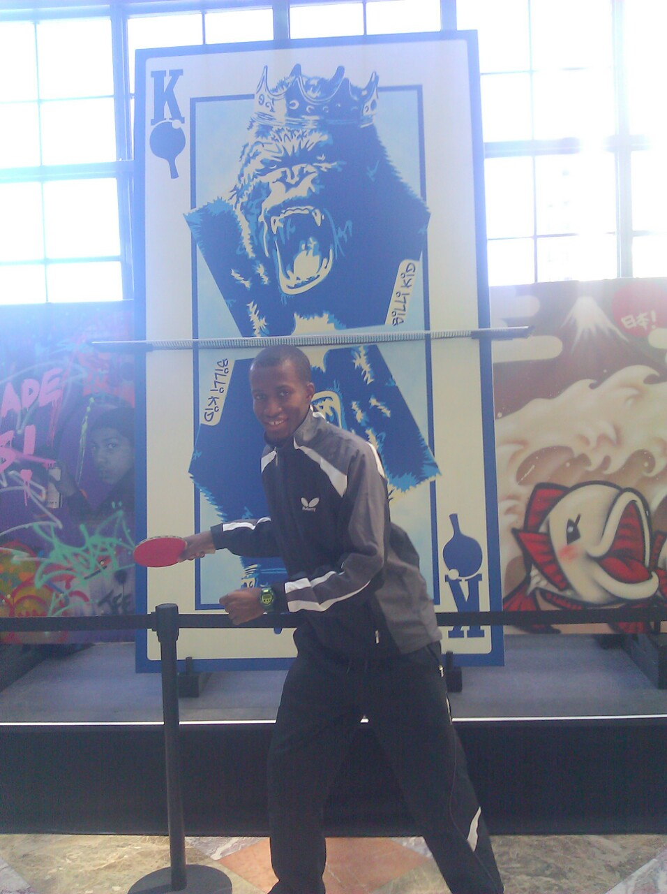  NYCCT STUDENT, DIVISION ONE CHAMPION FALL 2014  THE LAWS OF TABLE TENNIS  THE TABLE  2.1.1 The upper surface of the table, known as the playing surface, shall be rectangular, 2.74m long and 1.525m wide, and shall lie in a horizontal plane 76cm above the floor.  2.1.2 The playing surface shall not include the vertical sides of the tabletop.  2.1.3 The playing surface may be of any material and shall yield a uniform bounce of about 23cm when a standard ball is dropped on to it from a height of 30cm. |  |  | HISTORY  The sport got its start in England towards the end of the 19th century when, after dinner, some upper-middle class Victorians decided to turn their dining room tables into miniature versions of the traditional lawn tennis playing field. Several different every-day objects were employed in constructing the sport. They used a line of books as the net. Rackets were lids from empty cigar boxes, and a little later, parchment paper stretched around a frame. The ball would be either a ball of string, or perhaps more commonly, a champagne cork or rubber ball.  Table tennis Parks & Recreation  Address: 300 Jay St, Brooklyn, NY 11201  Phone: (718) 260-5500 |  |  | Table tennis Parks & Recreation  - By: Lyonel Narcisse Jr  HMGT4988 Spring 2015

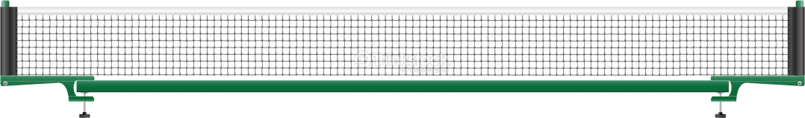  THE NET ASSEMBLY  2.2.1 The net assembly shall consist of the net, its suspension and the supporting posts, including the clamps attaching them to the table.  2.2.2 The net shall be suspended by a cord attached at each end to an upright post 15.25cm high, the outside limits of the post being 15.25cm outside the side line.  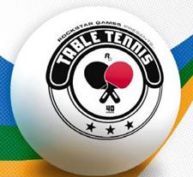  2.3 THE BALL  2.3.1 The ball shall be spherical, with a diameter of 40mm.  2.3.2 The ball shall weigh 2.7g.  2.3.3 The ball shall be made of celluloid or similar plastics material and shall be white or orange, and matt.  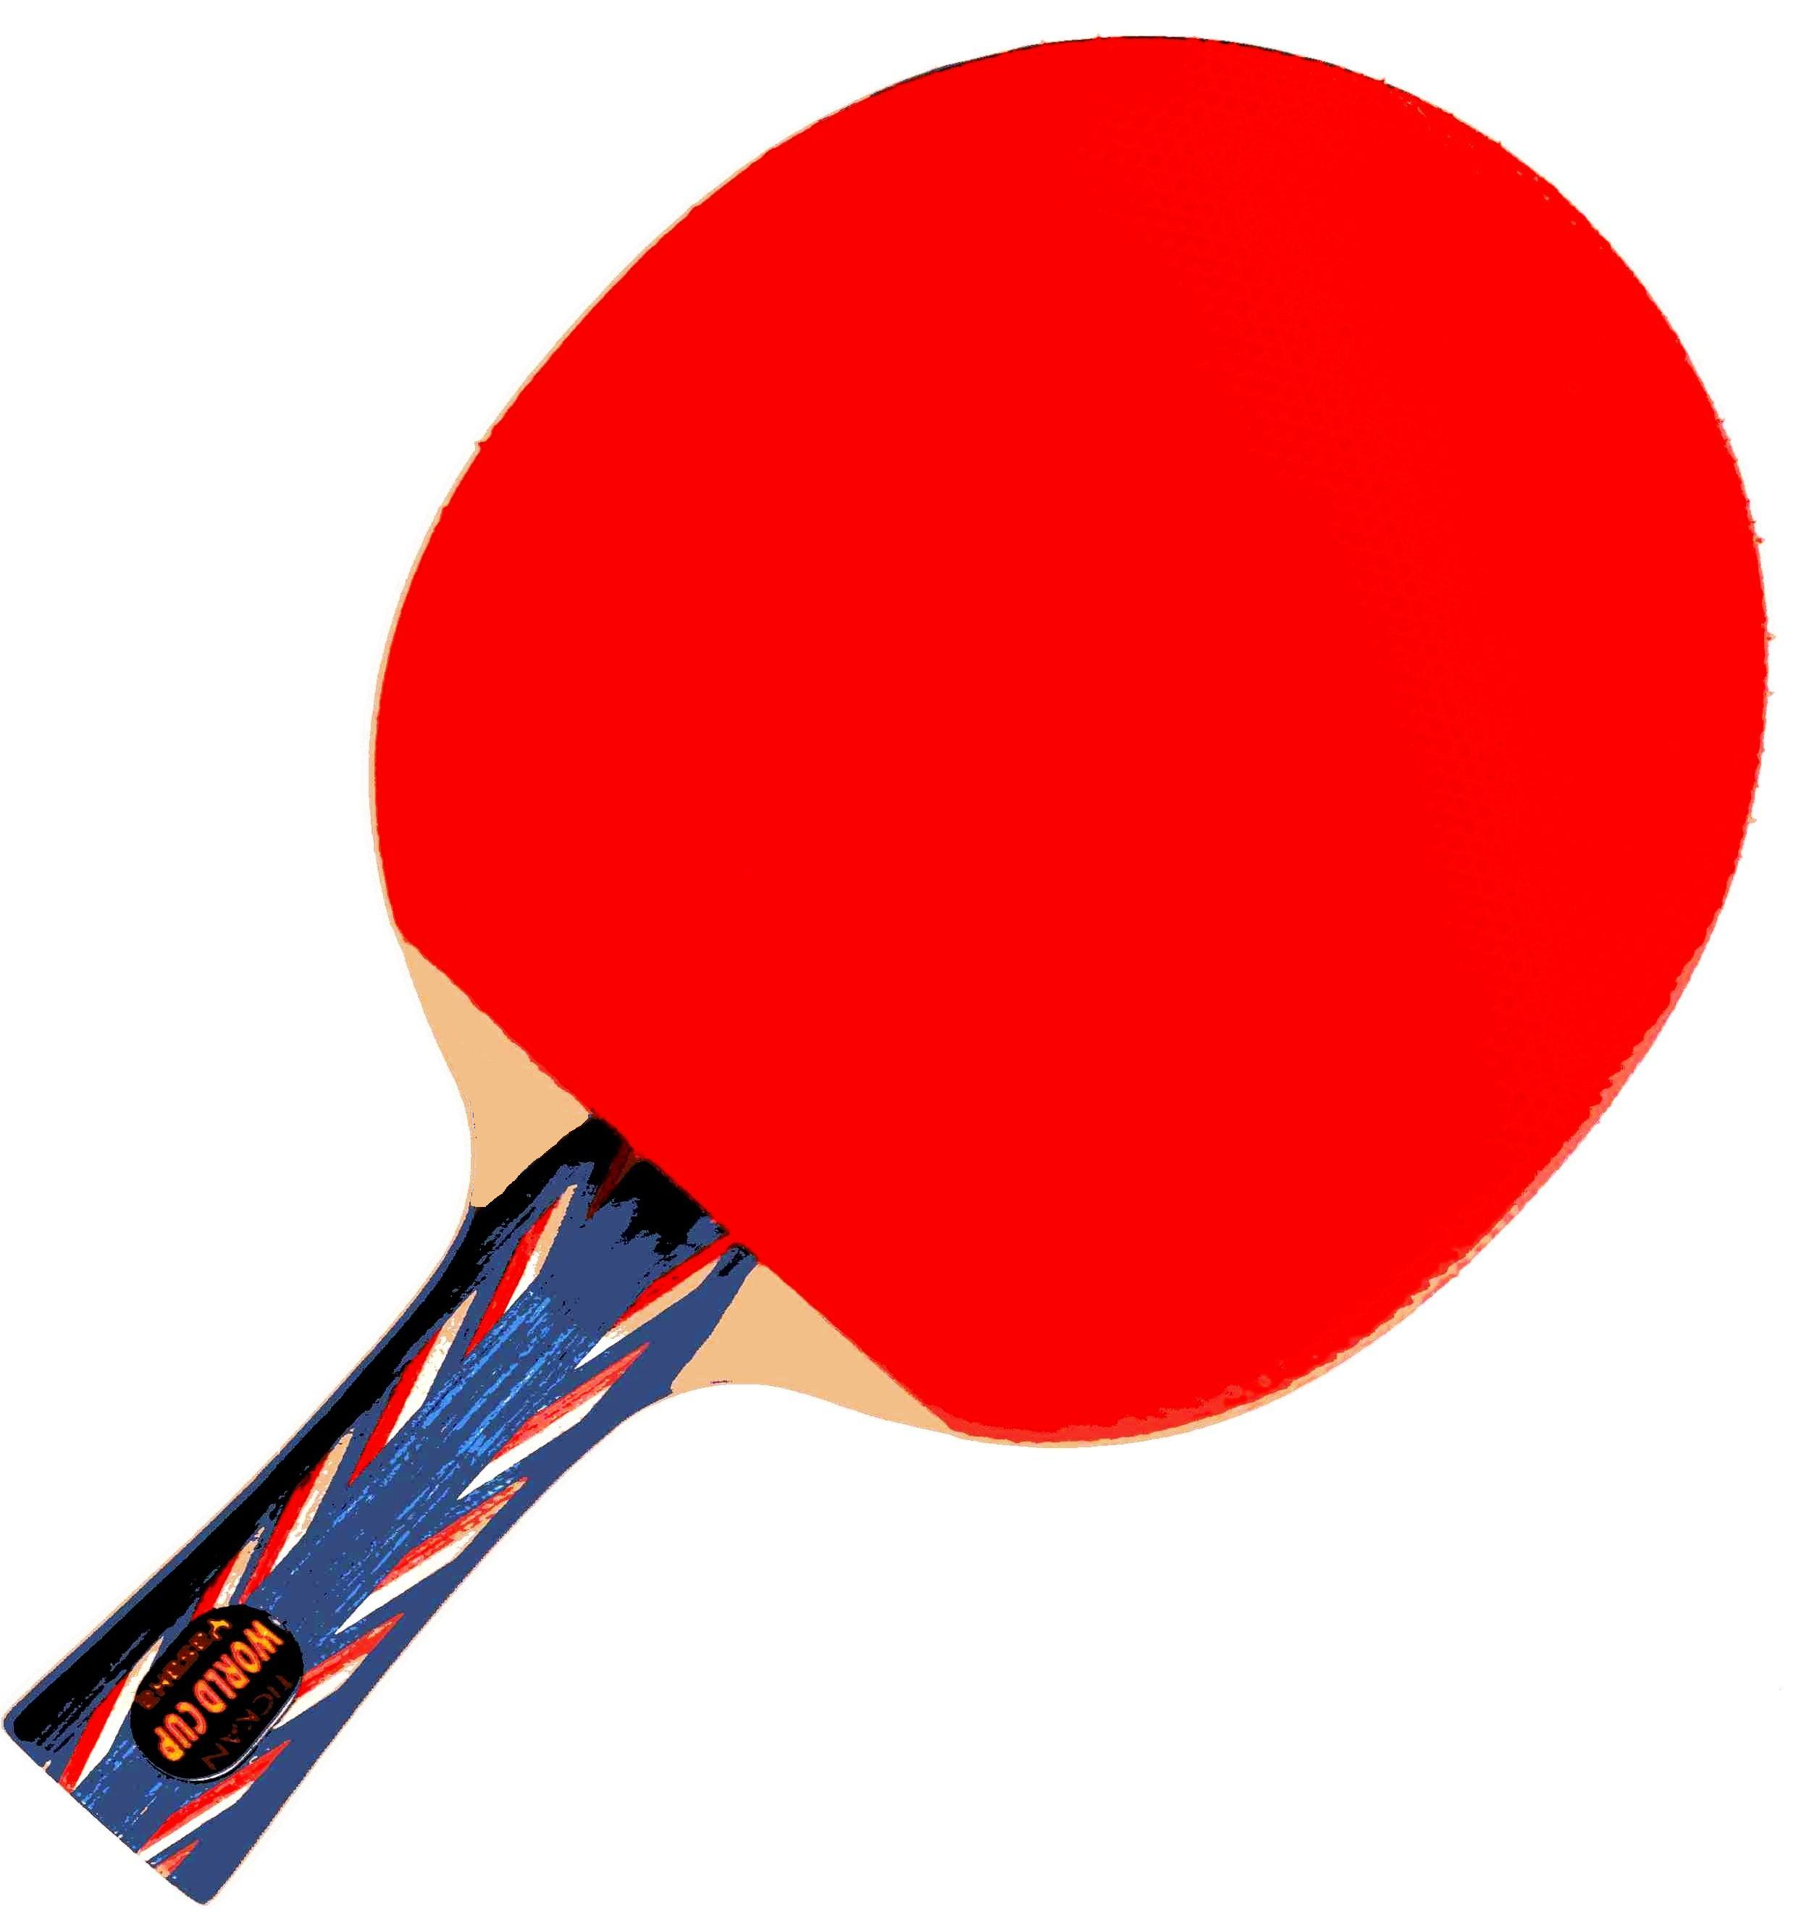  THE RACKET  2.4.1 The racket may be of any size, shape or weight but the blade shall be flat and rigid.  2.4.2 At least 85% of the blade by thickness shall be of natural wood; an adhesive layer within the blade may be reinforced with fibrous material such as carbon fiber, glass fiber or compressed paper, but shall not be thicker than 7.5% of the total thickness or 0.35mm, whichever is the smaller. |  |  | Why Playing Table Tennis? ( Ping Pong )  Top 10 Reasons:  - Health and Fitness  - Gentle on Your Body  - Everyone Can Play  - A Sport for Life  - Keeps You Mentally Sharp  - You Can Play Anytime  - You Can Play Anywhere  - Make New Friends  - You Don't Have to Spend a Fortune  - Enjoy Yourself  Basic of Table Tennis:  https://www.youtube.com/watch?v=NfmPcpi4sfc |  |  | WHERE TO PLAY?  Locations:  Bryant Park New York, NY  Directions  Bryant Park is situated behind the New York Public Library in midtown Manhattan, between 40th and 42nd Streets & Fifth and Sixth Avenues.  Take the B, D, F, or M train to 42nd Street/Bryant Park  Take the 7 to 5th Avenue  Spin New York  www.spingalactic.com  Address:  48 E 23rd St, New York, NY 10010  Phone:(212) 982-8802  Hours: 7 days a week  From 11:00 am – 2:00 am  Thursday 11:00 am – 2:00 am  Friday 11:00 am – 2:00 am  Saturday 11:00 am – 2:00 am  Sunday 11:00 am – 10:00 pm  Menu: spingalactic.com

