**PUNCH BALL**

*The New York Street Sport!*

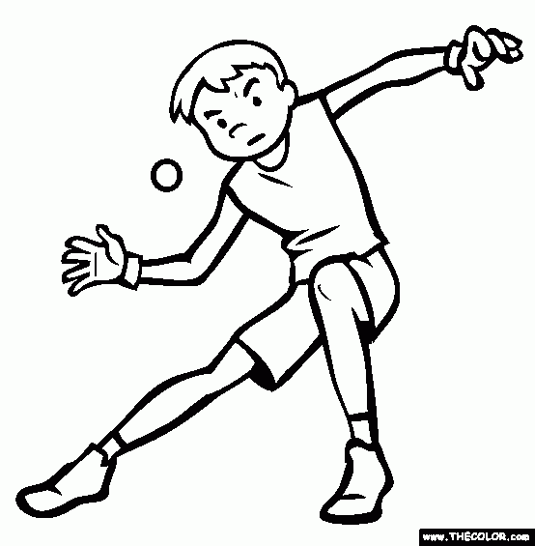

See why Baseball Hall of Famers such as Jackie Robinson and Yogi Berra enjoyed this sport growing up.

There are many things that you need to know about Punch Ball. You need to know rules, the knowledge of the field in order to play and why it is a great physical activity. I'm going to tell you what you need to know.

Free Activity

We will be meeting up every Friday from 5-8:30 to play 5 games. You may come before to stretch and warm up. We will provide equipment. Just bring a water bottle and your energy to punch the ball out of the ballpark.

How To:

First the rule of Punch ball is to have the ball above your waist and below your torso. Your fist is used as a bat and you can toss the ball high and hitting an overhand shot. You’re not allowed to bunt the ball or steal a base. All you need to do is let the ball come off your fist.



Punch ball is a great game that needs little equipment and can be squeezed into a school recess period, any park or even out in the streets

[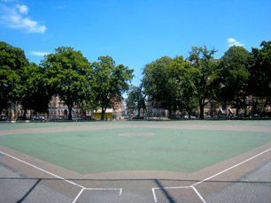](http://www.google.com/url?sa=i&rct=j&q=&esrc=s&source=images&cd=&cad=rja&uact=8&ved=0CAcQjRw&url=http://www.covehurst.net/ddyte/brooklyn/otherparks.html&ei=_7VcVeekIJCuyAS58YD4DQ&psig=AFQjCNFDSyYFQr2NJeu5dI8t2vmrAwTXqw&ust=1432225642888624)

Location

Maria Hernandez Park

Knickerbocker Avenue, Brooklyn, NY 11237