Peggy Zhang

DISCOVERY PROGRAMS

Central Park Conservancy offers a variety of educational programs and resources to help children explore Central Park and develop skills for learning in the great outdoors.

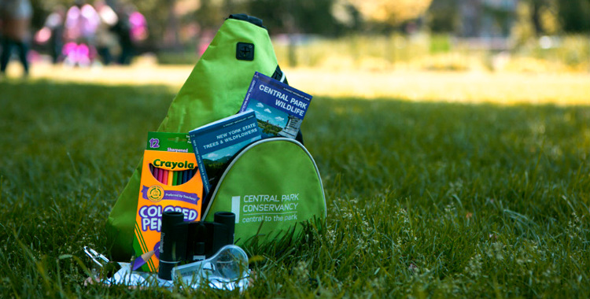

Discovery Kits:
- Borrow a Discovery Kit for an in-park adventure
- Includes a backpack with kid friendly binoculars, field guides, kid friendly hand lens, sketch paper, color pencils and a clipboard
- Best for ages 6-10
- Groups of 5+ needs minimum 2 weeks of advance registration
- Group size limited to 30 students
- Families may get up to 4 backpacks without registration, ID required
- Free 7 days; Monday-Saturday 10am-3pm, Sunday 10am-1pm

Discovery Journals and Exploration Guides:
- Includes activities for kids to investigate the connections between plants and wildlife
- Filled with hand drawn illustration and a large, kid friendly map
- Guides include a map with suggested route and activities for developing the kids’ observation skills
- Maps of the North Woods, the Ramble, the Harlem Meer, Turtle Pond, and the Pond
- Best for ages 6-10
- Discovery Journals $2 each; Free for members; Group discount available

Free 7 days; Monday-Saturday 10am-3pm, Sunday 10am-1pm
Pick up your backpacks at:

Charles A. Dana Discovery Center
110th St. & Lenox Ave.
(2/3 train to Central Park North 110th St)
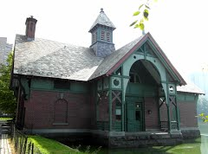See p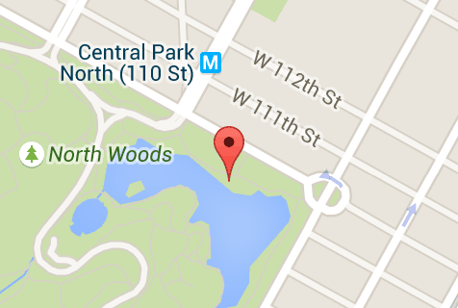

Belvedere Castle
(A/B/C train to 81st St. Museum of Natural History)

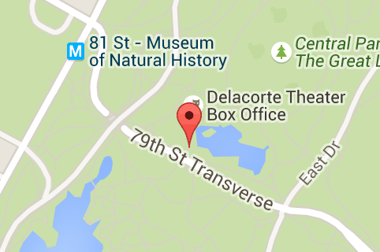

Chess & Checkers House
Central Drive
(N/Q/R train to 5th Ave/59th St.)

