Brooklyn Bridge Park
Welcome All Jump Ropers!

Explore all boroughs of New York City especially Brooklyn. One of the main parks in Brooklyn is the Brooklyn Bridge Park. It is located 334 Furman Street Brooklyn, NY 11201. The park has the best view of Manhattan, which is stunning.
Brooklyn Bridge Park offers a range of activities, attractions, and events. The Activity that I’m introducing is called Double Dutch, which many don’t know about.
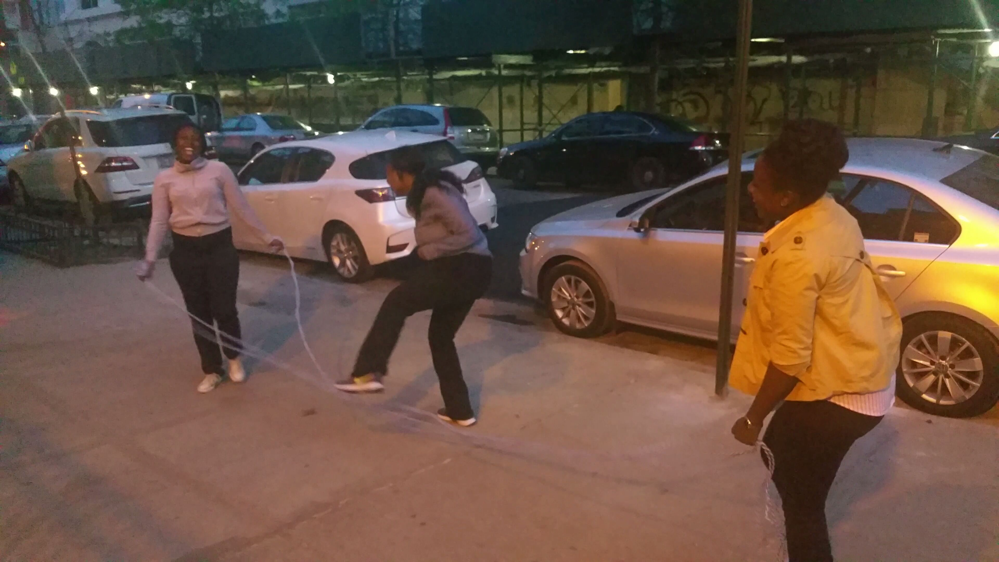
History - Double Dutch was founded by David A. Walker from New York. Dutch settlers brought the game to New Amsterdam also known as New York City. Then English then called it Double Dutch. In 1973 David A. Walker and his partner, Ulysses Williams transformed the street game in an actual team competitive sport. In 1974 Walker created The American Double Dutch League and held their first tournament on February 14, 1974. The tournament included as many as 600 people which consisted of fifth, sixth, seventh, and eighth grade students. The game has expanded and now has citywide and national championships.

Steps on How to do it
- To jump double Dutch first you need at group of at least 3 people.
- Two people will then grab each the end of the rope and begin to turn.
- They will turn their left arms clockwise and right arms counterclockwise.
- Then the third person will choose which side the will jump from.
- Jump through the ropes when the rope closest to you hits the ground.
- Continue the rhythm with all the motions
Safety Tips- If you have any heart conditions it is always best to check with your doctor to make sure you can participate.

Benefits of Jumping Rope- Many people see jumping rope as just a game but little do they know it also is an exercise. Jumping rope burns lots of calories, which can aid in weight loss. Jumping rope will strengthen your arms, calves, abs and shoulders. When jumping rope at a fast pace you may notice you’re heart rate rising and that’s where the calorie burning is taking place. Your metabolism is also being enhanced therefore even after your session of jumping rope is over your body still continues to burn calories at high rate. Jumping rope is also great for improving your bone density therefore it can
prevent osteoporosis.
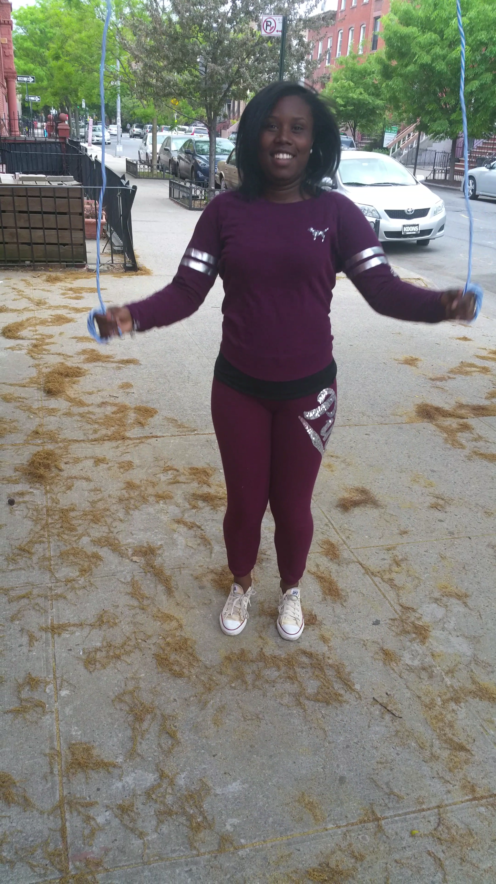

Finding the best routes to the park. The following directions are:
SUBWAY BUS
A or C to High Street B25 Fulton Ferry Landing
2 or 3 to Clark Street B63 Loop road on pier 6
F to York Street B61 Atlantic Ave. & Hicks St.
R to Court Street B67 Jay St. & York St.
4 or 5 to Borough Hall
How to Get Involved: At Brooklyn Bridge Park every Wednesday from June 24 until August 26 at 7 p.m. you will have the option to learn how to jump Double Dutch. You must be at least 15 years of age to participate.

