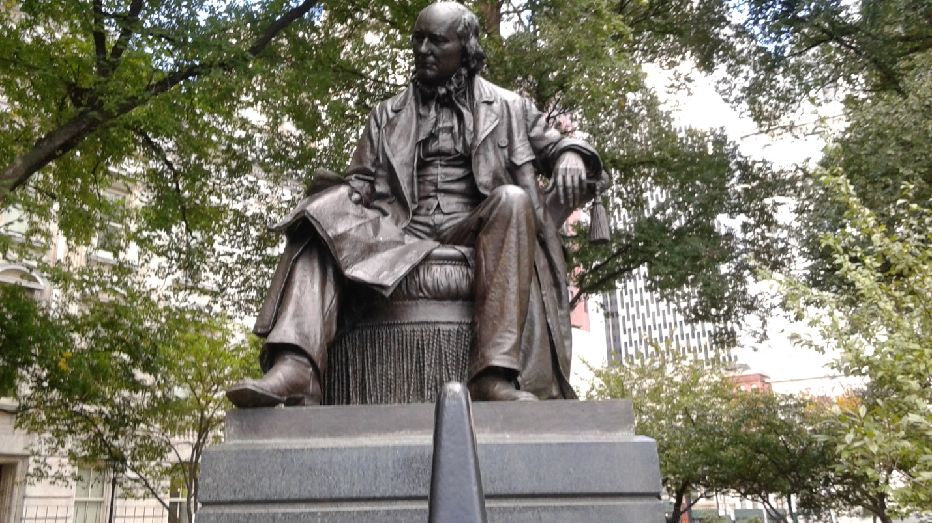
Horace Greeley was editor of the New-York Tribune. He served as a congress man from New York and was a candidate for the democratic and freely republican parties in the 1872 presidential election. His statue is located at the City Hall Park. Greeley was originally from New Hampshire. In 1831 he moved to New York. He worked for the New Yorker newspaper. Greeley supported the woman’s movement.
The statue is located in the city hall park. The statue is in honor of Horace Greeley. He is sitting down. His statue is over life size and it’s big. The statue was made in 1916 by John Quincy Adams Worth.
My reflection on Horace Greely is that I love his statue. I had never heard of him before, when I was walking at the park in city hall I located the statue and I took a picture of it. Then I did my research and found out who the person was and why he was famous for. I am glad that I found the statue because he was an important figure and they made a statue in honor of him.

