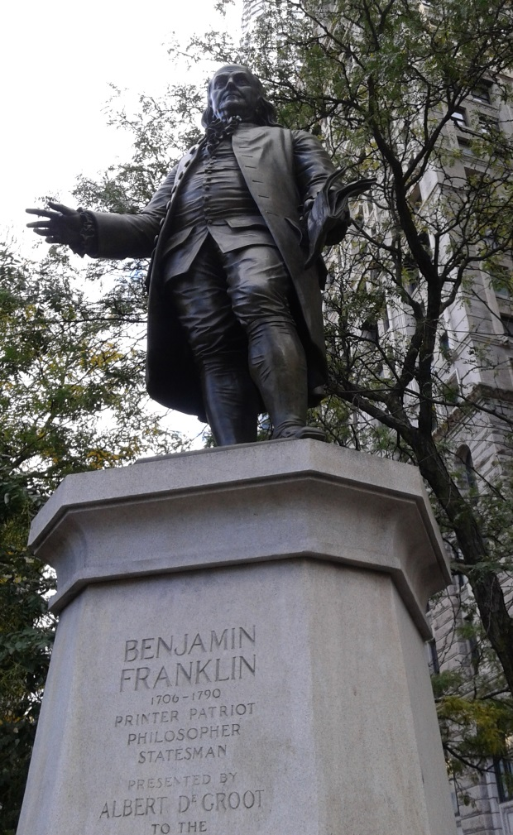
This is a statue of Benjamin Franklin one of the founding fathers. Franklin was also an author, scientist, printer, inventor, politician, civil activist, and statesman. His statue is located across the City Hall Park. Franklin is an extraordinary figure in the American history. He was also one of the richest man during his life time. He also negotiated the treaty with France. It is also known that Benjamin Franklin wanted the turkey to be the symbol of the United States not the eagle.
As said earlier the statue is located across the city hall park and close to the Brooklyn Bridge. He is a big figure for the United States. The statue honors this great man. The statue was made by Alberto D’Groot. As people are driving to Brooklyn or coming from Brooklyn they get to see the great statue of Benjamin Franklin.
My reflection of the commemoration is that this statue is beautiful. Benjamin Franklin is one of the people that I am grateful for. He played a big role in America getting its freedom. He also invented other things that I am grateful for. He was an inventor, thinker, scientist, printer, author, civil activist, politician and statesman.

