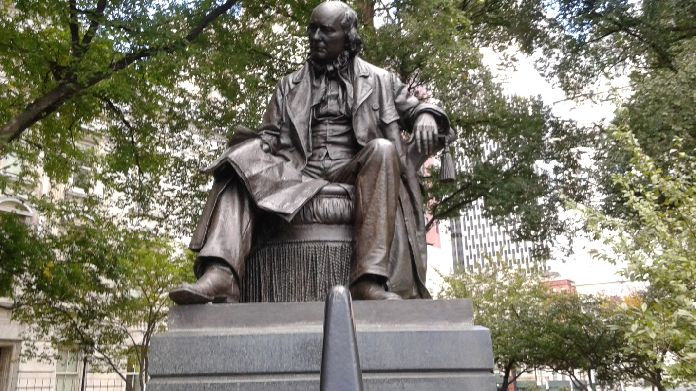
Horace Greeley was editor of the New-York Tribune. He served as a congress man from New York and was a candidate for the democratic and freely republican parties. His statue is located at the City Hall park.

