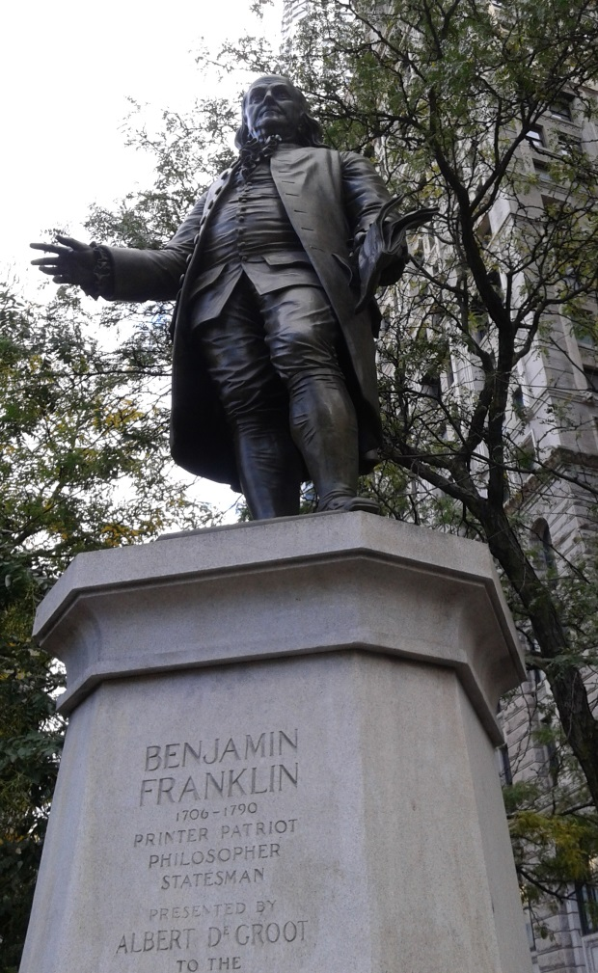
This is a statue of Benjamin Franklin one of the founding fathers. Franklin was also an author, scientist, printer, inventor, politician, civic activist, and statesman. His statue is located near City Hall Park.

