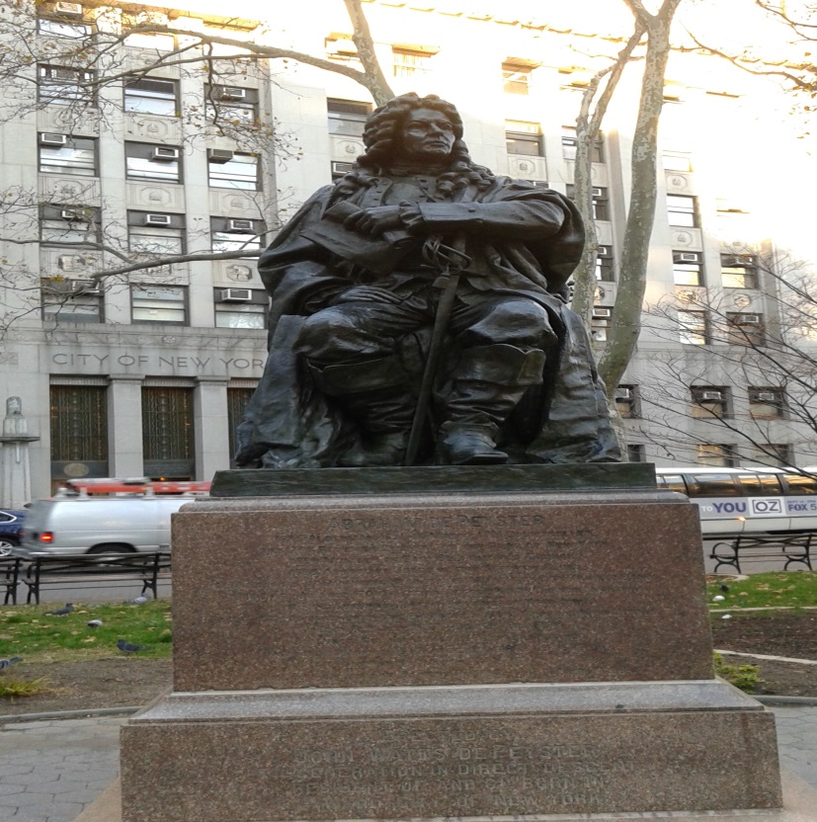
This is an image of Abraham de Peyster. Abraham de Peyster was the 2oth mayor of New York City from 1691 to 1694. His statue is located in Chamber St, near the courts.

