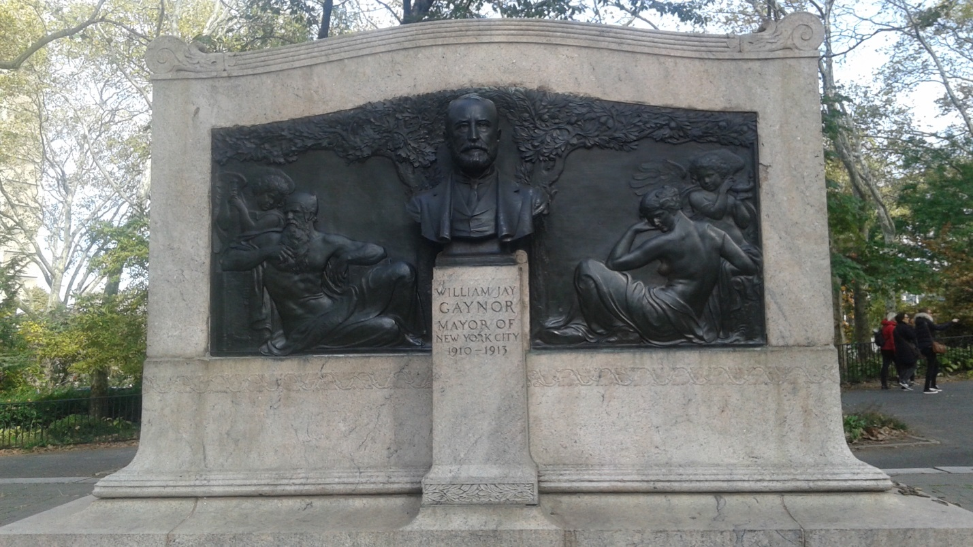
William Jay Gaynor was the 94th mayor of New York from 1910 to 1913 he was known for not taking orders from the Tammany boss. He also served as a Justice for the New York Supreme Court from 1893-1909. His statue is located in Brooklyn, near Hight street. He was also a lawyer, journalist, and Brooklyn resident.
The statue is located at Cadman Plaza near the Brooklyn Bridge. The sculptor who made the momentum was Adolph Alexander Weinman. The momentum was made in 1926.
My refection of William Jay Gaynor is that from what I have read he was a man with goals. He achieved a lot throughout his career. He went from a journalist to a lawyer to a judge to mayor. To me that is somebody who always wants to go higher and higher, and who does not settle for less.

