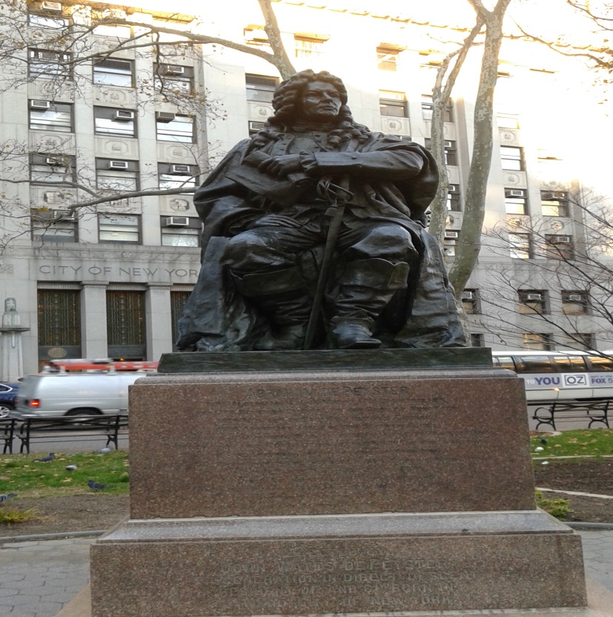
This is an image of Abraham de Peyster. Abraham de Peyster was the 20th mayor of New York City from 1691 to 1694. He was originally from Amsterdam. He had other important public roles he was a Judge and later a Chief Justice, and a Treasurer for New York and New Jersey province. He was also a colonel in the militia. He died at the age of 81 in 1728.
His statue is currently located in Chamber St, across Courthouses. His statue has been in a lot of places and parks throughout New York City. They did not know where to place the statue do they decided to place it in the park across the Courthouses. He was the former mayor of New York.
The statues say to me that this guy was an important public figure I saw the statue and decided to take a picture. The statue was beautiful I am glad I took the picture and later searched him up. I learned a lot about him. I was not aware of who he was but no I am glad I am aware of who he is. He accomplished a lot throughout his lifetime.

