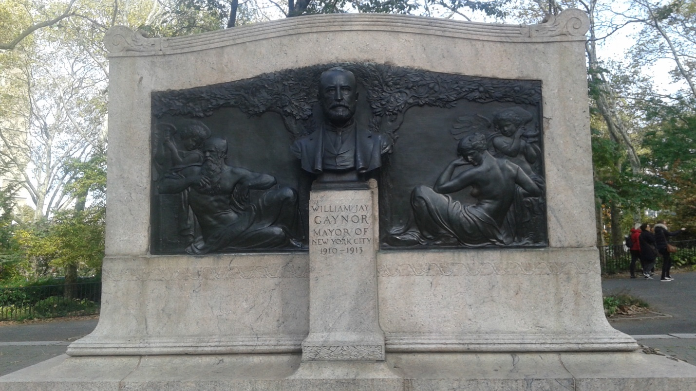
William Jay Gaynor was the 94th mayor of New York from 1910 to 1913 he was known for not taking orders from the Tammany boss. He also served as a Justice for the New York Supreme Court from 1893-1909. His statue is located in Brooklyn, near Hight street.

