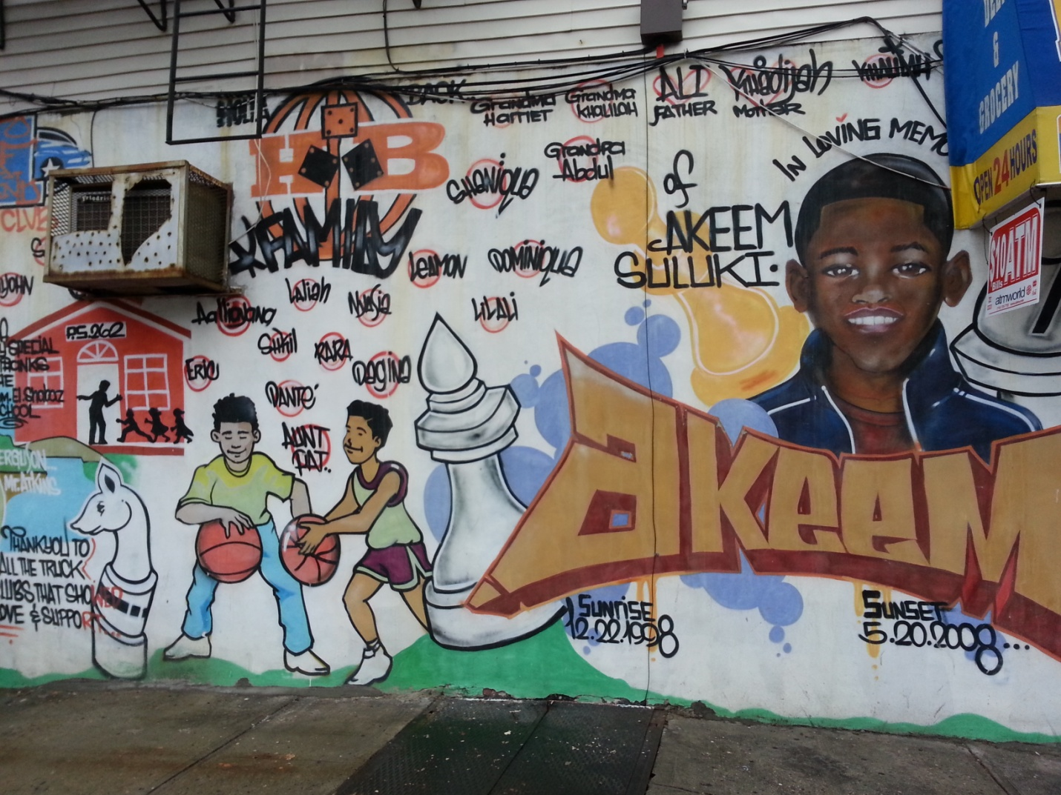
Honored Teacher’s son of Bedstuy. Akeem was hit by a car here while crossing the street from School. This wall is painted on the street of Hancock in Brooklyn.

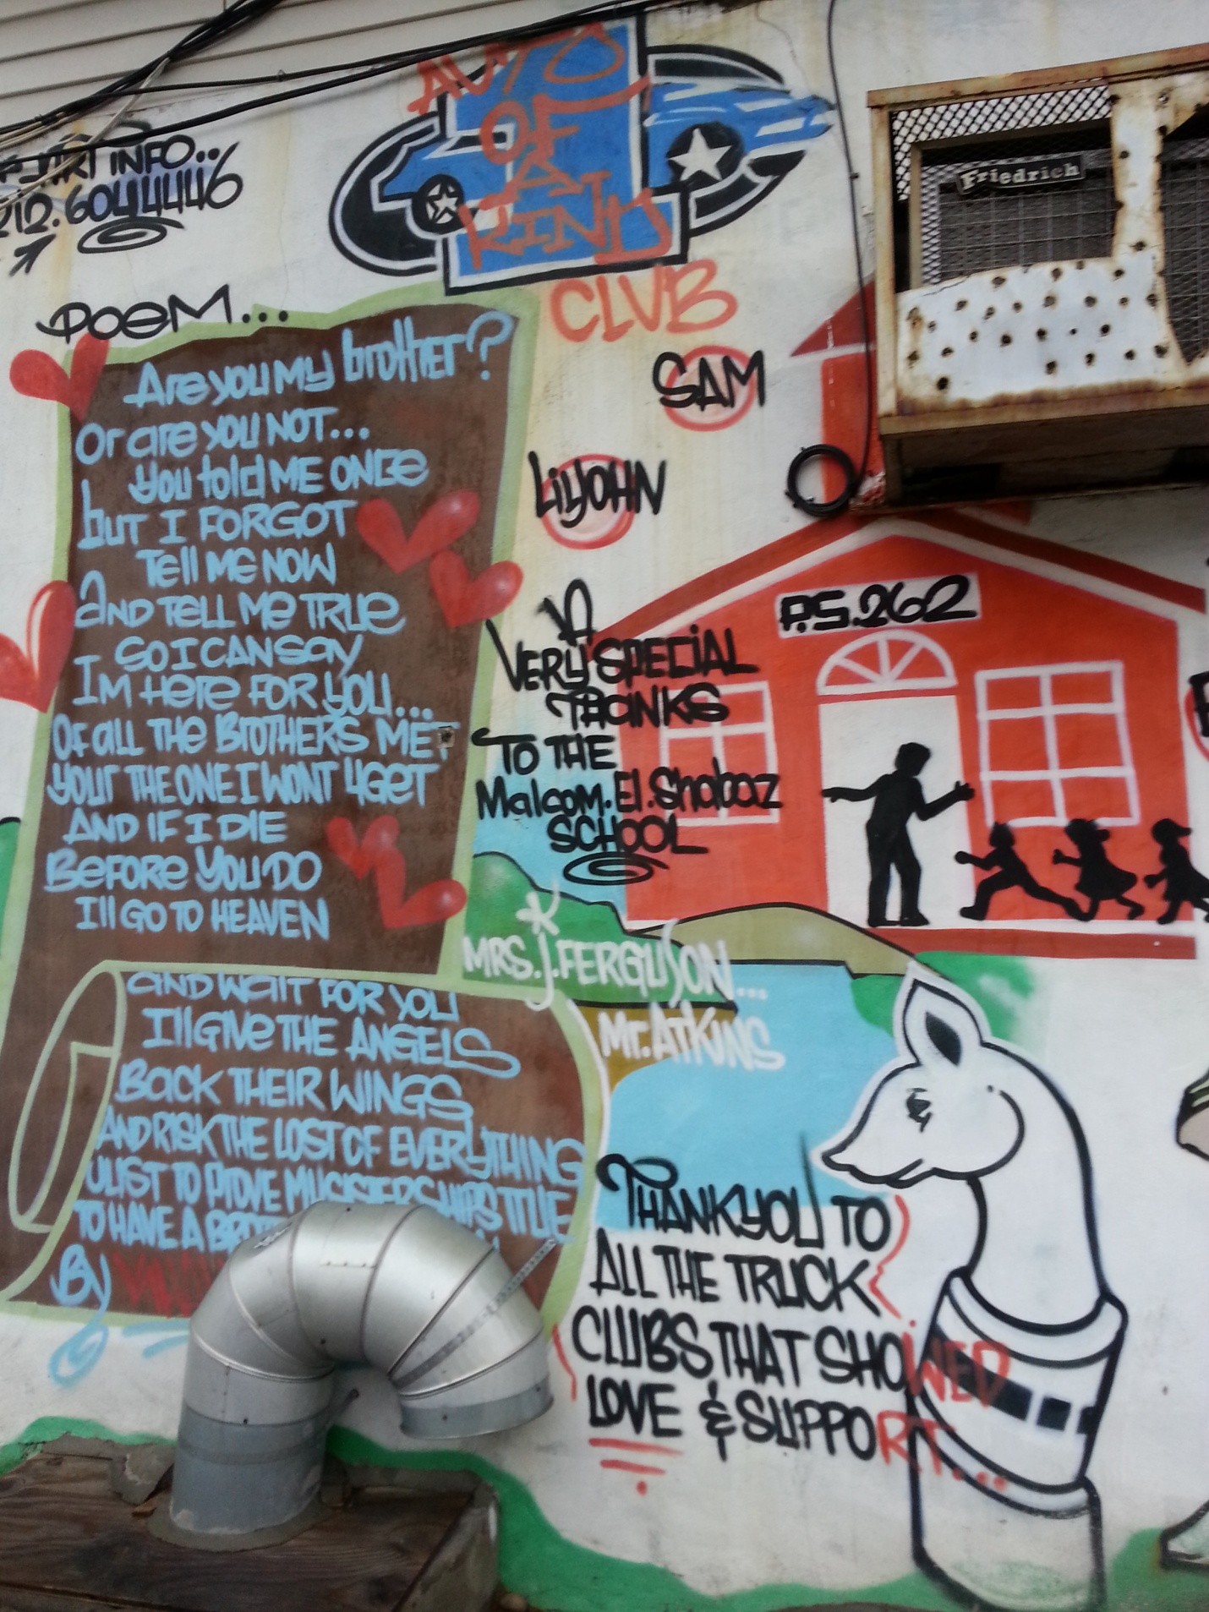

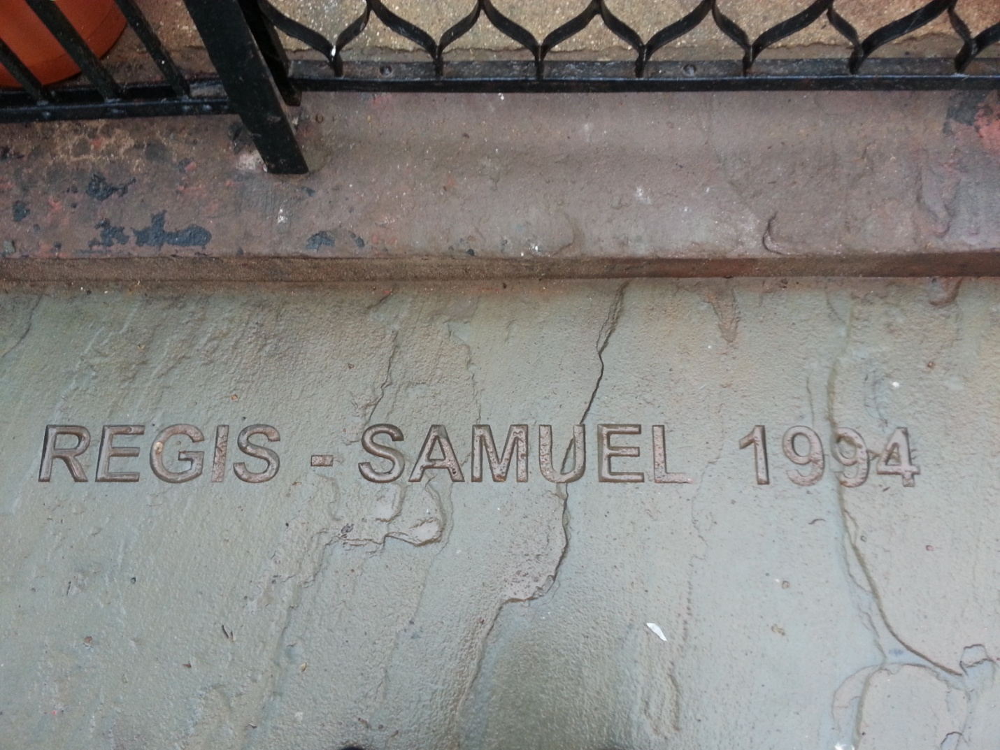

Regis Samuel Is honored at Williamsberg Playground.

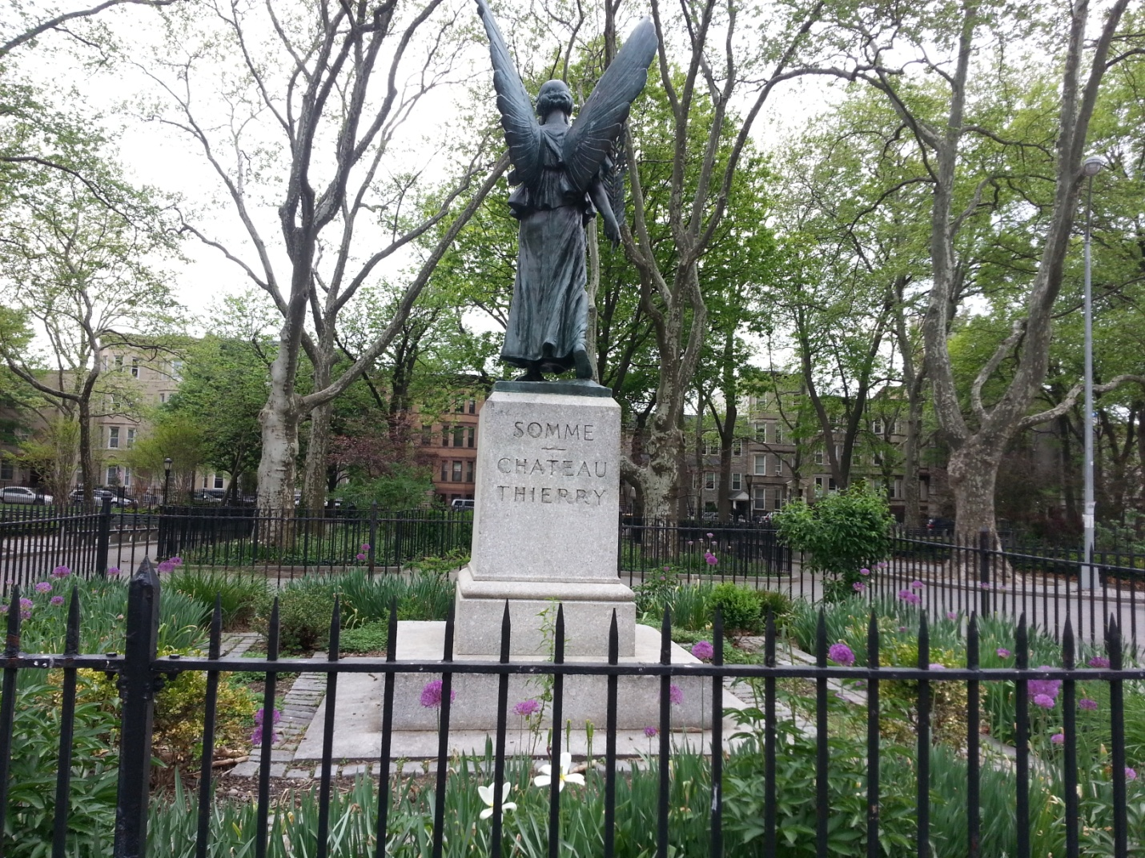

Somme Chateau Thierry is honored for

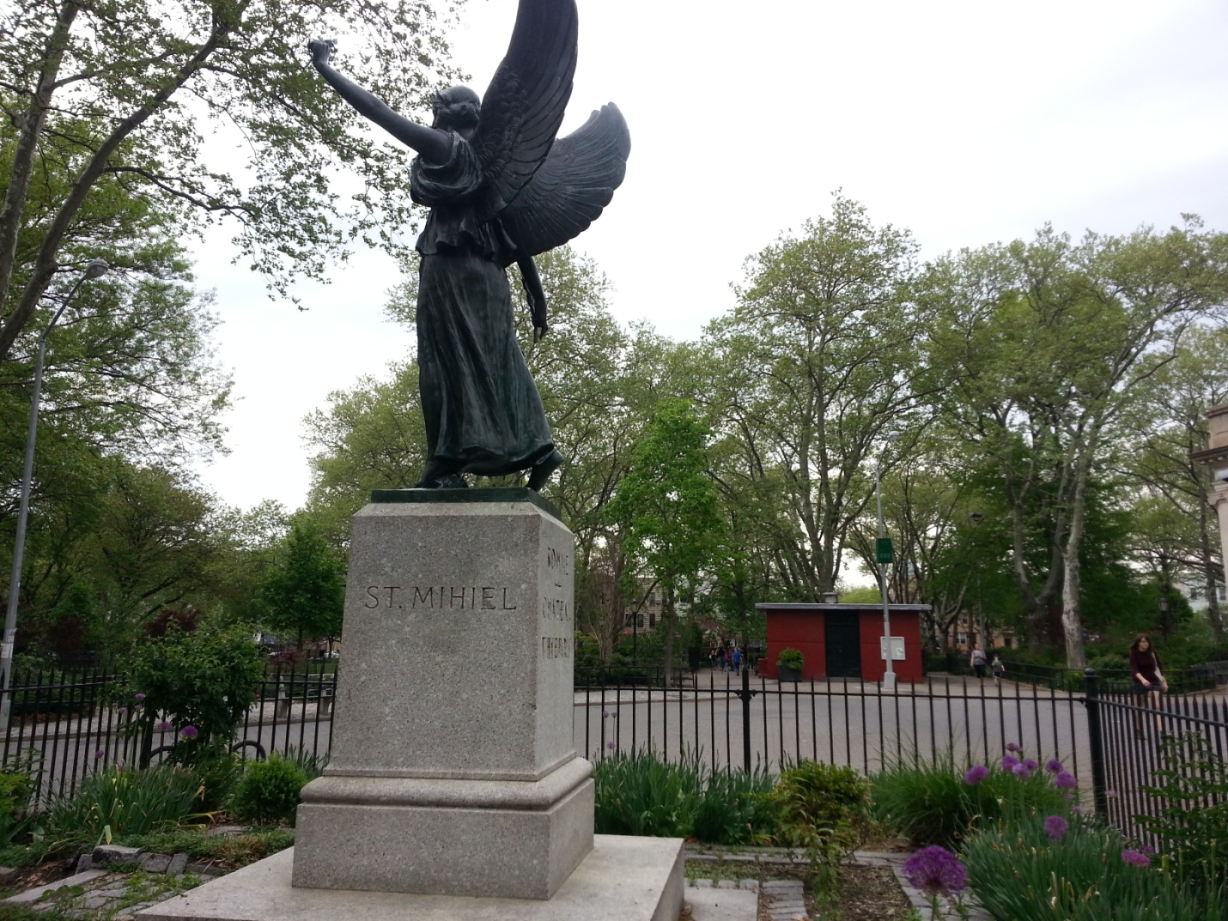

Williamsberg playground also honors St. Mihiel for

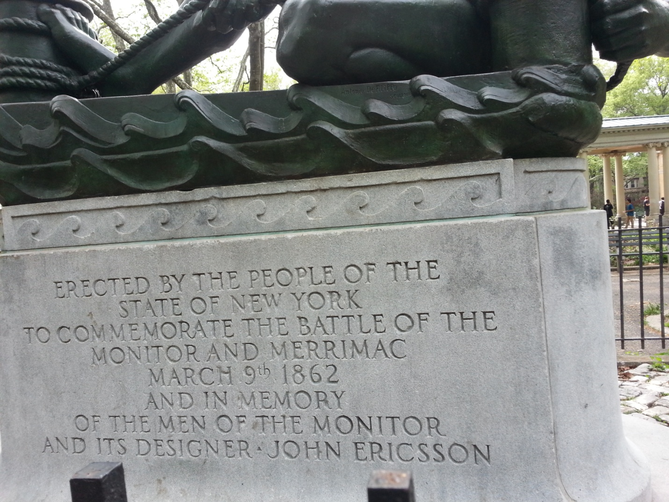

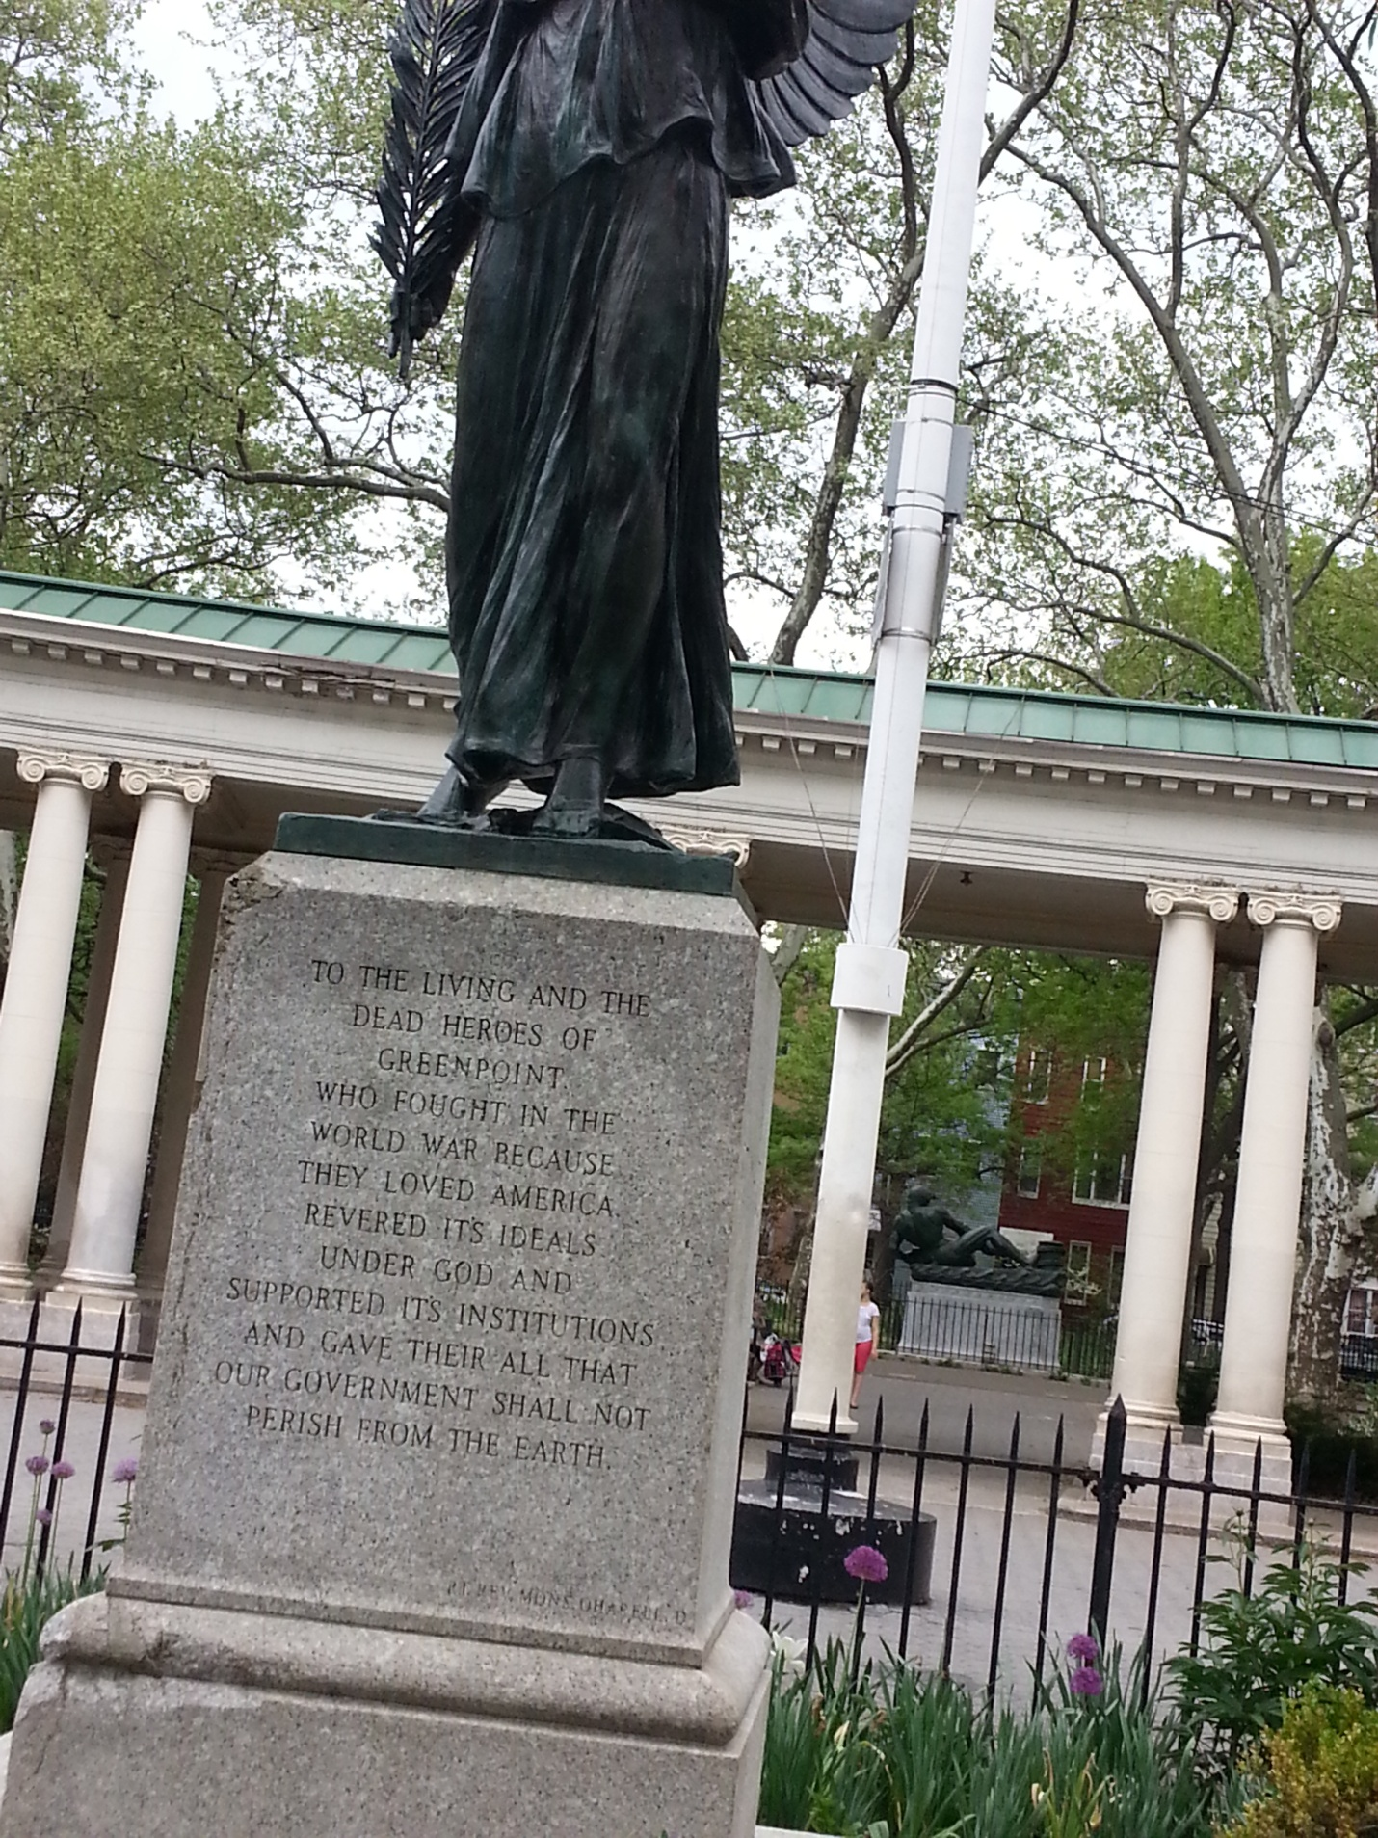
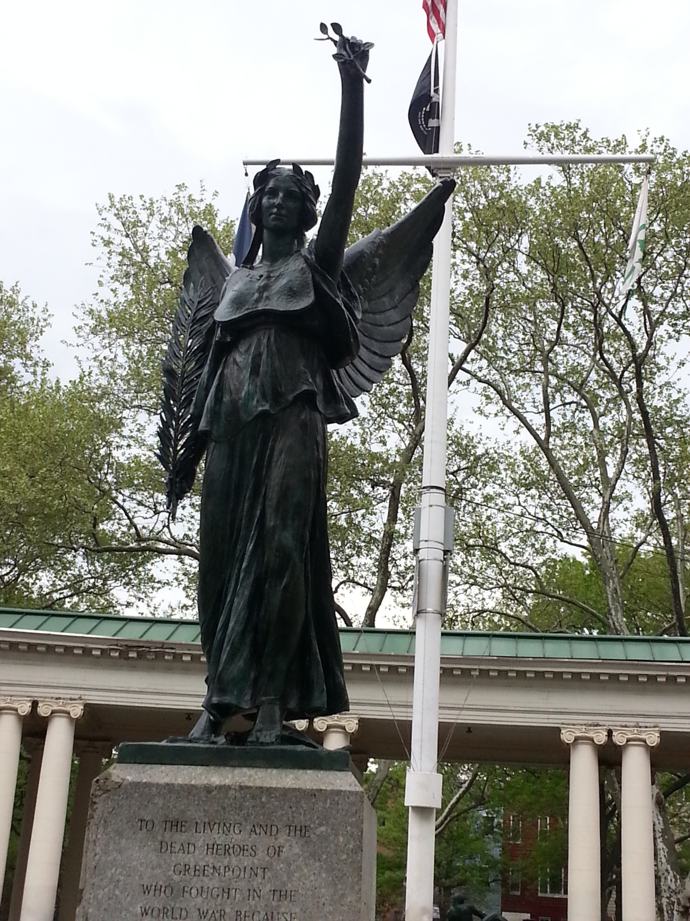

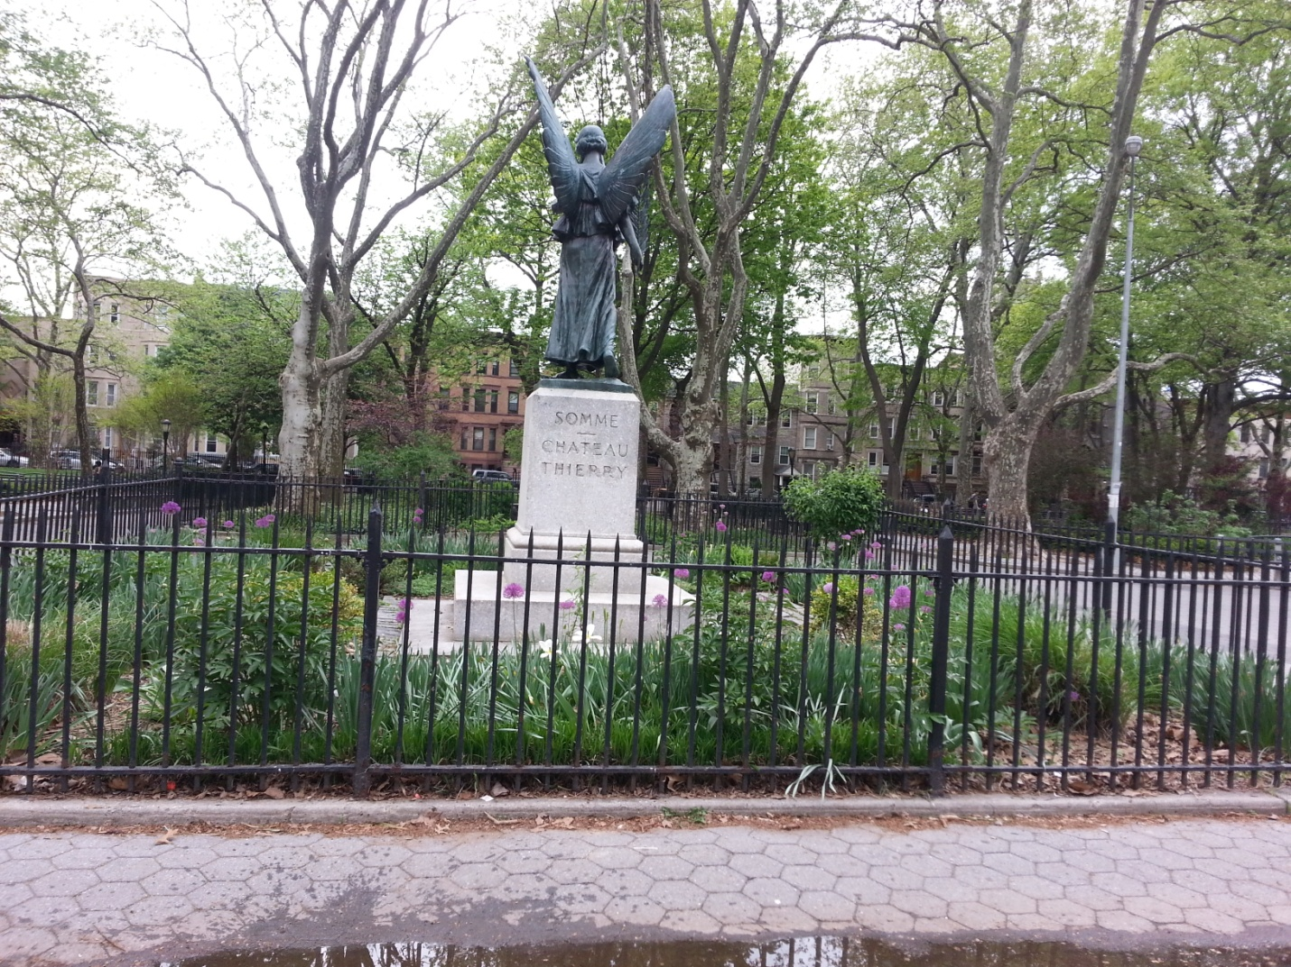

Robert Fulton, Bedstuy Park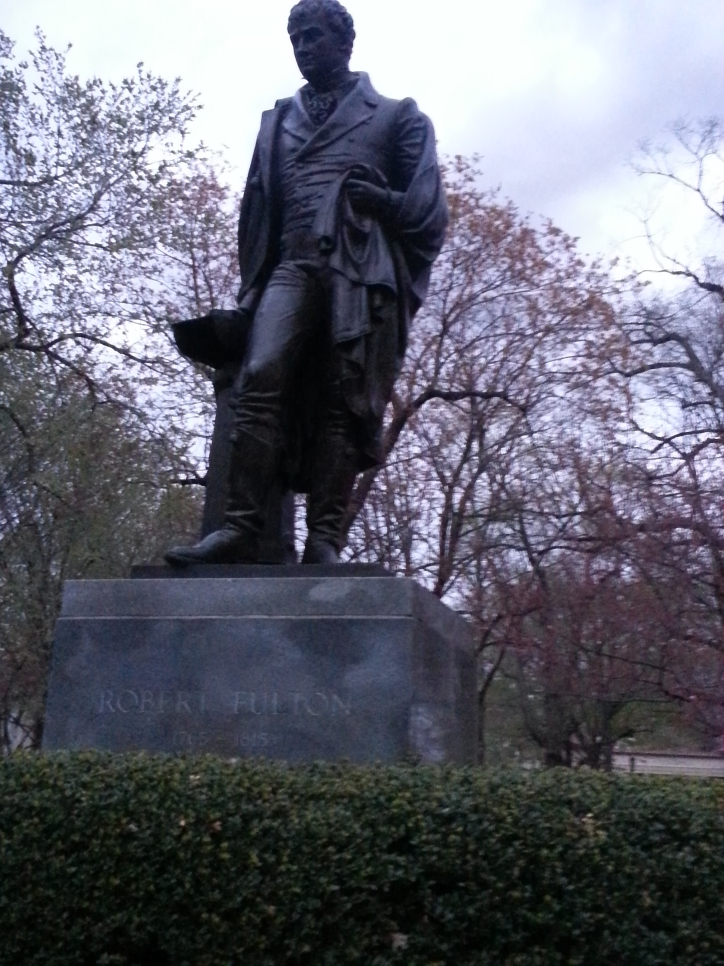
Robert Fulton was born in England in the year 1765 and died in the year of 1815 in New York City, from tuberculosis. One of the many places named after Robert Fulton is Fulton Street inside Bedstuy. His Statute lives on in the Fulton Park in Bedstuy of Fulton Street. In the year 1816, the Commonwealth of Pennsylvania donated a marble statue of Robert Fulton to the National Statuary Hall Collection in the U.S. Capitol Building. Robert Fulton was honored for his development of the steamship technology in New York City's Hudson-Fulton Celebration of 1909, and a replica of the first steam-powered steam vessel, was built named the Clermont. He was one son of five siblings and had four children of his own.

