Fortnight Festival
Omar Touray
BUF 3310

Fortnight Festival
The focus department store, in this case, is Saks Fifth Avenue, located within Fifth Avenue in New York. This is considered the epitome of luxury departments since it can cover several of the top designers. It is among the original retail enterprises which are responsible for the world-renowned shopping destination. The major features of the store can be seen from the construction, the use of different materials in the construction, the colors, and the arrangement of different designer boutiques, among others (HBC Heritage — Saks Fifth Avenue, Fifth Avenue, New York, 2021). For example, the store has utilized bronze, limestone, and marble, visible in all the stores. There are also colorings of the traditional faced bricks and limestone trimmings covering the rest of the building. This makes the store very attractive and welcoming to the designer boutiques. Saks has embraced the neo-Renaissance kind of style with the more conservative architecture. There is contemporary décor and amenities connected to the luxury departments from the early 20th century. It is also considered one of the city's designated landmarks, making it easy for people to access. It has taken major interior renovations to remain one of the most modern buildings globally and a luxury department store (Tabuchi, 2015). The department store plans to hold a fortnight festival brand for three of its designers, including Gucci, Burberry, and Prada. This assessment illustrates the festival's plan, including a simple description of the three top designers and the offered products.
PART 1:
Gucci
One of the top designers that the Saks department store covers are Gucci. Gucci is a brand that is well known globally. It employs experts in all of its designs. In this manner, it is easy to design something that can sync with the latest fashion trends. The designer ensures that it produces the best brands in the market that can satisfy the changing needs and requirements of the customers. The company is also famous for its trendsetters (HBC Heritage — Saks Fifth Avenue, Fifth Avenue, New York, 2021). The finished products always remain in style and have a continuous market and demand from the customers.
The major products of Gucci that are also presented at Saks include women's shoes, Jewelry of different types and watches, sunglasses, Grooming for men, and Beauty and Fragrance, among others. The figure below illustrates some of the sugarless and the watches sold and displayed by Gucci, especially at the Saks store. All the products are considered ready to wear.
Fig 1: Gucci brand products sample.
Gucci is among the brands that are considered very expensive. The main reason is that the brand is connected to a rich heritage and smart business tactic. It combines unique components in the designs and has clever marketing that helps create the increased market desire and high demand. The brand is known to instantly evoke a sense of prestige, desirability, and a sense of status. It is known to dominate social media with the mix of pop culture and high-end fashion. The company has millions of followers on different social media sites (20% OFF Saks Fifth Avenue Coupons, Promo Codes May 2021, 2021). It is also associated with its exclusivity since not everyone can afford to buy a product from this brand. It is a brand that suggests that the owner and the people using it have good taste, are solid financially, and stand out in the market.
It has taken a different turn into pivoting the gender fluidity, bucolic imagery, and the element of maximalism. It can illustrate a younger, less rigid, and eagerly looking individual looking for a sense of belonging associated with a new style of the tribe. Gucci is something that people associated with very strong branding. Hence, the people using the products from Gucci want to be associated with a strong brand name and rich status.
Prada
Prada has a name that is considered synonymous hence one of the features that make them unique with style and elegance. Their handbags, for example, are known to conjure the images of women wearing them who command attention with their grace and demeanor. The brand is also known to utilize the minimalist design s that they can achieve a traditional style with increased demand from the customers. The traditional style has been connected with the modern influence. Another significant product is the Prada bags. These are known to be well made and increase people's satisfaction since they can last for several years. Prada utilizes soft, high-quality leather and tough, durable synthetics in the design (20% OFF Saks Fifth Avenue Coupons, Promo Codes May 2021, 2021). A Prada product is not likely to go out of fashion for several years that a customer uses it. The brand has been well established, and as a result, it has continued to grow in terms of its sales and influence.
Some of the most common Prada products presented in Saks include Shoes, handbags, women's and men's accessories, and beauty products for both men and women. The figure below illustrates a display of shoes and the bags that Prada designer at Saks sells. These include the Logo Knit Sneakers, Leather Penny Driving Loafers, the Techno Stretch Sneakers, and the Diagrammed Leather Shoulder Bag.
Fig 2: Prada brand products sample
Mainly, the aesthetic characteristics of Prada can be observed from its sports fashion. It is considered to have much success connected to its innovative techniques that are used to promote sales. Prada also utilizes an innovative approach in designing clothes and accessories. It is easy to collaborate with internationally renowned architects who help increase the perfection of the design of the Prada shops. The name is synonymous when it comes to style and elegance. The brad clothes, together with its accessories, are described as being both classic and eccentric. They are also described as being frumpy but at the same time hip, which the ambiguous techno retro sensitivity has marked (HBC Heritage — Saks Fifth Avenue, Fifth Avenue, New York, 2021). The style is modern, which draws a lot from the traditions of Italy connected to the discreet elegance and the fine craftsmanship.
Burberry
This is considered the most quintessentially brand that utilizes gabardine fabric. The fabric is known to repel water, making it the most suitable to be worn during the wet weather seasons. For example, trench coats have become the most popular fashion item people have used after the war. It is also considered distinctive thanks to the trademark check pattern, which ensures that it can be recognized instantly among customers worldwide. The brand is connected with increased elegance and class, which has lasted for decades. Most Saks' common products include Women's clothing, shoes, handbags, women's accessories, beauty products, men's wear, and kid's products (20% OFF Saks Fifth Avenue Coupons, Promo Codes May 2021, 2021). There are several of these products that can be purchased directly from the Saks stores.
Fig 3: Burberry brand products
Some of the products include the Farley Vintage Check Pool slides, the canvas sneakers, and the little kids & the kids Kayson Puffer Down Jackets. The products of Burberry have been in the market for over 150 years, for example, the iconic trench coats. They continue to offer new and unique designs regularly but still ensure that they have maintained their historical touch. Therefore, one of the most important features that are important to the brand is history. The brand is known to be among those who developed or helped with the development of gabardine. This is still widely used today and still revolutionary (20% OFF Saks Fifth Avenue Coupons, Promo Codes May 2021, 2021). The trenches are known to be breathable and waterproof. It has cornered the market due to its fabrics and patent, which has been around since 1888. Its history makes the brand special for the customers. The brand is also known to have enjoyed mass appeal over the years but has still ensured that they have retained its air of luxury. It can command premium prices in the market along with its ubiquity hence making it incredible (HBC Heritage — Saks Fifth Avenue, Fifth Avenue, New York, 2021). It makes the brand imply scarcity hence motivating the customers towards purchase.
They offer everything from clothes, bags, shoes, sunglasses, fragrances, and other make-up products. This indicates that there is something that is offered for everyone hence explaining its appeal. If one does not like one product, such as trench coats, they can purchase something else such as cologne or a pair of shoes. However, they continue to offer important classics which are eye-catching.
PART 2:
Where the promotion will be held
The promotion will be held at Saks Fifth Avenue, located within Fifth Avenue in New York. This is a department store that is frequented by thousands of people daily. Therefore, the promotion will be able to access thousands of customers both locally and internationally. The store is located in a very accessible area by bus, walking, or even self-driving individuals. Individuals taking taxis can also access the place easily. Another important component is the fact that the department store is common within the city. Therefore, even people not used to the city can easily access it by asking around or even directing the tax drivers. This makes it suitable for managing to capture a wide audience who are likely to be into the products offered by the designers.
When it will begin and end
The promotion is intended to last for two days. Since this is a post-Covid-19 promotion, it will help welcome the customers back to the market and the season of reopening of the stores around the country and even around the world. Therefore, the promotion will start on 28th May through to 11th June.
The brands being promoted
Three main brands will be promoted in this festival as indicated above, including Gucci, Prada, and Burberry. These are among the top brands globally that occupy the Saks department store, and they are famous globally. This is due to their unique designs and products are known to increase the demand and desirability in the market. Most customers are known to associate these brands with prestige, status, and class. These brands offer products that are mainly purchased by the rich and a few from the middle class. Hence, the promotion offered indicates that it will be possible to accommodate all the customers, including those with no ability to purchase the product normally. This is a chance that the brands will be offering products at a subsidized price hence ensuring that the lower class people can purchase something that has been branded. Therefore, the promotion week is expected to accommodate several people hence better preparations to ensure that the store can accommodate all those potential customers. Gucci is the motivation behind Yves Saint Laurent and Balenciaga. Prada is the motivation behind MIU MIU and Church's. All these brands will be covered in the promotion, including Burberry.
Why is each great designer significant both then and now?
The brands are well known globally. The brand employs expertise in all of its designs. In this manner, it is easy to design something that can sync with the latest fashion trends. The designers ensure that they produce the best brands in the market that can satisfy the changing needs and requirements of the customers. Finished products always remain in style and have a continuous market and demand from the customers.
What will be featured in products and incentives to shop?
There are specific products that each brand designer will feature. These include clothes, watches, jewelry, and shoes. These products will have a 10% to 30% discount on each of them, with the discount depending on the type of product and the brand. Another incentive will be to buy three at a certain discounted price, buy two, and get one free. There will be a promotion of buy three and get a gift bag, among others. All these are components meant to help motivate the customers into purchasing.
How are you setting up the departments with products and décor?
Purple and red roses will decorate the entryway to appeal to the customers and motivate even the passerby to walk into the store and check some products. The entryway will also display photos of products on promotion and different incentives on each of the products. The walkways will be clear, and the promotion will be facilitated on one side of the department store. This is to ensure that there is no disturbance to the rest of the businesses within the store. The display areas will be arranged in a manner that each product will have a different sector (Xie & Sinwald, 2016). The items will be organized to be easy for the customers to visualize the products at home or when wearing them. The products will be organized to have a casual family room look and a comfortable and stylish dressing area to cater to various customers. There are products to be displayed on a table, such as jewelry and watches with chairs around to allow the shoppers to sit down, view, and make their purchases (Xie & Sinwald, 2016). Some of the displays for clothes can be done as illustrated in the figure below.
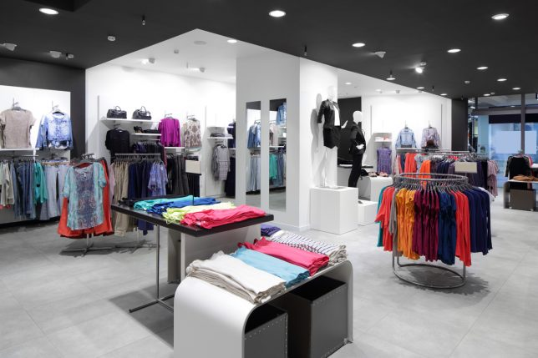
Fig 4: Arrangement of the clothing display
Some models will be hired for the display of different clothes. Another important component will be to try and appeal to multiple senses of people. This will be facilitated by selecting the playlist carefully so that it will be able to suit all the designers and for all the products. It is important to understand when to change the music and observe the customers' reactions, among others. Similarly, promote a blissful scent in different areas to reflect the products offered (Xie & Sinwald, 2016). Keep the air as fresh as possible by making the area as open as possible and avoiding crumbling.
Fig 5: arrangement of the entryway.
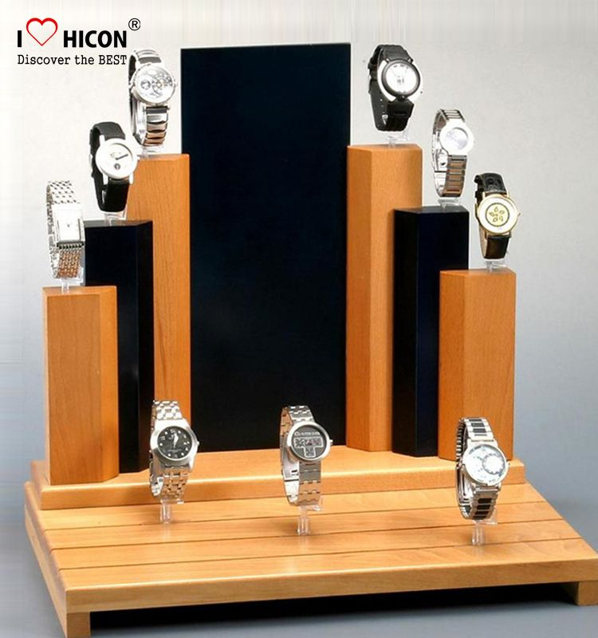
Fig 6: Watch display
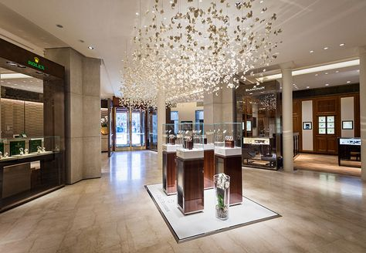
Fig 7: Display for jewelry

Store layout
Shoes, watches, jewelry, clothes
Shoes, watches, jewelry, clothes

To Gucci
To Burberry
To Prada
Shoes, watches, jewelry, clothes
Shoes, watches, jewelry, clothes

Shoes, watches, jewelry, clothes

Shoes, watches, jewelry, clothes
ENTRYWAY
CHURCH’S
MIU MIU
PRADA
MARC JACOBS
VICTORIA BECKHAM
BURBERRY
GUCCI
Yves Saint Laurent
Balenciaga

Reference Page
Xie, P. & Sinwald, A. (2016). Perceived impacts of special events by organizers: a qualitative approach. International Journal of Event and Festival Management, 7(1) pp.50-65
Tabuchi, Hiroko (November 14, 2015). "Saks Is Shaking Off Retail Gloom With a Fifth Avenue Face-Lift". The New York Times.
HBC Heritage — Saks Fifth Avenue, Fifth Avenue, New York. Hbcheritage.ca. (2021). Retrieved 7 May 2021, from https://www.hbcheritage.ca/places/places-other-institutions/saks-fifth-avenue-fifth-avenue-new-york.
20% OFF Saks Fifth Avenue Coupons, Promo Codes May 2021. Wsj.com. (2021). Retrieved 7 May 2021, from https://www.wsj.com/coupons/saks-fifth-avenue.

