## Smoking affects periodontal health

* Destruction of gum and bone surrounding the teeth

## Dental Hygiene Department

Ecaterina Olisevshi

Sevda Silit

Olesya Shumeyko

* Teeth Mobility/Loss

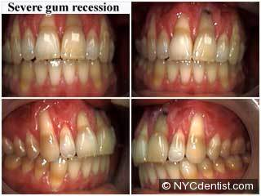

* Recession of gum line
* Slower Healing Process

**REFERENCES**

# 



Date of publication

* **Guillermo M. Rosa, Gabriela Q. Lucas, Oscar N. Lucas. Cigarette smoking and alveolar bone loss in young adults. J Periodontol. 2008 Feb; Vol.79**
* **Ojima M, Hanioka T. Destructive effect of smoking on molecular and genetic factors of periodontal disease. Tobacco Induced Diseases (71 ref). Aug 2010**
* **Yong H.Chu,Dimitris N. Tatakis, Alvin G. Wee. Smokeless Tobacco Use and periodontal health in rural male population. J Periodontol. 2010 June 81(6): 848-854**
* **Yostallo P., Sakki T., Laitinen J., Knuuttila M. The relation of tobacco smoking to tooth loss among young adults. Eur J Oral Sci 2004; 12:121-126**

SMOKING AND PERIODONTAL DISEASE



# 

Date of publication

What Is periodontal Disease?

* **Periodontal Disease** – disease that attacks gum and bone around the teeth
* **Periodontal Disease** – inflammatory destruction of periodontal tissue and alveolar bone supporting the teeth

.

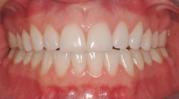

healthy mouth

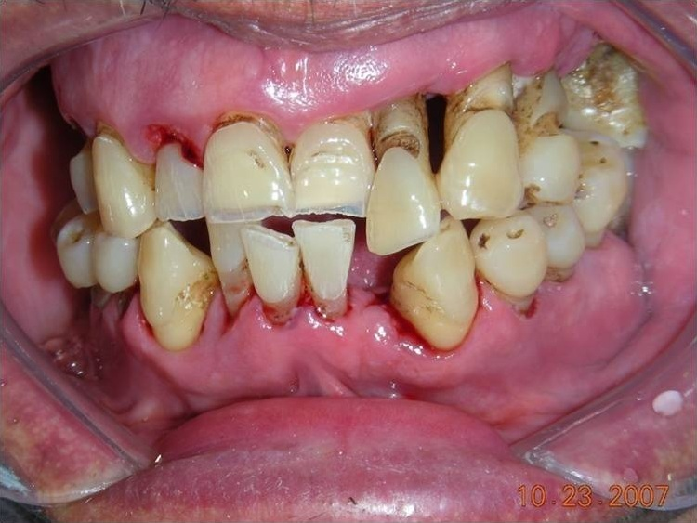

PeriodontitisRisk Factors

(for developing periodontitis while smoking):

* Systemic Diseases (Diabetes)
* Medications
* Genetic factor
* Immune System Response
* Specific Bacteria

### Cessation Methods:

* NYC Programs
* Rx Medications
* Nicotine Patches
* Nicotine Gum
* E-cigarette

Role Of Dental Hygienist

* Interviewing the patient
* Patient Education
* Oral Health Promotion
* Motivation to life style changes
* Cessation Intervention
* Thorough Periodontal Maintenance



Company Name

Street Address

Address 2

City, ST ZIP Code

Phone (555)555-0125

Fax (555)555-0145

Web site address