Obed Ledezma
05/10/18
ARTH 3311
Professor Trofimova
Final Project

For my final project I was assigned to visit the Cooper Hewitt museum located on 2 E 91st St, New York, NY 10128. The Cooper Hewitt Museum was founded in 1896. It is one of nineteen museums that fall under the wing of the Smithsonian Institution and is one of three Smithsonian facilities located in New York City. It is the only museum in the United States devoted to historical and contemporary design. Its collections and exhibitions explore approximately 240 years of design aesthetic and creativity. The Cooper Hewitt is located in the Andrew Carnegie Mansion. The Georgian style mansion was built over the course of the years 1899 to 1902 and has sixty-four rooms. From the outside it looks like a mansion with a historic architecture like design. For this assignment I had to take photos of each object and describe it. I picked 7 design objects, each in different design style. Then I had to find out the Design Style of the object, such as a poster, book, textile or sculpture/jewelry. When I arrived at first I got lost because of the few entrances the museum has. When I finally found the entrance and found my way in I decided to start first with the Saturated: The Allure and Science of color exhibition. This exhibition was my favorite because it studies the color spectrum and shows the complexities of color. Teaching and showing the many attempts of capturing color and its historical philosophy of designers that devoted their life into this wavelength of light. The first work from the exhibit that captured my interest was the Color Wheel.
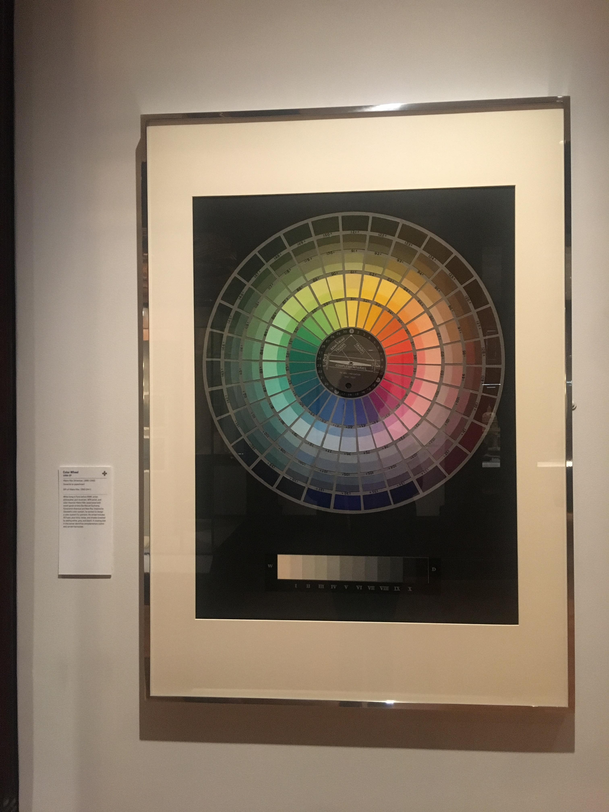
- The COLOR WHEEL is a color wheel that shows the ranges and spectrums of color in a circular motion.
- The wheel was created by Hilaire Hiler and dated 1936–37.
- The wheel was acquired in 1960 and its medium/ design style is oil paint on composition board.
- The design style shows a frame like board but it looks like a print out.
- The artist used a big amount of meticulousness so it could come out perfect

My next work I moved passed the color section and went back to the 19th century. I got the part of the exhibit where they were showcasing miniature stair models. The stairs had a strong amount of detail and also looked like they belonged to a mouse or some other kind of small animal

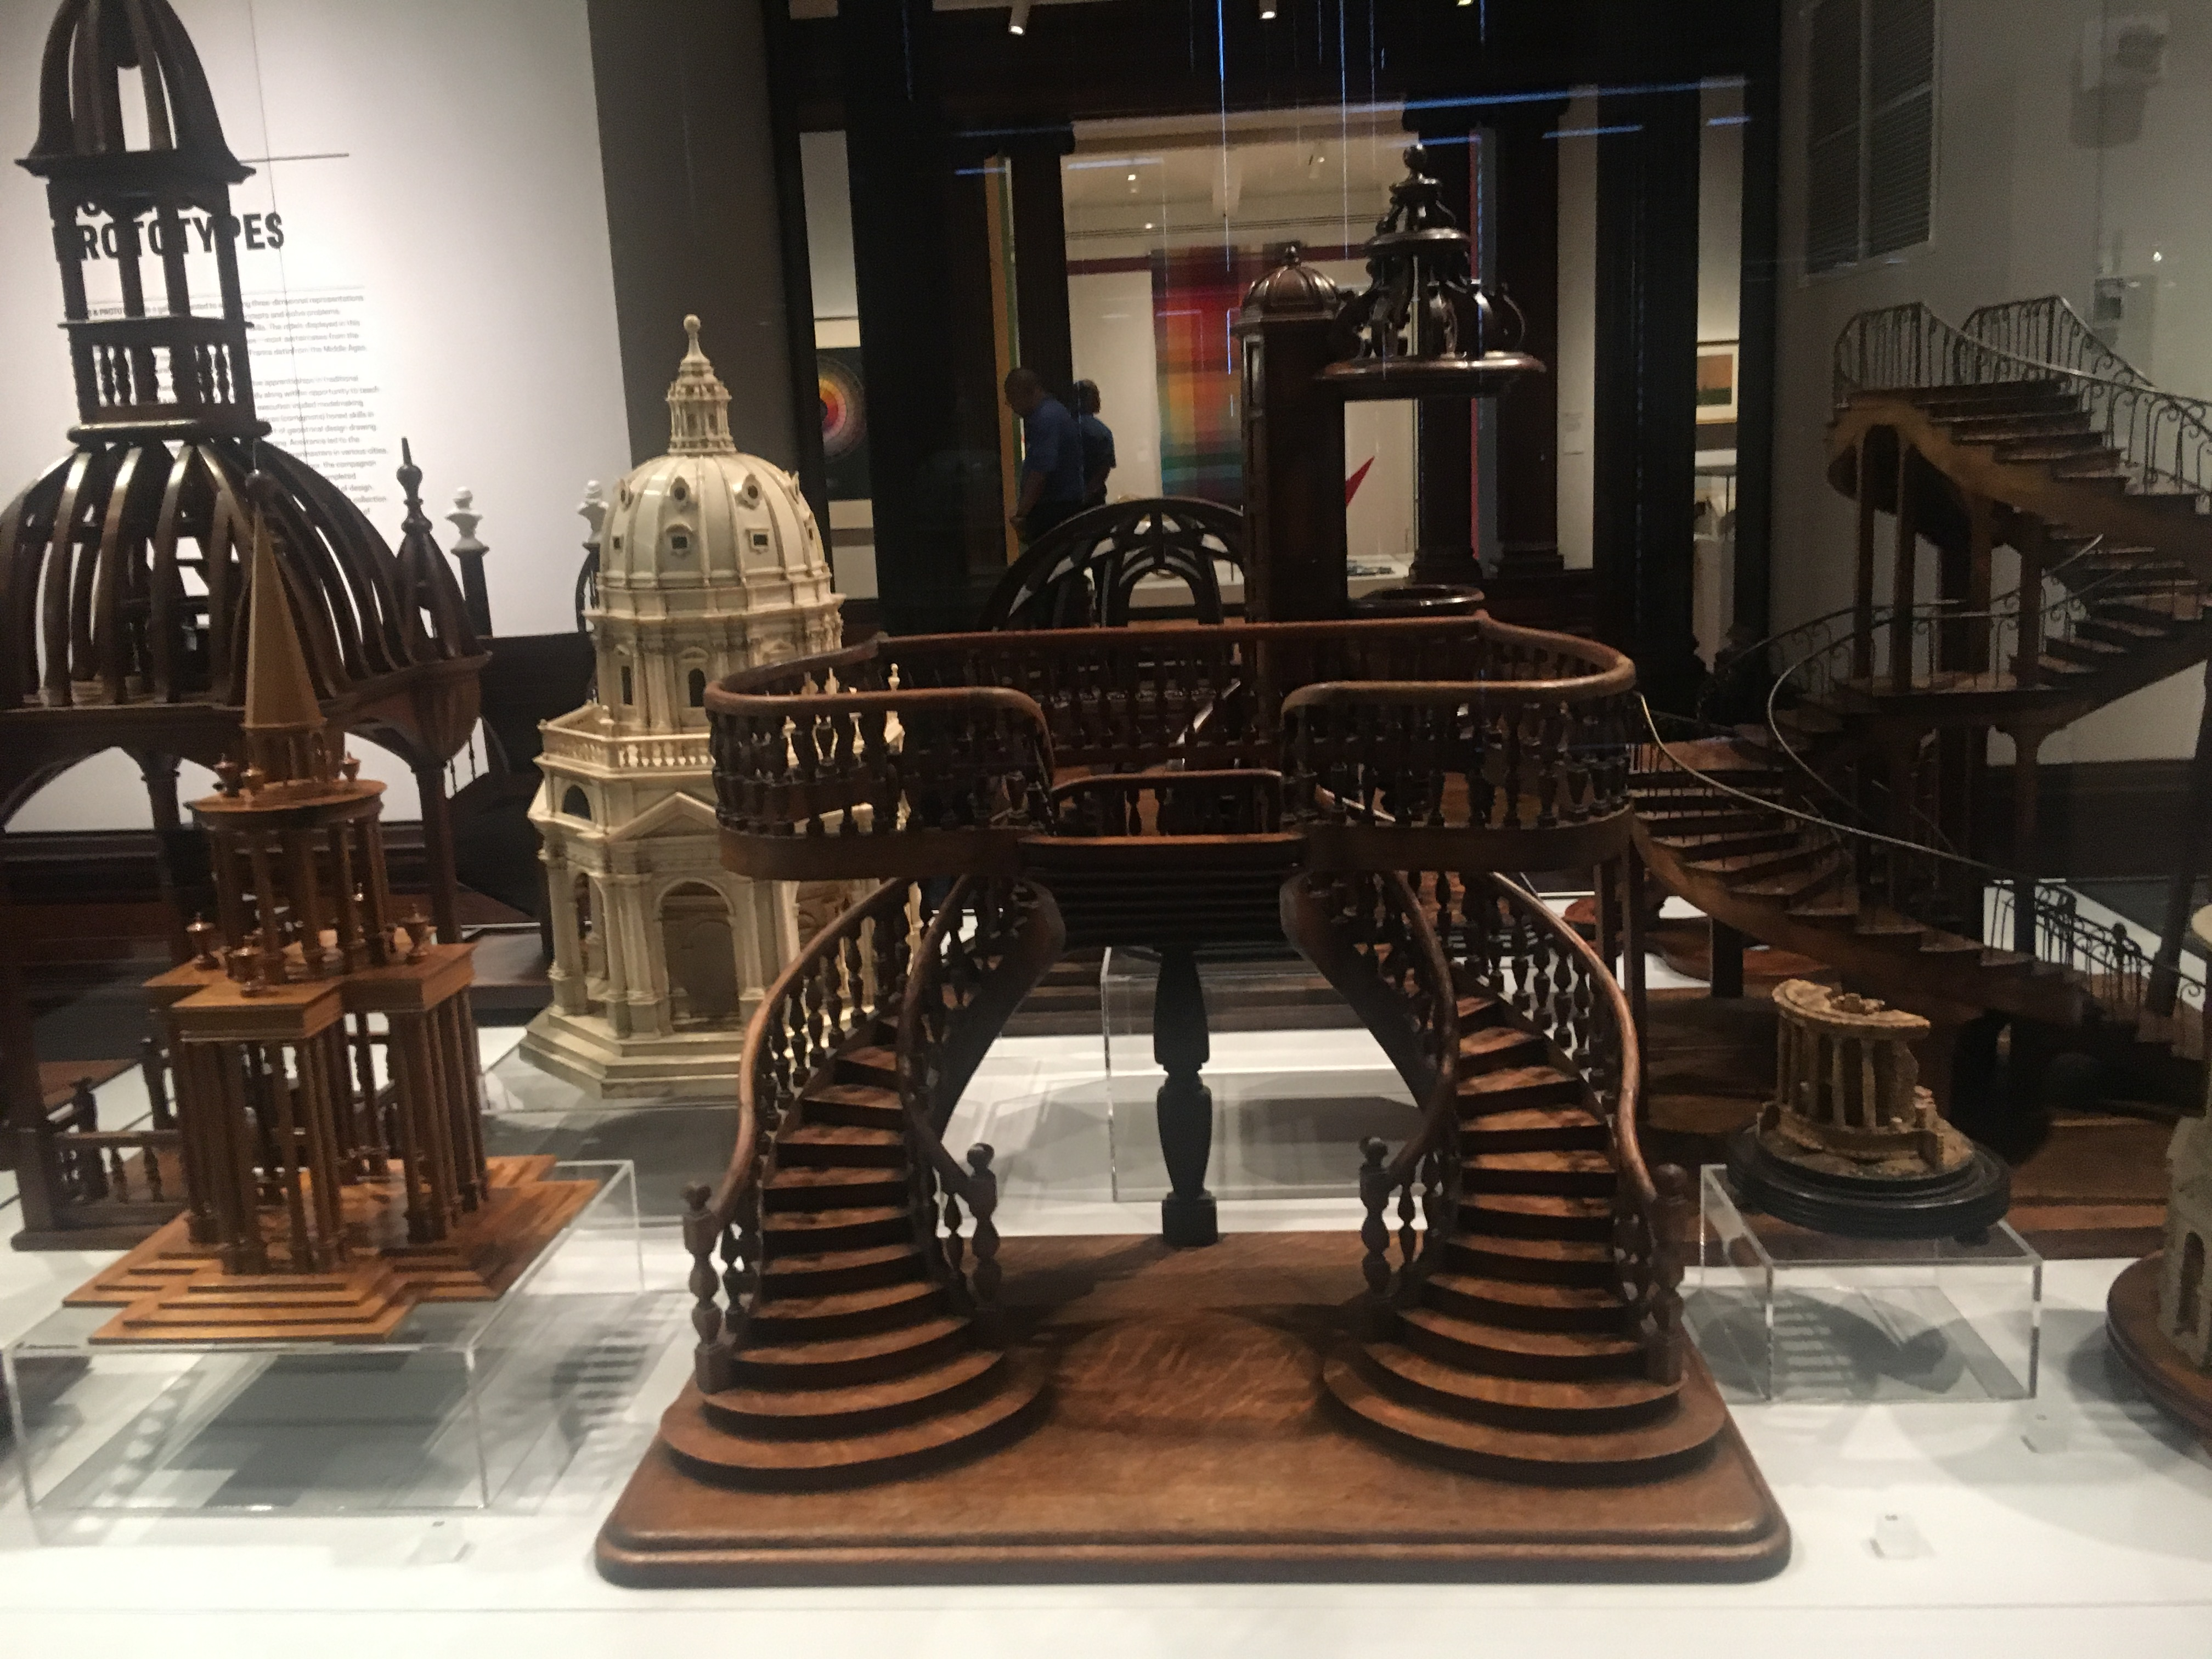
- STAIRCASE MODEL (FRANCE), is a Staircase model.
- Dated mid–late 19th century and we acquired it in 2007.
- Its medium and design style is carved, joined, turned, bent, and planed oak.
- This double-revolution staircase model is similar to one described as being “in Renaissance style for a store,” in plate 17 of a folio by E. Delbrel, published in Paris in the 1880s.
- The upper level is self-supporting and the railings’ balusters are turned.

My next work goes back the Saturated: The Allure and Science of Color exhibition. This work stood out to me because of all the recurring forms and ways of hues occurring in different designs and forms.

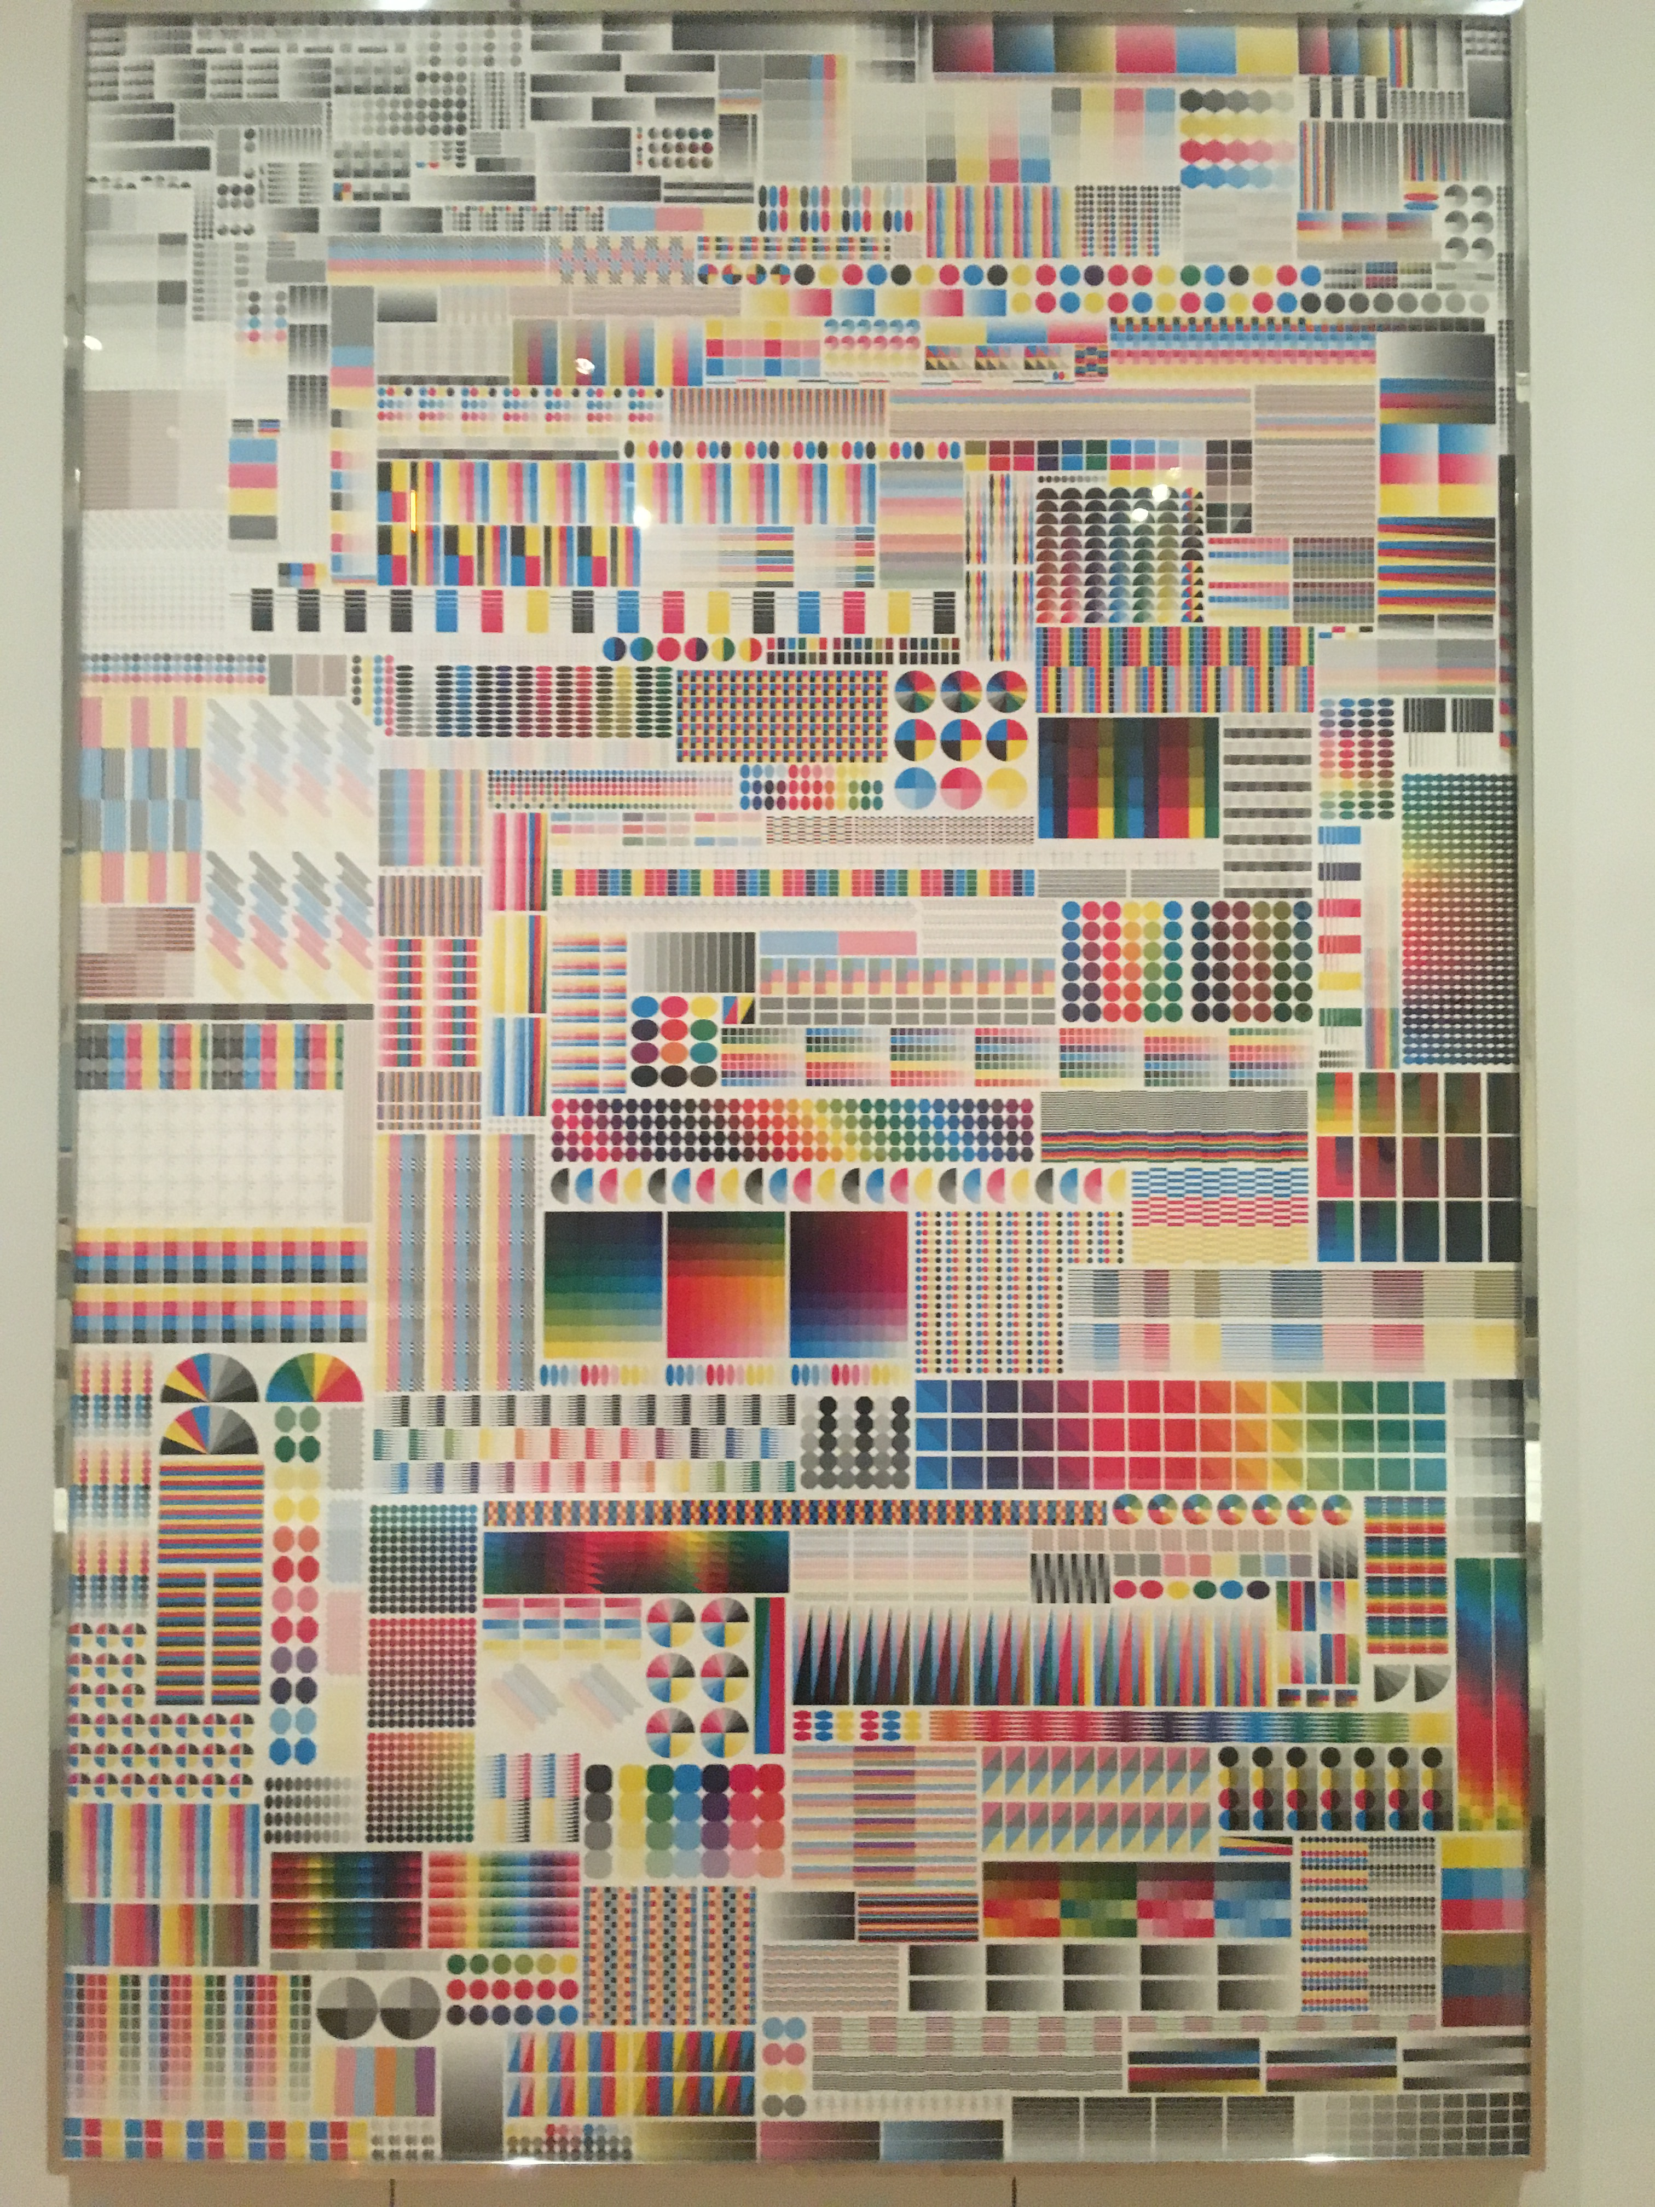

- POSTER, SPECIMEN,
- The design style is a poster.
- It was designed by Fanette Mellier.
- It is dated 2008 and was acquired in 2013.
- Its medium is offset lithograph on paper.

