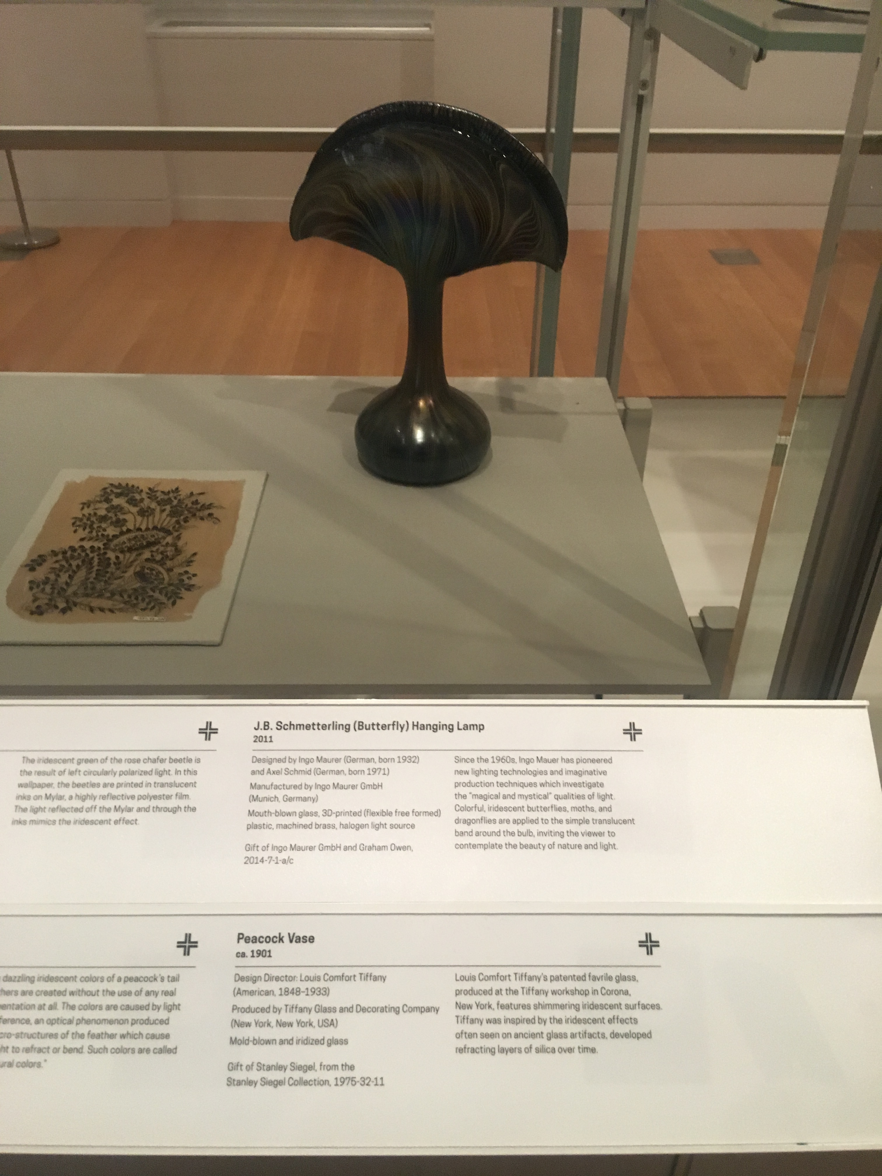
The next work that I decided to choose was The Peacock vase. The Peacock Vase was showcased on the Saturated: The Allure and Science of Color exhibition.

- PEACOCK VASE VASE
- This is a Vase that was produced by Tiffany Glass and Decorating Company and Tiffany and Co.
- The design director was Louis Comfort Tiffany.
- Dated ca. 1901 and we acquired it in 1975.
- Its medium is mold-blown and iridized glass.

The next work that I chose was the Color Blanket. The color blanket was showcased on Saturated: The Allure and Science of Color of exhibition.

- COLOR BLANKET,
- This is a Color blanket
- Produced by Designtex Group.
- Dated 2016 and acquired on 2016.
- Its medium is 50% acrylic, 50% polyester
- Its technique is plain woven with chenille yarns.
- Design style is textile because of the woven part

The next work of art goes to one of the Jewelry sections of the museum.

- THE MANHATTAN PIECE SMOKING JEWELRY,
- This is a Smoking Jewelry.
- It was designed by Otto Künzli
- Dated 1987 and we acquired it in 2016.
- Its medium is dannemann cigarillos box, brass, rubber, resin (ureol), paper, linen (book).
- Design style is jewelry.

- ASSISTIVE DEVICE, IVANIA 2.0,
- Created in 2014
- This is an Assistive device. It was designed by Evan Kuester
- Its medium is sls 3d-printed nylon 12.
- Design style is object.

For my last object I decided to go to the prototype section of the museum. I liked how they added this section to their museum because it shows the complexities of prototypes and how they’re worth a lot of money just like works of art. My overall time at the Cooper Hewitt Museum was awesome. I was able to learn about the spectrum of color, history of contemporary design, models and prototypes. I will definitely be going again very soon.

