SJOGREN'S SYNDROME
By Olga Gorokhovskiy
Oral Pathology 2018
Section: Tuesday AM
Overview
Sjögren’s syndrome is a chronic autoimmune disease affecting exocrine glands, particularly salivary and lacrimal glands, and resulting in decreased glandular secretion (xerostomia and xerophthalmia) due to lymphocytic infiltration and subsequent destruction of the glands (primary Sjögren syndrome). Secondary Sjögren syndrome is usually accompanied by systemic immune disorders of extraglandular connective tissues such as rheumatoid arthritis, systemic lupus erythematosus, scleroderma (Cartee et al. 365), biliary cirrhosis, systemic sclerosis, and polymyositis (DeNisco and Ferro 9). Distal renal tubular acidosis (dRTA) and interstitial nephritis are also common in patients with Sjögren's syndrome (Sengul et al. 218). The condition was first identified and described in 1933 by a Swedish ophthalmologist Henrik Sjögren. He found correlation between dryness of the mouth, dryness of the eyes, and polyarthritis.
Etiology
Although the underlying cause of the disease is still unknown, most likely a combination of genetic, environmental, hormonal, and viral factors is involved. The condition is not hereditary, but some genetic correlation is reported. For example, family members of patients with Sjögren's syndrome have higher chances of developing this syndrome, and other autoimmune diseases (Neville et al. 434). Viruses such as Epstein-Barr virus, Hepatitis C virus, and human T-cell lymphotropic virus (Neville et al. 434) are also found to be causative factors, but reports are still contradictory (Harley and Zoller 2328). Some authors also mention hormones such as estrogen as possible factors contributing to the autoimmune response (DeNisco and Ferro 9).
Clinical Presentation
Manifestations of the disease can range from mild to severe. Most patients will present with three classic symptoms of the primary Sjögren's syndrome: xerophthalmia (dry eyes), xerostomia (dry mouth), and enlarged and tender parotid gland. Condition involves both major and minor salivary glands. Patients will complaint on itchy and red eyes, eye infections, corneal ulcerations, heartburn, difficulty chewing and swallowing, mouth sores, dental decay. Women can also experience vaginal dryness. Mucosal lining in the respiratory tract, gastrointestinal tract also can be involved, therefore patients may present with recurrent sinusitis, nasal bleeding, recurrent bronchitis, pneumonia, upset stomach (Catanzaro and Dinkel 220). Early symptoms of secondary Sjögren's syndrome can include pain in joints, fatigue, Raynaud’s phenomenon (local vasoconstriction causes reduced blood flow to adjacent tissues), loss of appetite and weight loss (DeNisco and Ferro 10). Approximately 15% of patients with rheumatoid arthritis and 30% of the patients with systemic lupus erythromatosus will have secondary Sjögren's syndrome (Neville et al. 434).
Demographic
Different authors mention different population prevalence ranging from 0.5% (Neville et al. 434) to 3% (Saccucci et al 2) depending on the clinical criteria used for diagnostic purposes. The condition is seen predominantly in middle-aged women with female-to-male ratio 9:1 with the median age of onset 50 years old. In rare cases Sjögren's syndrome can also be diagnosed in children and adolescents. There are two characteristic waves noticed – postmenarcheal and postmenopausal (Saccucci et al 2) pointing out to some hormonal component in Sjögren's syndrome’s etiology.
Biopsy / Histology / Radiographs
An incisional biopsy of major and minor salivary glands is usually performed to confirm Sjögren's syndrome. The histological representation is characterized by the replacement of the gland tissue by the lymphocytes and the presence of epimyoepithelial islands in major salivary glands (Saccucci et al 2) (Fig.1). Biopsy of the minor salivary glands of the lower lip is assessed for the presence of multiple lymphocytic foci confirming focal chronic inflammation (Fig.2) (Neville et al. 436-437).
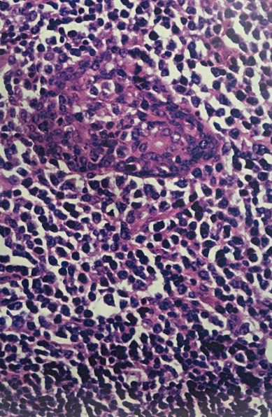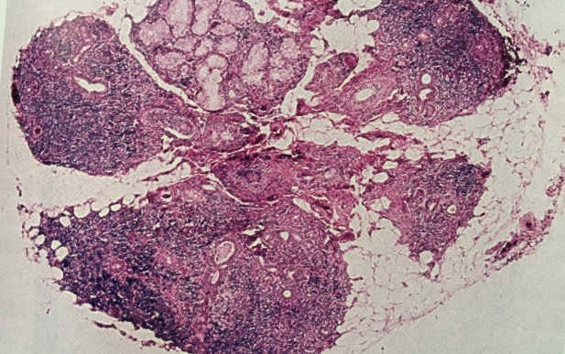
Fig.1 Benign lymphoepithelial lesion (parotid salivary gland) | Fig. 2 Numerous lymphocytic foci in labial gland biopsy
(From Neville et al. 436-437)
Differential Diagnosis
The diagnosis of Sjögren's syndrome is mainly made based on the clinical signs and symptoms, confirmed by oral presentation and laboratory tests. Sjögren's syndrome can be confused with other autoimmune diseases, such as systemic lupus erythematosus and multiple sclerosis (Cartee et al. 365), as well as diseases that present similar to Sjögren's syndrome - rheumatoid arthritis, hepatitis C, fibromyalgia, depression, HIV, and hypothyroidism (Catanzaro and Dinkel 221). To rule out these conditions a labial gland biopsy, parotid salivary gland biopsy, and blood laboratory tests are usually performed. The patients in 90% of cases will test positive for the rheumatoid factor, an anti-IgG antibody in the patient’s blood test. Autoantibodies such as anti-Sjögren A and anti-Sjögren B also are found in patients with Sjögren's syndrome (Saccucci et al 3). Other tests can involve but not be limited to determination of the erythrocyte sedimentation rate, C-reactive protein, thyroid stimulating hormone, electrolytes, total serum protein, complete blood count, urinalysis (Catanzaro and Dinkel 222).
Treatment
Treatment of patients with Sjögren's syndrome is mainly symptomatic and supportive. It has to be provided in collaboration with other healthcare providers. Dry eyes and dry mouth can be managed with artificial tears and artificial saliva. For additional secretion of stimulated saliva it is recommended to use sugar free candies or gums with xylitol. Various alcohol free mouth rinses with salivary components (lactoferrin, lactoperoxidase, lysozyme) are also reported to be effective. Cholinergic agonists (pilocarpine) can be prescribed for salivary flow stimulation only if there is enough functional glandular tissue left (Neville et al. 437). Patients with Sjögren's syndrome very often are susceptible to candidiasis caused by Candida albicans which is treated with antifungal drugs. In major Sjögren's syndrome cases, corticosteroid and immunosuppressive therapy may be used (Saccucci et al 3).
Prognosis
As Sjögren's syndrome is a lifetime autoimmune disease its progression for both primary and secondary is variable. Usually oral and ophthalmic clinical manifestations do not progress and are manageable with supportive therapy. For patients with extraglandular symptoms who experience fatigue, pain, neurological symptoms, sleep problems progression of the disease eventually decreases the quality of life significantly (Hackett et al. 2025). Patients with primary Sjögren's syndrome have increased risk for lymphoproliferative disorders, including non-Hodgkin's lymphoma. (5%-15%). Tumors initially appear within the salivary glands and the lymph nodes. Risk factors for tumor development include persistent lymphadenopathy, splenomegaly, and bilateral parotid enlargement, history of radiation treatment, neutropenia, and palpable purpura (Neville et al. 437), (DeNisco and Ferro 18). Secondary Sjögren's syndrome’s progression involve damage the vital organs of the patient’s body, therefore complicating the illness, course of treatment and worsening the prognosis.
Professional Relevance
Dental hygienists can collaborate with other healthcare professionals treating patients with Sjögren's syndrome. As primary symptoms in many cases are confined to the oral cavity, the dental hygiene professional can be the first healthcare professional to detect the disease, and early detection will allow preventing many complications. DH recommendations elaborated with a primary healthcare provider must be tailored for the specific patient taking into account the severity of the disease, patient’s compliance, and receptibility. Due to hyposalivation patients with Sjögren's syndrome are more susceptible to dental erosion, dental caries, mucosal friability, dry cracked or peeling lips, angular cheilitis, dry plaque laden coarse tongue, erythematous tongue, mucositis, ulcers, oral candidiasis, halitosis, and oral/dental infections (Cartee et al. 366). Salivary stimulants, salivary substitutes, prescription fluoride products and professional application of topical 5% sodium fluoride varnish, dietary counseling along with thorough oral homecare instructions can increase the quality of life significantly.

Works Cited
Cartee, Deborah L., et al. “Sjögren’s Syndrome: Oral Manifestations and Treatment, a Dental Perspective.” Journal of Dental Hygiene, vol. 89, no. 6, Dec. 2015, pp. 365–371. EBSCOhost,citytech.ezproxy.cuny.edu:2048/login?url=http://search.ebscohost.com/login.aspx?direct=true&db=ccm&AN=112160042&site=ehost-live&scope=site.
Catanzaro, Jeanne, and Shirley Dinkel. “Sjögren’s Syndrome: The Hidden Disease.” MEDSURG Nursing, vol. 23, no. 4, July 2014, pp. 219–223. EBSCOhost, citytech.ezproxy.cuny.edu:2048/login?url=http://search.ebscohost.com/login.aspx?direct=true&db=ccm&AN=103993077&site=ehost-live&scope=site.
DeNisco S, and Ferro L. “Sjögren’s Syndrome: Recognizing and Treating an Autoimmune Disease.” American Journal for Nurse Practitioners, vol. 8, no. 5, May 2004, pp. 9-21. EBSCOhost, citytech.ezproxy.cuny.edu:2048/login?url=http://search.ebscohost.com/login.aspx?direct=true&db=ccm&AN=106672739&site=ehost-live&scope=site.
Hackett, Katie L., et al. “A Systematic Review of Non-Pharmacological Interventions for Primary Sjögren’s Syndrome.” Rheumatology”, vol. 54, no. 11, Nov. 2015, pp. 2025–2032. EBSCOhost, doi:10.1093/rheumatology/kev227.
Harley, John B., and Erin E. Zoller. “Editorial: What Caused All These Troubles, Anyway? Epstein-Barr Virus in Sjögren’s Syndrome Reevaluated.” Arthritis & Rheumatology, vol. 66, no. 9, Sept. 2014, pp. 2328–2330. EBSCOhost, doi:10.1002/art.38725.
Neville, Brad W., Damm, Douglas D., Allen, Carl M., and Chi, Angela C. Oral and Maxillofacial Pathology. Fourth ed. 2016. Print.
Prater, Sonya L. “Sjögren’s Syndrome: How It Affects How Dental Hygienists Offer Treatment.” RDH, vol. 32, no. 3, Mar. 2012, pp. 98–109. EBSCOhost, citytech.ezproxy.cuny.edu:2048/login?url=http://search.ebscohost.com/login.aspx?direct=true&db=ccm&AN=104537793&site=ehost-live&scope=site.
Saccucci, Matteo, et al. “Autoimmune Diseases and Their Manifestations on Oral Cavity: Diagnosis and Clinical Management.” Journal of Immunology Research, May 2018, pp. 1–6. EBSCOhost, doi:10.1155/2018/6061825.
Sengul, E., Bunul, F., Yazici, A., Sengul, A., Dindar, S., Selma Kilic Halhalli, G., & Binnetoglu, E. (2013). “An Unusual Initial Presentation of Sjögren’s Syndrome: Severe Hypokalemic Paralysis Secondary to Distal Renal Tubular Acidosis”. Eurasian Journal of Medicine, 45(3), 218–221. https://doi-org.citytech.ezproxy.cuny.edu/10.5152/eajm.2013.43.

