Creating an OpenLab site for your OER
Step by step documentation
Here is documentation for how to create an accessible and usable OER on the OpenLab. You can also consult the OER Checklist to help you through the process.

Clone the OER Site Template

Cloning Process
    - Log into the OpenLab and navigate to the OER Site Template: https://openlab.citytech.cuny.edu/groups/oer-template/
    - To begin cloning the course, click on the Clone this Course button (beneath the course avatar).

Site Set-Up

Course Name
      - Name your course.
        - This is the name that appears on the course profile (e.g. OER Template), and in the Courses directory on the OpenLab. If you need to change the name later, it can be changed in the Course Settings.

Sharing Settings
      - If you do not want shared cloning enabled, uncheck the box.
        - Since the template course has shared cloning enabled, this setting will be enabled by default, which allows other faculty on the OpenLab to clone your course.

Site Details
      - “Name your cloned site” will be chosen by default; keep this setting to allow you to choose the URL for your site.
      - Choose a unique site URL (e.g. “LastNameMAT1275OER" is better than “MathOER”). If you intend to use the site over multiple semesters, don’t include the semester in the URL.

Privacy Settings
      - Privacy settings will depend on what is best for your workflow. You may want to keep the course private while you’re building it out or keep it open from the beginning.

Edit your Site

Customize your site’s homepage

Theme
      - The default theme for your site is Hemingway, which is accessible and responsive for mobile devices. You can test out different themes in Dashboard > Appearance > Themes. Hover your mouse over the theme and click Preview.

Site tagline
      - To change your site’s tagline, go to Dashboard > Appearance > Customize. This will take you to the customizer where you select Site Identity. There you can change the tagline. When using the customizer, be sure to click the blue Publish button when you’re finished and then click the X in the upper left hand corner to close.

Header image
      - To change your site’s header image, go to the site Dashboard > Appearance > Header. The steps are fairly self explanatory but do pay attention to the suggested image dimensions for the header. Your image should be at least as large as those suggested dimensions.

Activate Menu
      - All pages and the menu from the template site will be in draft form on your cloned site.
        - To activate your menu and publish pages, go to Appearance > Menus > Click Save Menu - this will activate the menu and automatically publish pages from draft.
      - If you are creating new pages on your site, think about grouping content to avoid too many menu items, which can make it harder to navigate the site. Consult the Usability Module’s section on usable navigation for guidance. Keep your dropdown menu items to a minimum. Make sure if you do have dropdowns that you link to the relevant pages via the top level menu item.

Widgets
To edit or add widgets, go to Dashboard > Appearance > Widgets. Click the arrow to the right of the widget name for settings and to edit text. Refer to the screenshot on the following page.

Screenshot for editing Text Widget
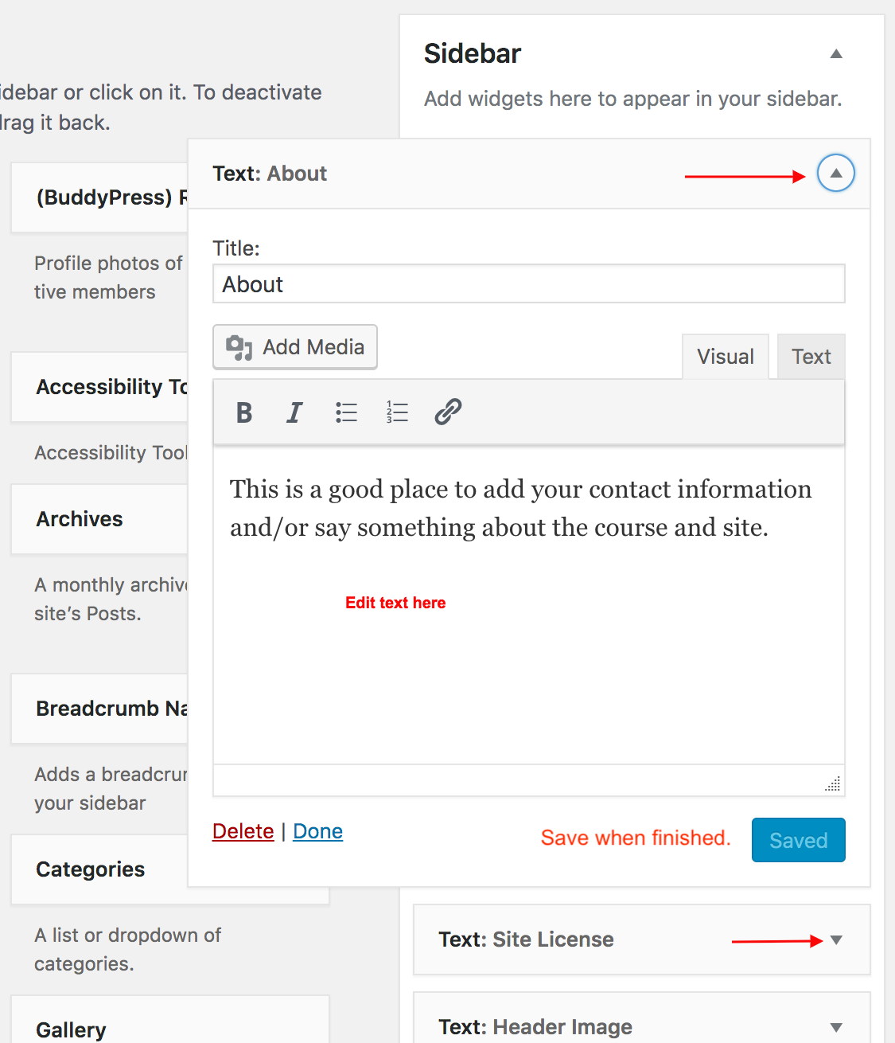

The widgets outlined below are already activated. You will need to customize some of them.

Text: About
  - We recommend you keep the text widget and include instructor contact information and/or something brief introducing the course and site.

Site License
  - Your site must be Creative Commons licensed. Keep the default license or choose another one.

Library Subject Guide
  - If students are conducting research as part of your course, encourage them to use this guide. You can also change or select a specific subject guide by editing the widget.

Header Image attribution
  - Include attribution for your header image here by hyperlinking to the site you got the image. If it’s your own image, cite yourself.

Credits
  - This widget is automatically included when you clone another faculty member’s course. Since it doesn’t make as much sense in this context, and might even be confusing for students, we suggest that you delete it.

Plugins
The plugins outlined below are already activated on your cloned site.

To add plugins, go to Dashboard > Plugins. Find the plugin you want to add, and click the Activate link below the plugin’s name. Find out more in the OpenLab plugins tutorial.

Easy Table of Contents
      - Easy Table of Contents allows you to create a table of contents box at the top of the page if you are using heading styles to demarcate new sections of the text in a page. This plugin will already be activated on your site.
      - Next, edit a page or post where you have multiple sections demarcated by headings. Create headings by choosing the appropriate heading style/size (e.g. Heading 1, etc) from the dropdown that says “Paragraph” in the editing toolbar while editing a page. Before you update or publish the page, scroll down until you see the Table of Contents metabox, and check the box for “Insert table of contents.”
      - By default, Easy TOC will only create a table of contents if there are at least four headings (of any type) in a post or a page. Keep this in mind if the table of contents doesn’t show up on the page you want it to. You can change this in the plugin settings.
      - To adjust some settings, go to Dashboard > Settings > Table of Contents. You can adjust the minimum number of headings required, whether you want a TOC to appear automatically, where the TOC displays on the page, whether or not you also want it to appear on posts, and other display options. Important note: if you want a TOC to show up on your front page, you’ll need to scroll down to the Advanced settings at the bottom of this page and then check the box next to “Show the table of contents for qualifying items on the homepage” and then click the blue “Save Changes” button at the bottom of the page.

Mammoth .docx Converter Plugin
      - The Mammoth .docx Converter plugin allows you to more easily import documents from Microsoft Word without losing formatting. The degree to which Word formatting is preserved will vary among documents, but generally the more semantic your markup in Word (e.g. using heading styles, etc), the better the formatting will translate. This plugin will already be activated on your cloned site.
      - Edit or create a page or post where you want to import content from a Word document, and scroll down to the Mammoth .docx converter meta box. Click the “Choose File” button, select the file you want to use, and the contents of the file will appear in the meta box below. If you want to import it, click the button, “Insert into editor.”
      - Once it appears in the text editor, you can check the formatting, and edit, add, or delete, as necessary.

Links for reference
  - Cloning a Course (OpenLab Help tutorial)
  - The Usability Module
  - Accessibility One Pager
  - Summary of Accessibility on the OpenLab
  - Making Your Work Accessible
  - Reading Ease and Accessibility
  - Webaim Best Practices for Powerpoint Accessibility

OpenLab Help has a tutorial for cloning a course, which you can follow if you have any questions.
Once your site is finished, you must confirm that both the site and the course profile are set to public view
To learn more, see the OpenLab Help page on Shared Cloning.
For more information about editing your menu, see this tutorial from OpenLab Help.
You can also drag and drop the widgets to change the order. For more information about widgets, see this OpenLab tutorial.

