Session 2 Activity - Identifying Licensing Information for Course Content

- Describe your resource and where you found it.

- Locate and transcribe the intellectual property license here (e.g. all rights reserved, CC-BY).

- Select the applicable license or designation:

USABLE
Public Domain , 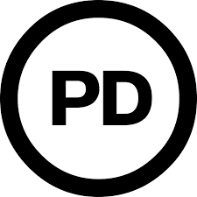
Open Educational Resource 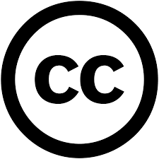
Open Access 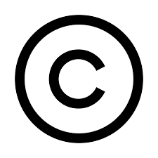, +
City Tech Library resource
Free online material
NOT USABLE
Rogue / pirated file
Copyright infringement

Symbol key:
no copyright / public domain
public domain
Creative Commons license
Non-derivative C.C. license
Copyright

- Based on the license and accompanying permissions / restrictions, what are your options for sharing this material with students (select all that apply)?

___ Link to it only
___ Link to it and upload a copy to my site

