Session 2 Activity - Identifying Content for your O.E.R.

- Describe your resource and where you found it.

- Locate the intellectual property license (e.g. CC-BY) and transcribe it here.

- Select the applicable license or designation:

Public Domain , 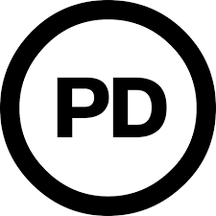
Open Educational Resource 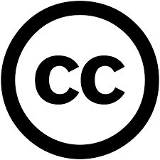
Open Access 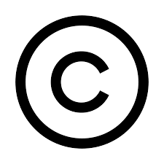, +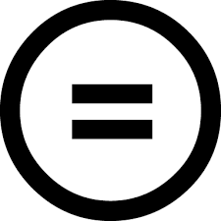
Library digital resources
Free materials online
Rogue / pirated file

Symbol key:
no copyright / public domain
public domain
Creative Commons license
Non-derivative C.C. license
Copyright

- Based on the license and accompanying permissions / restrictions, what are your options for sharing this material with students?

___ Link to it only
___ Link to it and upload a copy to my site

