Laboratory 6: ZOOLOGY PART I: KINGDOM ANIMALIA - LOWER INVERTEBRATES
After completion of this laboratory session, and with 70% accuracy on the first laboratory quiz, the student should be able to:

- Describe the characteristic features of Kingdom Animalia
- Explain the features and criteria for animal classification: level of organization, body symmetry, body cavity, embryological development, segmentation
- Describe the distinguishing features of members of the phylum Porifera and the phylum Cnidaria
- Describe the body forms of cnidarians
- Describe reproduction of those species alternating between polyps and medusa
- Compare the feeding methods of sponges and jellyfish
- Describe the general morphology of flatworms
- List characteristics that phylum Platyhelminthes has in common with phyla Porifera and Cnidaria
- List characteristics of flatworms that are more advanced than those of more primitive phyla
- List examples of each major class of flatworm.
- Answer the review questions at the end of the exercises
---

Laboratory 7: ZOOLOGY PART II: KINGDOM ANIMALIA - LOWER INVERTEBRATES (CONTINUED)
After completion of this laboratory session, and with 70% accuracy on the first laboratory quiz, the student should be able to:

- Discuss anatomical characteristics that distinguish acoelomates, pseudocoelomates and coelomates
- Discuss anatomical characteristics of cephalization and segmentation
- Describe the general morphology of roundworms and rotifers
- List characteristics present in roundworms that are more advanced than those of more primitive phyla
- Describe the general morphology of organisms of the phylum Annelida and phylum Mollusca
- List the characteristics that annelids and mollusks share with Platyhelminthes and Nematoda
- Discuss the characteristics of annelids and mollusks compared to more primitive phyla
- List examples of the major classes of annelids and mollusks
- Answer the review questions at the end of the exercises
---

Laboratory 8: ZOOLOGY PART III: KINGDOM ANIMALIA - HIGHER INVERTEBRATES AND CHORDATES
After completion of this laboratory session, and with 70% accuracy on the first laboratory quiz, the student should be able to:

- Describe the general morphology of organisms of phylum Arthropoda.
- List characteristics that arthropods share with the phyla studied in previous exercises
- Discuss characteristics of arthropods that are advanced over more primitive phyla
- List representative genera of the major classes of arthropods
- Describe modifications of the exoskeleton and paired appendages of arthropods
- Discuss embryological characteristics that distinguish protostomes from deuterostomes
- Describe the morphology of organisms of phyla Echinodermata,
- Describe the water vascular system of echinoderms
- Describe the morphology and features of the Chordata (Urochordates, Cephalochordates and Vertebrates)
- List characteristics that echinoderms and chordates share with phyla previously studied
- Discuss characteristics of echinoderms and chordates that are unique or advanced compared to more primitive phyla
- Discuss the evolution of vertebrates
- Answer the review questions at the end of the exercise

Live/ Fresh Specimen observed/dissected | Domain | Kingdom | Phylum/Group | Lab
Hydra | Eukarya | Animal | Cnidaria | 6
Planaria | Eukarya | Animal | Platyhelminthes | 6
Rotifers | Eukarya | Animal | Rotifers | 7
Clam | Eukarya | Animal | Molluscs | 7
Earthworm | Eukarya | Animal | Annelids | 7
Grasshopper | Eukarya | Animal | Arthropoda | 8
Sea star | Eukarya | Animal | Echinodermata | 8
Frog | Eukarya | Animal | Chordata | 8
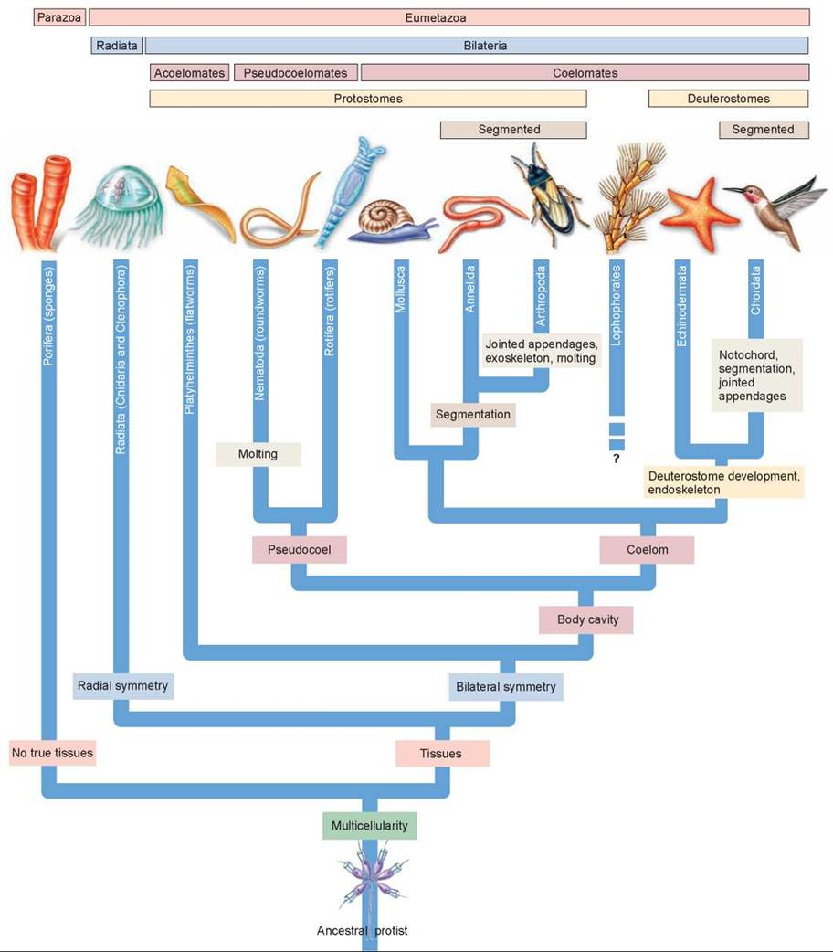
---
Phylogenetic Tree of Animals

