Group One: Samuel A-Y., Victor O., Elmer R., Jorge S., Tatyana S.
Prof. Bugg
LIB 1201
19 May 2014
Subway Tutorial Proposal
Our presentation is going to be used as an informational tool for people who have never used the subway in New York City. We’ve created this tool to hopefully help these first time straphangers navigate the subway system like a native New Yorker. We will cover the basic concepts they will need to know in order to get from their starting point to a desired destination.
For our sources we used the MTA’s website, mta.info for facts, figures and fares. Images were mostly photographed by group members. Those that were not were cited. NYC Tourist was another resource we used for information along with our groups’ collective first-hand knowledge as subway commuters.
There were a number of interesting facts that came to light that people either did not know or were unclear about. With this project, we were hoping to get a clear picture of how we could guide someone to and fro via the subway without confusing them in the process.
This information resource will provide an individual with concise information they would need to know when it comes to using the subway system. There is a flowchart will guide them down a path of how to buy an all important MetroCard. Step by step instructions of how to find a subway station and how to find your way once in a subway station will keep people aware of their surroundings. The benefits of using and refilling a MetroCard will be described expressed.
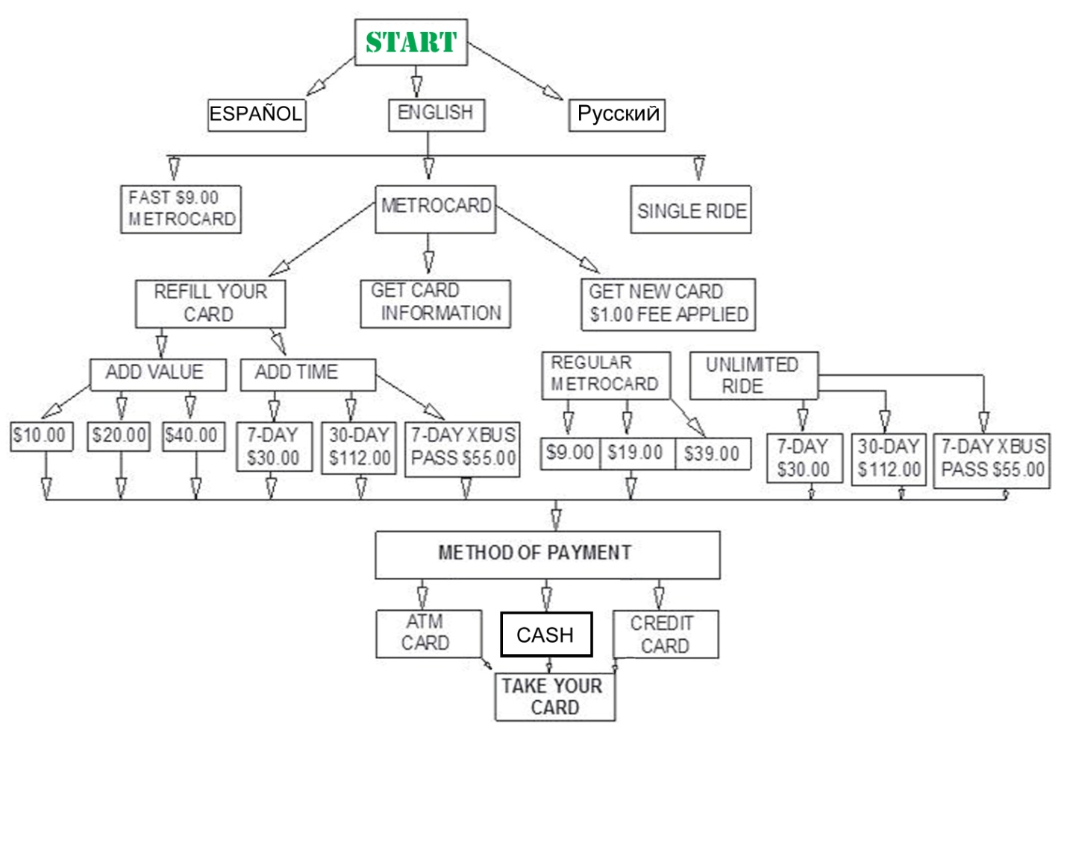

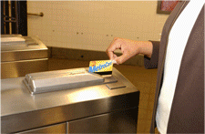
MTA. MetroCard at Turnstile. MTA.Info. GIF. n.d. Web. 28 Apr. 2014
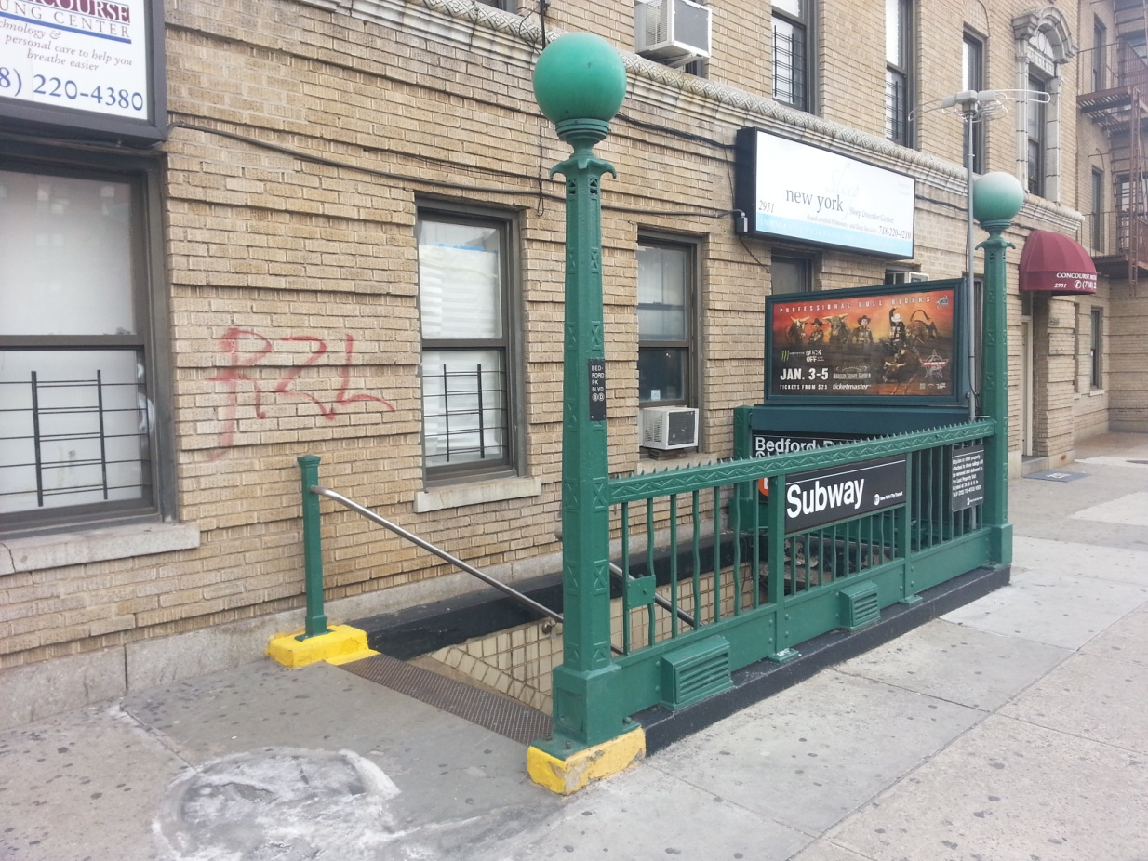
Onyekwere, Victor. Subway Station Entrance. Photo. 3 May 2014

