English 2200 Essay Guide Tip Sheet Developed by Dr. Caroline Hellman

A few helpful tips:

- Remember to focus on the texts themselves, rather than the authors’ biographies.
- Each text you discuss can be summarized briefly (a few sentences); otherwise, avoid plot summary and focus on analysis and interpretation instead.
- Remember that you are trying to persuade your reader of your position, so a thesis cannot be “In this paper I will discuss this text alongside another text.” Your thesis needs to make a claim, or argument.
- In answering your chosen essay topic, be sure to consider:
- WHAT is the author’s argument or point in the text? What does s/he convey to the reader?
- HOW (through what literary devices) does s/he convey this argument?

- Literary devices to possibly consider: choice of genre, language, narrative voice (first person? third person?), intended audience, choice of allusions/outside references, important themes discussed.
- 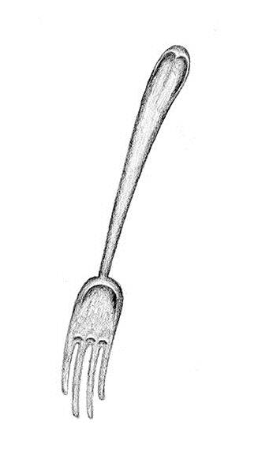Think of your body paragraphs as the tines of a fork. Without these tines, the fork can’t work as an implement! Each tine must contribute a different point to support your argument.

Thesis Example: The genre of poetry is important to Walt Whitman’s poem “Mannahatta” because it allows him to use free verse, to offer loose lists of people’s identities, and to mirror the linguistic diversity of the city he loves.

Paragraphs/tines 1: How loose lists contribute to reader’s understanding of poem
2: How free verse affects reader’s understanding
3. How diversity of the poem and city are important to structure of poem

Body Paragraph Structure Guide
1. Topic sentence (your claim)
2. Description of relevant plot point to support your claim
3. Quote from text to help prove your point
4. Quote analysis (example: This quote shows that…)
5. Any additional pontification you’d like to add/ concluding sentence

- All quotes must include citations in MLA style. “…..” (Smith 89). For poems, include the line number: “…..” (Bradstreet line 20). Avoid quotes beyond four typed lines in length, so they don’t overwhelm your analysis.

- Remember that any information copied from elsewhere without citing the source is plagiarism, resulting in a failure of the paper. Please be careful and simply avoid secondary sources!

