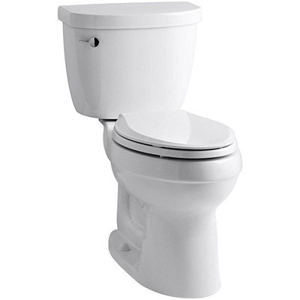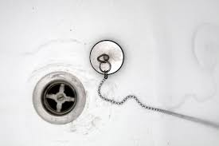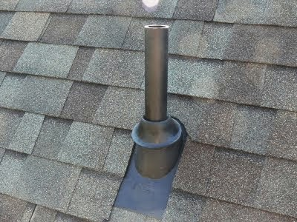

**By: Natalie Kavral**

Drainage

Waste

Vent

Drain, Waste & Venting System

Why wait, start today

“You can save yourself major bucks by simply following this guide”

**Let me teach you how to solve them!**

*Having plumbing problems?*

DRAIN, WASTE & VENTING SYSTEM

**Table of Contents:**

1. Introduction to what a Drain, Waste & Venting System 3
2. The six major elements in a DWV system 4
3. How to calculate the size for drainage and a vent system 6
4. Different type of plumbing material used for a DWV 7
5. Fittings needed for a Drain, waste & Venting System 8
6. Safety & Contamination Prevention 11
7. Personal Protection 12
8. Assemble the Rough-In 13
9. Test the system 15
10. Note from author 18
11. Bibliography 19

**Introduction**

Plumbing can be a very complex trade that requires skill, knowledge and hands on practice. Unfortunately, you cannot know the fundamentals of plumbing without being able to perform the hands-on skill. Both hands on experience and theory go hand in hand to conduct a secure, safe and functioning system. The Drain, Waste and Venting system is a combination of three different categories in plumbing that is constantly installed, repaired and dealt with in our everyday lives. These three elements work together to remove and dispose of waste and provide proper venting to eliminate bad sewer gases from entering. Throughout this guide you will learn the six main components involved when installing a drain, waste and venting system. You will also acquire knowledge based on not only installing plumbing, but professionally per plumbing code. It is important that you not only obtain this information, but educate yourself when performing hands on practical so ensure that it is being done not only to your personal standard but the plumbers national standard as well.

The DWV system is one general idea, but it comes with various approaches in how you do it, which material and where you are installing. But, the code and fittings used when installing a DWV system do not change. Therefore, I will also introduce the different type of plumbing materials in which this job can get done and approached as well as the different fittings that will be needed to get the job done. I will also be presenting illustrations hoping that it enhances your idea of the job and the final look. I will also go through the safety and the importance on “why” this must be installed properly and what could go wrong if you do not. Lastly, I will go through the different steps and phases on how to assemble a drain, waste and venting system.

**Chapter: 2 Major Elements**

There are *six main components* within a Drain, Waste and venting system you need to be familiar with. Throughout these next two pages you will learn what they are, what their purpose is and where they belong. The order in which they are installed are *building sewer, building drain, waste stack, stack vent, vent stack and clean out*. However, be aware not all six of these components are going to be installed but perhaps repaired. If you are working in a new renovated building all six will get installed, if it is an existing building they will only be located and if needed repaired.

1. **Building Sewer:** Also, known and abbreviated as [BS] on a schematic drawing. The building sewer is the main pipeline, which collects all the buildings wastewater and directs it into the septic tank. This is run outside of the exterior wall of the building underground. One end of this run has a cleanout and the other is the septic tank. The cleanout provides you with access to both clean and maintain the line.
2. **Building Drain:** Also, known and abbreviated as [BD] on a schematic drawing. The building drain is a horizontal pipe that runs underneath the house or building. This pipe is connected from the house up to the building sewers cleanout.
3. **Waste Stack:** Also, known and abbreviated as [WS] on a schematic drawing. The waste stack is the DWV’s main vertical pipe inside the building. The waste stack receives all the discharge and directs it with flow to the building drain. The waste stack must always have a clean out at its base per code.
4. **Stack Vent:** Also, known and abbreviated as [SV] on a schematic drawing. The stack vent is a dry piping system that continues from the waste stack to the roof releasing sewer gases. The diameter of the stack vent must be the same as the waste stack to work effectively.
5. **Vent Stack:** Also, known and abbreviated as [VS] on a schematic drawing. This is the primary vent on a drain, waste and vent system. This vent size depends on the amount of discharge load throughout the building. Vent stacks are also required to have cleanouts at the base. The vent stack picks up all the lines in the building and redirects it to the stack vent to exit the building.
6. **Cleanout:** Also, known and abbreviated as [CO] on a schematic drawing. The cleanout is designed to access the inside of the pipe in case anything was to go wrong. Per the code a cleanout is required at the base of every stack. A cleanout is always the same size as the pipe run.

**Figure 1**: Demonstrates the schematic layout containing the six elements in a DWV system. (Plumbing Schematic Drain and Vent, Retrieved March 22, 2017)

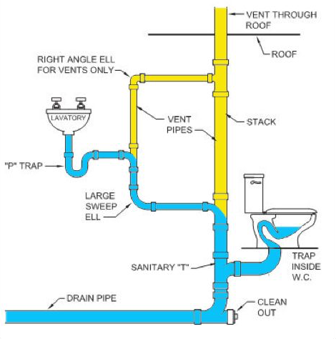

When installing a DWV system it is important to first locate the *building sewer* and know where you are going to be draining too. You also want to make sure there is a clean out at the base and that it is accessible.

However, keep in mind when installing plumbing appliances, drains, vents and pipe you need to apply your installation per code. In the next page, I will begin to explain the different variations in sizes that you will need to focus on.

**Chapter 3: How to calculate Drainage, Waste, and Vent Sizing**

There are a few things you must know first when it comes to the process of drainage and removal of waste throughout a building using the DWV system.

First off, always remember that waste in a pipe that is running on a vertical direction can dispose of itself faster than in a horizontal pipe. However, with proper pipe sizing waste can also travel smoothly in a horizontal pipe. Theoretical methods that determine sizing are based on the rate of flow at which a fixture discharges wastewater into a drainage system. This measuring factor is a drainage fixture unit (DFU). “Residential Construction Academy” (Joyce, 2005)

**Figure 2**: Provides you with direct sizing for both drain pipe and vent pipes. The size depends on the amount of fixture units being installed on that run.

(Drain Waste Vent Pipe Sizes. (2014). Retrieved April 3, 2017)

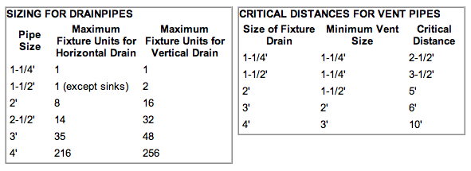

**Figure 3***:* Provides you with exact information with the fixtures you will be installing in a home or building, the number of units and the minimum drain size required per code.

(DWV Waste-Line-Size. Retrieved April 3, 2017)

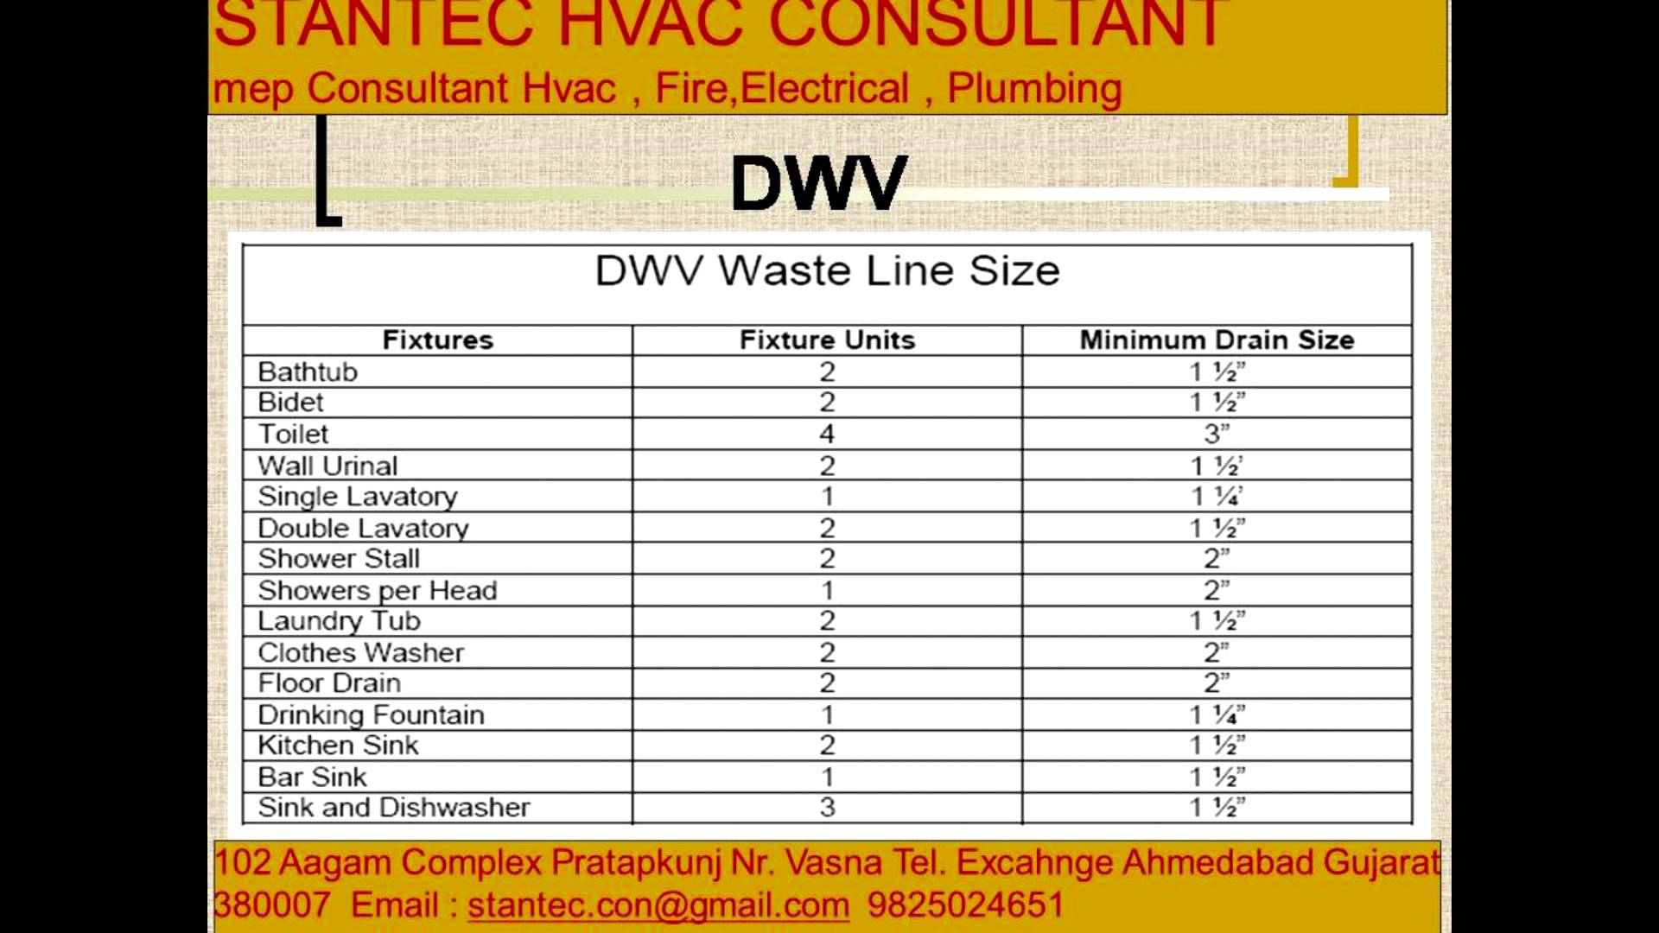

Now that you are familiar with the different sizes required to meet with code, we will move onto the different fittings you will need.

**Chapter 4: Different piping material used for a DWV installation**

A Drain, Waste & Vent system can be installed in three different type of material.

1. Polyvinyl Chloride (PVC)
2. Acrylonitrile Butadiene (ABS)
3. No-Hub Soil pipe
4. Cast- Iron

All four of these materials are durable and will work effectively for the installation; however, what it depends on is the owner or in some cases the installer.

* Both PVC and ABS are non-toxic and resistant to abrasion. They are light in weight, affordable and easy to join and work with. (Blankenbaker, Keith, E. (2005) Modern Plumbing)
* No-hub is a heavier type of pipe and the original type that was used for a DWV system. This material is harder to join and seal. It requires larger and heavier equipment to work with. However, it is also durable and effective to complete a DWV system. (Blankenbaker, Keith, E. (2005) Modern Plumbing)
* Cast Iron pipe is commonly used, but it’s also a heavy material that requires equipment to cut the pipe and install it. (Blankenbaker, Keith, E. (2005) Modern Plumbing)

**Figure 4:** Provides you with an example of a Drain, Waste & Vent System done in PVC piping and fittings. (Bathroom Plumbing. Retrieved February 14, 2017)

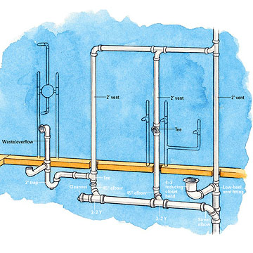

**Figure 5:** Provides you with an example of a Drain, Waste & Venting system installed in an entire house in cast iron piping containing all six elements spoken about on page four.

(House Plumbing. (2013) Retrieved May 7,2017)

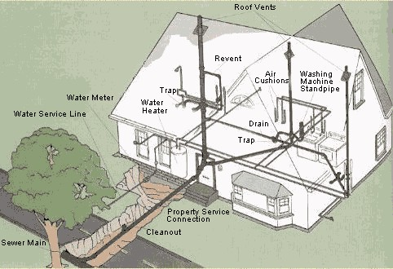

**Chapter 5: Fittings Needed to Correctly Install a Drain, Waste & Venting System**

After you decided which material you will be using you must gather your material such as, pipe, fitting and supports. Always remember, you are better off having more than the material needed. You never know what could occur, or change while installing plumbing fittings and pipe. The amount of pipe you will be using all depends on the square footage and sizing of your home/building. Therefore, I can only advise you to first measure your space and figure out the amount of space you have and how many lengths of pipe you will consume throughout your installation.

Remember, when buying a length of pipe a length is 10 ft. Therefore, you want to make sure you have more pipe than your precise estimation. Whether you choose to install your drain, waste and vent system in cast-iron, ABS, PVC or No-Hub the fittings are not different for each type.

Below is a chart with the fittings needed already, now that you have the correct sizing for your installation use this chart as a checklist to ensure you obtain each fitting.

**Figure 6:** Fill out the table below to organize the material that is going to be needed per your installation.

(Fitting Material, Quantity and Sizing Chart. Retrieved May 11. Created by N. Kavral)

|  |  |  |  |
| --- | --- | --- | --- |
| Quantity | Type of Fitting/Material | Size | Check-List |
|  | Clean out |  |  |
|  | P-Trap |  |  |
|  | Sanitary Tee |  |  |
|  | T-Wye |  |  |
|  | Flange |  |  |
|  | Sanitary Wye |  |  |
|  | ¼ Bend |  |  |
|  | 1/8 Bend |  |  |
|  | Sanitary Cross |  |  |
|  | Test Tee |  |  |
|  | Combination Wye |  |  |
|  | Long Sweep Elbow |  |  |
|  | Reducer (If Necessary) |  |  |
|  | Cap |  |  |
|  | Length of Pipe for drain |  |  |
|  | Length of Pipe for Vent |  |  |
|  | Supports/Hangers/Braces |  |  |
|  | Riser Clamps |  |  |
|  | Screws |  |  |
|  | Cement & Primer (ONLY for PVC/ABS) |  |  |
|  | Couplings (ONLY for Cast-Iron) |  |  |
|  | Lead & Oakum (ONLY for no-hub) |  |  |
|  | Rubber-Push Caskets (ONLY for no-hub) |  |  |

To figure out the quantity of each fitting you need to think about a few things first. Such as, are you installing a DWV system for just a house, a building or a bathroom?

When you figure that out you can than move into figuring out the quantity for each fitting. I will be focusing on a general DWV system and providing you with the number of fittings that will be needed.

|  |  |
| --- | --- |
| * Hangs & Supports | * **(2)** Clean outs |
| * **(1)** Long sweep | * **(3)** P-Traps |
| * **(2)** Test Tee | * **(2)** Combination Wye |

**Figure 7:** Below are presented the different fittings used to install the Drain, waste and venting system. The fittings below are essential to the DWV system due to safety and contamination prevention.

|  |  |
| --- | --- |
| **Clean out** | (Cleanout. (2015) Retrieved 4/3/17) |
| **Long Sweep** | (Long Sweep. [Cleanout Access] Retrieved 4/28/17 |
| **P-Trap** | (Plumbing P-Trap. Retrieved 3/21/17) |
| **Test Tee** | (Test Tee. [ABS] Retrieved 5/4/17 |
| **Combination Wye** | (Combination Wye Plumbing. Retrieved 4/9/17) |

**Chapter 6: Water Contamination**

Contamination is a huge scare in the plumbing industry due to various reasons. However, it is up to us to prevent this from occurring. Contamination prevention begins at the start of your installation. From the planning, sizing to properly installing all the fittings and selecting the appropriate material being used.

**Figure 8:** Shows you an example of what a backed-up tub looks like due to a clogged trap

(Drain Cleaning Service [Drainage] (2014). Retrieved March 20)

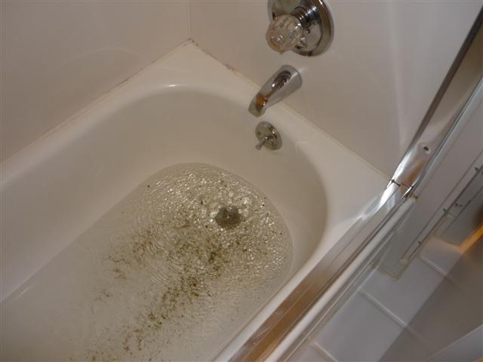

Looking at the presented image, take a second and think, has this ever happen in my tub?” The answer to that, is probably yes! All of this can be avoided by properly installing a DWV system. Two things can occur. One, being that the water will not drain correctly due to improper fitting selection. Or two, the actual installation process being done incorrectly. However, both will result with your dirty sewer water contaminating your potable water. This can lead up to serious sicknesses, nausea, skin rashes and simply personal living discomfort.

Therefore, to prevent the backflow contamination, you want to ensure you always install a trap. Depending on where you are installing you want to make sure you always install your type of trap and size per code. Attached I will be providing you with a website where you can check your local plumbing codes based on your location using your zip code.

* **Website**: http://www.constructconnect.com/building-codes/?search=new%20york

Keep in mind a trap is not only required for a bathtub, but any plumbing appliance in a home that is a form of water source. If you are working on brand new construction your only concern is to install all the fittings listed in the previous pages and making sure they are all either new or intact.

**Figure 9**: Demonstrates an example of what your existing trap might look like, as well as what you do not want it to look like. (Clogged Trap [Drainage]. Retrieved April 1)

[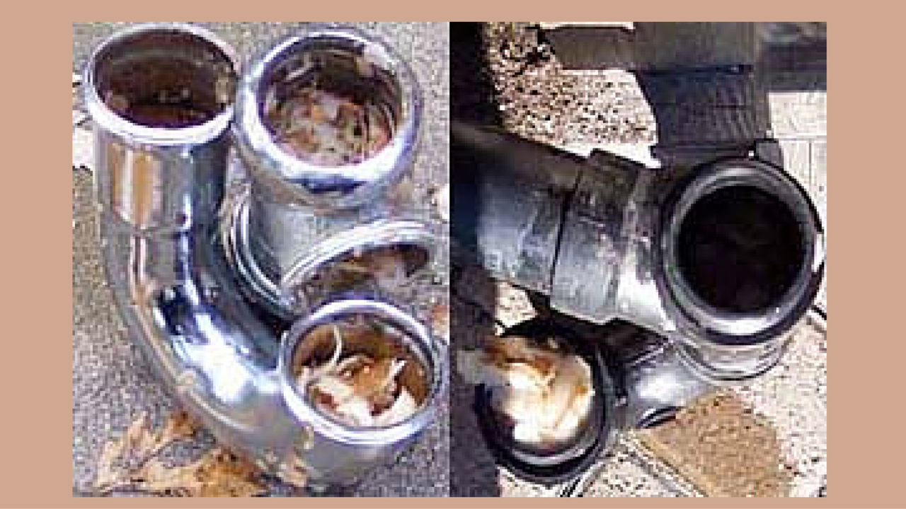](http://www.google.com/url?sa=i&rct=j&q=&esrc=s&source=images&cd=&cad=rja&uact=8&ved=0ahUKEwjVobPfutnTAhWGOyYKHSgDDDIQjRwIBw&url=http://citywideplumbingpros.com/blog/how-to-unclog-a-garbage-disposal-drain-pipe/&psig=AFQjCNF5Nf6zFAjsKK-MuGgY9nWyRzcQyg&ust=1494097935891996)

I recommend dismantling the fittings, unions, and traps to clean and always replacing the pipe. Due to various safety reasons and the health department you always want to make sure your work is done properly. Treat every plumbing installation as if it were being done in your own home.

**Chapter 7: Personal Protection Equipment**

Personal Protection Equipment, also referred to and known as PPE. It is essential you do not only install professional work, but you look professional as well. And I do not mean only your attire, but the personal protection equipment that you use for safety purposes.

**Figure 10:** Below is a check-list of different personal protection equipment that you should have while installing a DWV system. (Blankenbaker, Keith, E. (2015) Modern Plumbing 8th Edition)

|  |  |  |
| --- | --- | --- |
| **Personal Protection Equipment** | **Price** | **Description** |
| Safety Glasses/ Goggles | $30 | Eye protection |
| Ear plugs | $23 | Protect your ears |
| Industrial Respirator | $19 | Avoid hazardous fumes |
| Work Boots | Price various on brand | Protecting your feet/toes |
| Work gloves | $26 | Protects your hands |
| Hard hat | $10 | Protects your head |
| Proper Work attire | Depends | Protects you |
| Harness | Depends on brand | When 6’ off the ground |

**Chapter 8: Assemble the Rough-In**

Now that we have completed all the theoretical reasoning and gathered all the equipment and material necessary, it falls into the actual installation process. Keeping into consideration that you have already obtained all the material and safety equipment necessary, (Figure 6 & 10) you are now ready for the assembling process. Throughout this process you want to ensure that you have the following tools that are going to be needed. A few of the most important tools will be listed below. Keep in mind, wrench sizes are optional based on your personal comfort and work space.

|  |  |  |  |
| --- | --- | --- | --- |
| * Measuring Tape | * Level | * Snap Cutter | * Torch Wrench |
| * Pipe Wrench 12” | * Hacksaw | * Power Tools | * Pro-Dope |
| * Adjustable Wrench | * Plumb Bob | * Chisel | * Pipe Cutter |

**Figure 11:** A DWV schematic diagram example of what your diagram should appear like to follow throughout your installation.

(Schematic Diagram. (Diagram) Retrieved on 5/16/17

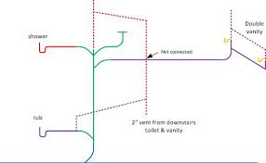

**Figure 12**: Below is an illustration of a schematic diagram, including fixtures and fittings for a better understand of how fittings must be placed and its direction.

(Stack. (Plumbing Stack) Retrieved 5/16/17

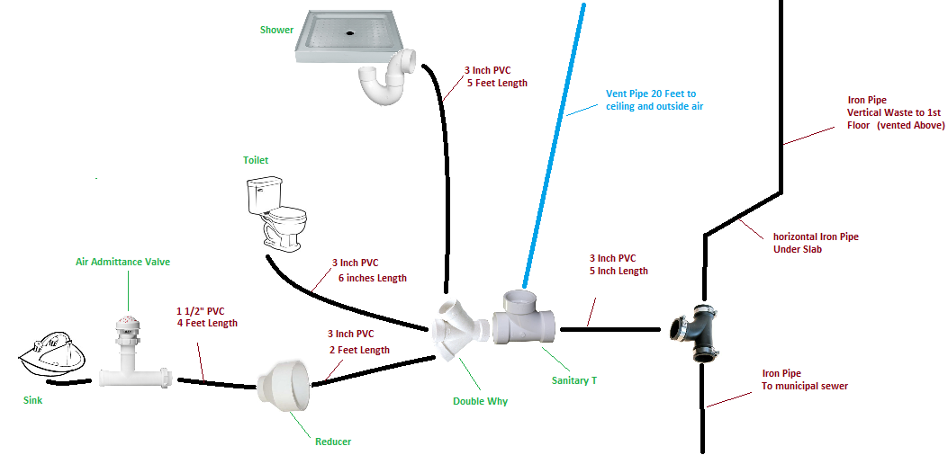

Keep in mind, that the illustration above will not be the same one as yours, however feel free to reference yourself to the fittings and pipes being connected to each other.

1. Make sure you understand the general schematic drawing for the DWV system and the layout of where everything is going to be installed.
2. The installation requires TWO stacks that are going to extend through the roof. The stacks are your vertical piping throughout the house.
3. The horizontal run is going to be installed under the floor one end attaching to the building sewer the other attaching to your stack.
4. Remember that the horizontal run is the pipe transporting your waste to the drain. It must be pitched with a slope of, ¼” per foot for proper draining.
5. Keep in mind that any floor drains you will be installing are to branch off the horizontal drain pipe line.
6. Knowing for example, you are connecting to one kitchen, one bathroom and one washer machine. Remember that each of these fixtures are going to connect to the stack draining down to the horizontal run draining out into the building sewer.
7. If you are working with other plumbers, it is best to divide the work into sections. Having one crew work on the horizontal drain line connecting to the building sewer in the basement and have the other crew work on the stacks for all the appliances.
8. Within each of these groups, assuming all the holes and openings are already made, they are simply working on the installation process. Referring to the schematic drawing that was developed.
9. To get and install a leveled stack, from the highest point drop the plumb bob. This is essential to receive appropriate waste direction and flow.
10. Remember that a clean out is required at each change in direction of the DWV piping that is greater than 45 degrees. And a trap is required before the fixture.
11. When connecting the vent for air circulation throughout the pipes, keep in mind that this pipe will be starting from the stack pipe, extending through the roof working as ventilation.
12. Be sure to extend through the roof a minimum of 7 inches. Keep in mind when cutting the pipe, the thickness of the roof and take that into consideration with your measurement.
13. The most important part when passing pipe through an outside wall is installing a flashing. A flashing is a material typically formed metal or plastic that is used to prevent water from leaking into the building/house around the stack.
14. The flashing MUST be installed before the stack is put into position so that it can fit perfectly under the shingles.
15. Make sure that both the horizontal and vertical runs are always properly supported and have its appropriate pitch.
16. You want to ensure that you create a strong foundation for the horizontal drainage pipe to lay on.
17. While you are joining the fittings to the pipe, depending on the type of material you choose to use, check the following:

**Chapter 9: Test the System**

The best way to test a DWV System is to perform a pressure test. Thereare two ways you can perform a pressure test. You can either do the following:

* Fill the entire system with water and inspect every pipe and fitting joint
* Fill the entire system with air and check the gauge to see if the system is holding

Why must we always check the system? You want to ensure the entire system is leak-free. The last obstacle you want to be dealing with is all the plumbing work being done, walls are intact, ceiling is fixed and flooring is installed, to then hear you need to make a hole, you have a leaking pipe! Not only is testing all your work a good habit to develop, but generally local codes require a pressure test. Below I will be explaining the different steps that must be taken into action while performing this test.

1. Turn off the main water supply
2. Block the vent and drain pipes at T-fittings close to the main stack
3. Make sure ALL openings such as drains, fixtures and stub outs are capped off, you can use an inflatable test balloon

(Now that you have check every possible outlet on your system and you secured everything was capped off you know that no air will be able to escape causing the gauge to drop unless there is a leak somewhere throughout your connections)

1. Connect the air compressor and pressure gauge at an access point, usually a cleanout fittings on the system that can be easily and comfortably accessed
2. Run the compressor until the pressure gauge registers the correct PSI (pounds per square inch

(You can figure out how much PSI is required by checking the manufacturer or by local code)

1. Check the pressure gauge from time to time for at least 15 minutes
2. You want to ensure the pressure remains unchanged at the correct PSI
3. If the pressure remains unchanged, yours DWV lines are leak free

NOTE: Falling of pressure indicates a leak in the system.

Even if the gauge is not dropping drastically the leak point MUST be found. Or else, it will continue to drop within time and all the work put into this installation will not be worth it.

(Pearson Education, Plumbing Level One Trainee Guide Fourth Edition, 2012)

**Figure 10:** Provides you with different examples of inflatable test balloons that can be used throughout the air pressure test. The size of the balloon various upon the size of the pipe or fitting.

(Inflatable Tester. (System Test) Retrieved 5/15/17.

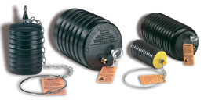

**Figure 11**: Demonstrates how the inflatable test balloon creates a seal and how it works. Looking at the image below will provide you with a greater concept of how to install it properly to ensure that it is creating a clean-seal.

(Pipe Plug Test (Inflatable Tester) Retrieved 5/3/17.

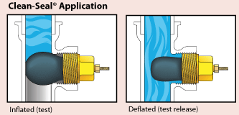

Now, if the system does NOT hold the pressure we have established that it means there is a leak in the system. How do we detect where the leak is?

1. Fill the system back up with its required PSI
2. Trace the line from start to finish
3. Make sure ALL your test balloons are holding and all pipe nipples are capped off
4. Grab a spray bottle, fill it with water and a little soap
5. Spray every pipe and fittings connection on the line
6. When spraying be sure to spray the entire diameter
7. Have your partner or as you spray wait and check to see if any bubbles accumulate around the fitting
8. The air in the system, releasing with the soap you are spraying will cause the joint to bubble
9. Where ever the joint bubbles-up you know that it must be tightened because it is loose and air is escaping
10. Always check the unions, and hold back with two wrenches when tightening it
11. Lastly, find leak, fix leak, test again!

**Chapter 10: A Final Note from the Author**

This is the end and it concludes the process of, “How to properly install a drain, waste, and venting system.” All the information presented to you throughout this booklet will guide you in the right path to install a complete DWV system or a simple repair in your existing system. All the information presented was placed in sequence making it much approachable accord to your installation. Be sure, to not only follow the instructions throughout this guide, but to continue always educating yourself and staying up-to date with the plumbing codes and technology that is constantly evolving.

I hope that all the pictures in this booklet will assist you with a greater understanding of what you are looking for and what it will appear as in stores. Be sure to follow the sequential order when/while installing a DWV system. Remember, that safety is key to all installations including and *especially* in plumbing. You want to make sure you protect yourself, and if so the person whom is working with you. As well as properly and safely hanging, supporting and securing all the pipes and plumbing fixtures. Remember, majority of all plumbing appliances, fixtures and material are extremely heavy. Therefore, you want to keep in mind the substance that is going to be passing through these pipes and fixtures and understand that it is only going to make the weight greater.

Plumbing installations take patience, hard work, dedication, understanding and guidance. Whether you are installing in your own home, a customer or a friend you want to ensure you always promote the best quality of your work. Throughout the plumbing trade, a person cannot express how knowledgeable he/she is throughout paper and words. They need to present their work in such a professional manner, that the customer can tell her/she knows that they are doing and their trade and by following this guide you will successfully install/repair a DWV system professionally.

**Bibliography**

**Text**

1. Ripka, L.V. (2012) Plumbing Design and Installation 4th Edition, Orland Park, Illinois, -American Technical Publishers.
2. Hall, Prentice. (2009) Core Curriculum Introductory Craft Skills 4th Edition, Gainesville, Florida- National Center for Construction Education and Research, Pearson Education, Inc.
3. Hall, Prentice. (2015) Core Curriculum Introductory Craft Skills 5th Edition, Gainesville, Florida- National Center for Construction Education and Research, Pearson Education Inc.
4. Pearson Education. (2012) Plumbing Level 1 Trainee Guide 4th Edition, Upper Saddle River, NJ- National Center for Construction Education and Research.
5. Blankenbaker, Keith, E. (2005) Modern Plumbing, Gainesville, Florida- National Center for Construction Education and Research, Pearson Education Inc.

**Images:**

1. Digital Image. N.p., n.d. Web. <http://www.janetjackson-tour.com/thumbnail/t/typical-plumbing-diagram-showing-drains-and-vent-adapted-from-lechner-15.png>.
2. *Drain-Waste-Vent Pipe Sizes.* Digital Image. N.p., n.d Web. <https://www.hometips.com/buying-guides/drain-waste-vent-pipe-sizes.html>.
3. Digital Image. N.p., n.d. Web. <https://i.ytimg.com/vi/MIZJwlO_T0o/maxresdefault.jpg>.
4. Digital Image. *Bathroom Plumbing*. N.p., n.d. Web. <https://s-media-cache-ak0.pinimg.com/orginals/85/b3/85b3c2238cf898326b200eb5c2670d7c.jpg>.
5. Digital Image. N.p., n.d. Web. <http://diyinahour.com/diy/wp-content/uploads/2013/02/houseplumb1-482-x-330.jpg>.
6. Digital Image. *Plumbing House Trap.* N.p., n.d. Web. <http://home.howstuffworks.com/home-improvement/plumbing/ho-to-unclog-a-drain2.htm>.
7. Digital Image. *Cleanout.* N.p., n.d. Web. <https://i0.wp.com/media.boingboing.net/wp-content/uploads/2015/09/en5112a00756.gif?w=970>
8. Digital Image. *Plumbing P-Trap*. N.p., n.d. Web. <http://planta1.com/blog/how-to-deal-with-the-p-trap-in-revit-mep/>.
9. Digital Image. *Test Tee*. N.p., n.d. Web. <http://www.homedepot.com/p1-1-2-in-ABS-DWV-Hub-x-Hub-x-Cleanout-Test-Tee-C5814HD112/100345730>.
10. Digital Image. *Combination Wye*. N.p,. n.d. Web. <https://terrylove.com/forums/index.php?attachments/img_3-png.34632/>.
11. Digital Image. *Clogged Drain*. N.p., n.d. Wedb. <http://www.draincleaningservice.ca/wp-content/uploads/2014/04/drain-back-up.jpg>.
12. Digital Image. *Schematic Diagram*. N.p., n.d. Web. <https://terrylove.com/formus/index.php?attachments/diagram-jpg17252/>.
13. Digital Image. *Stack*. N.p., n.d. Web. <https://i.stack.imgur.com/QWBW1.png>.
14. Digital Image. *Pipe Plug Test.* N.p., n.d. Web. <https://terrylove.com/images/cherne_clean_seal_1.gif>.
15. Digital Image. *Inflatable Tester*. N.p., n.d. Web. <https://www.petersenproducts.com/v/images/plumber-style-130-0-group.jpg>.
16. Digital Image. *Inflatable Tester*. N.p., n.d. Web. <https://www.petersenproducts.com/v/images/plumber-style-130-0-group.jpg>.