Genetic Lab Report
Meiosis and Genetic Recombination
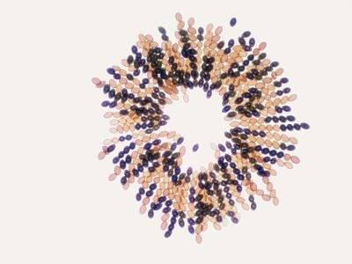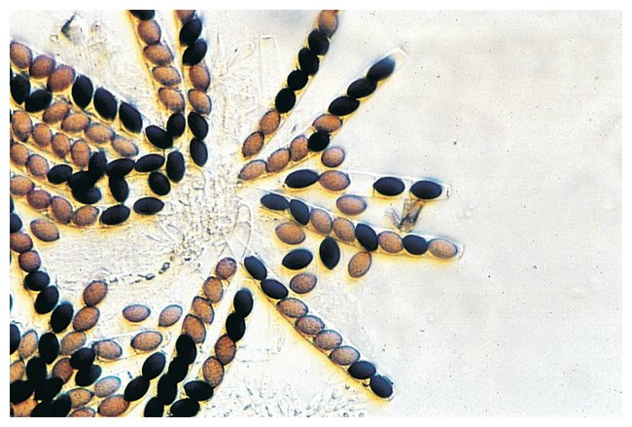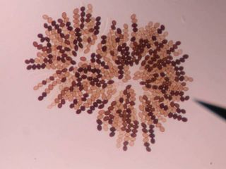
Nadia Gordon
02.27.2019

INTRODUCTION
In this lab, I used a type of ascomycete fungus called Sordaria fimicola to demonstrate crossing over. The fungus produces 8 ascospores in sac that is called perithecium. I used a microscope to detect if crossing over occurs by observing the order of ascospores in the
crossing between the different type of fungus, wild-type which is found in nature, tan
and gray strains.

MATERIALS
- Wild Sordaria
- Tan Sordaria
- Gray Sordaria
- Toothpick
- Agar plate
- Microscope
- Cover slip

PROCEDURE
I used a sterilized tooth pick, I removed a few perithecia from the cross plate and gently press on the perithecia to release the asci. After releasing the asci, I create a wet mount to keep the spore from drying. Then used a cover slip to observe the asci and ascospores under the microscope.

DATA
Strains Crossed | # Non-recombinant Asci | # Recombinant Asci | Total Asci | % Recombinant | Map Units
Wild-type x Gray | 14 | 15 | 29 | 52% | 26
Wild-type x Tan | 10 | 13 | 23 | 57% | 29

RESULTS
The arrangement of ascospores in ascus will determine if crossing over has occurred.
When an ascus has a 4:4 pattern, then no crossing over occurred between the homologous chromosome. If a 2:2:2:2 or 2:4:2 ratio occurs in the ascus, then crossing over has occurred. In the wild type and gray plate only 52 percent of the fungi has crossover in the ascus I observed. Whereas only 57 percent of the fungi has crossover in the wild type and tan.

CONCLUSION
Meiosis produces haploid cells from a cell that was originally diploid. Meiosis I separate
homologous chromosomes. Whereas, Meiosis II separate sister chromatids. Meiosis has subdivided called prophase, metaphase, anaphase, and telophase. In prophase, the nucleus starts to break apart and the chromosome start to condense. In metaphase, the homologous chromosome starts to a line in the center. In anaphase, the homologous chromosome gets separated. In telophase, the nucleus begins to form around each set. Crossing over occur during pachytene of Prophase I. Crossing over is an exchange of genetic information with the homologous chromosome. In the wild type and gray plate only 52 percent of the fungi has crossover in the ascus I observed. Whereas only 57 percent of the fungi has crossover

REFERENCES
- Lab Manual

