Nadia Gordon
Lab Report 1- Cytogenetics
Thursday, February 14,2019

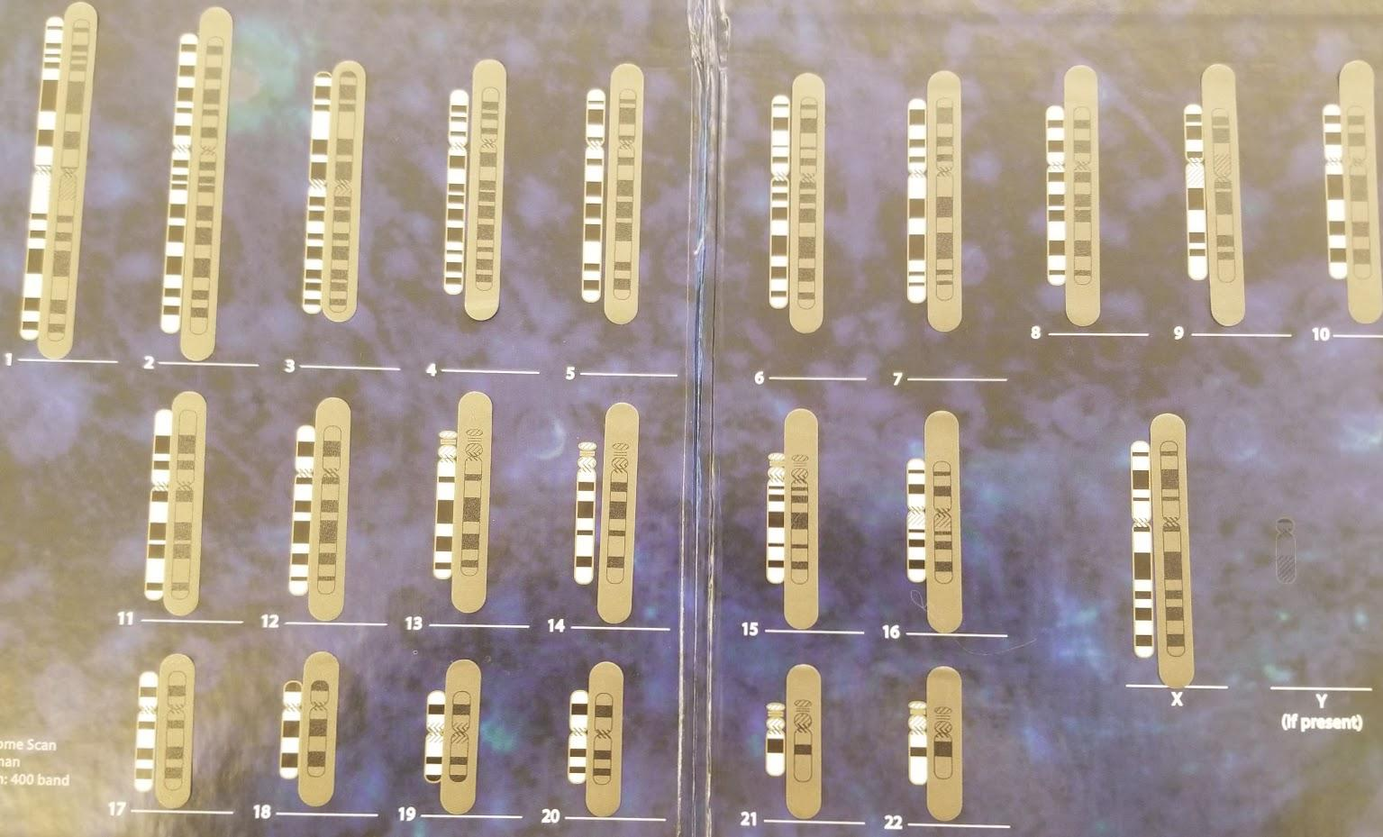
Case Study identity is O. Patient name is Nadia. Nadia was referred for karyotyping because she is 39 and is pregnant with her sixth child. Nadia is concern that her age would cause the baby to have some abnormalities. At eleven weeks, Nadia underwent chorionic villus sampling to test for birth abnormalities. Nadia diagnosis is she is having a baby girl with no abnormalities. There was a chromosome study on embryos that were aborted in the first stage of pregnancy in women 35 and older. Karyotypes for this study showed 2 of 123 cases in women who are between the ages 35- 39 showed several chromosomal anomalies as high as 1.6% but 7 of 117 cases in 40- to 44-year-old mothers an incidence of 6.0%; which prove as you increase in age it also increases the chances of abnormalities (Tsuji,1978). In Nadia case, her child would not have any abnormalities, but this child might be her last if she does not want to risk the chances of any abnormalities. As age increase, the study state “all chromosomal anomalies were trisomies, mainly trisomy 21 and 18(Tsuji,1978)”. Trisomy for chromosome 21 would cause the baby to have down syndrome which would cause intellectual impairment and physical abnormalities. Trisomy 18 would cause Edwards Syndrome which involving physical deformities including small size and defects of the heart, kidney, and brain.

Resource
Tsuji, K, and R Nakano. “Chromosome Studies of Embryos from Induced Abortions in Pregnant Women Age 35 and over.” Current Neurology and Neuroscience Reports., U.S. National Library of Medicine, Nov. 1978, www.ncbi.nlm.nih.gov/pubmed/152877.

