GENETICS LAB REPORT
Fingerprinting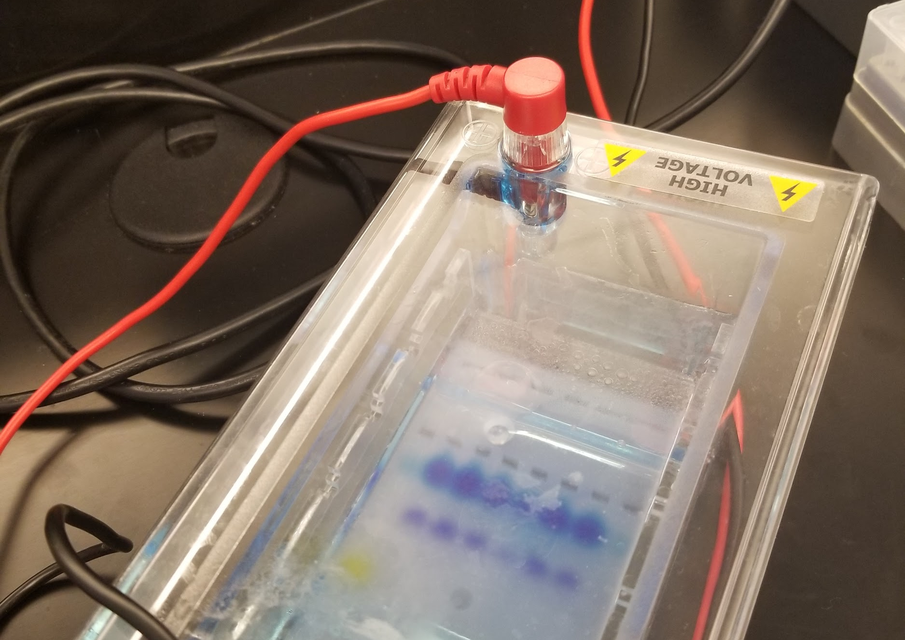
Nadia Gordon
04.11.2019

ABSTRACT
DNA fingerprinting is normally used to examine polymorphism in DNA samples. To determine who did it fingerprinting needs restriction enzymes to cut DNA. Once the DNA is cut there is technology that can show each band represents the piece of DNA. Fragments of DNA are inherited from mother and father, which is why in paternity they would compare the banding pattern of a child with another man who could be the father. To see the banding pattern, we use a Gel Electrophoresis which is used to separate fragments by on size. Larger fragments tend to travel slower through the gel whereas smaller fragments move faster. Polymerase Chain Reaction is a form of technology that amplifies specific parts of the DNA. Then it adds a primer complementary to a DNA template to start the reaction. Once the reaction is started a polymerase begins to add nucleotides. The PCR has three steps which are denaturation, annealing, elongation. In denaturation, the DNA is heated up so it can break. In annealing, the temperature is lowed, and a primer is added to every strand of DNA. In elongation, a polymerase begins to add nucleotides. In this lab, I used DNA that was left at a crime scene to find the suspect. I created a gel for the Gel Electrophoresis. Then, I transferred 10 ul of the DNA into a colored tube. For negative control, I will use water. Then add 10 ul of the enzyme to each tube. The samples from suspect 3 match the crime scene meaning there could be possible that suspect 3 committed the crime

MATERIALS
In the lab, I used a restriction enzyme, and five samples of DNA. Also, use gel electrophoresis, gels, and pipettes. I also use a PCR machine, distill water, and transilluminator. A 1Kb DNA ladder and a ruler.

PROCEDURE
To setting up restriction enzyme digests. I label colored tubes green is for the crime scene DNA, the blue tube is for Suspect 1, the orange tube is for Suspect 2, the violet tube is for Suspect 3, the pink tube is for Suspect 4, the yellow tube is for Suspect 5, and the clear tube is for the negative control. Then, I transferred 10 ul of the DNA into a colored tube. For negative control, I will use water. Then add 10 ul of the enzyme to each tube. After, I place all of the tubes inside a dry bath for 45 min at 37ºC. Once the dry bath was complete, I store the tubes in the refrigerator for a week. After a week, I created a gel for the Gel Electrophoresis. Also, add 5 ul of loading dye to each tube. Then set up the electrophoresis and added 20 ul from each tube into a well. Then, let the electrophoresis run for 30 minutes place the gel on a transilluminator to show the results.

DATA
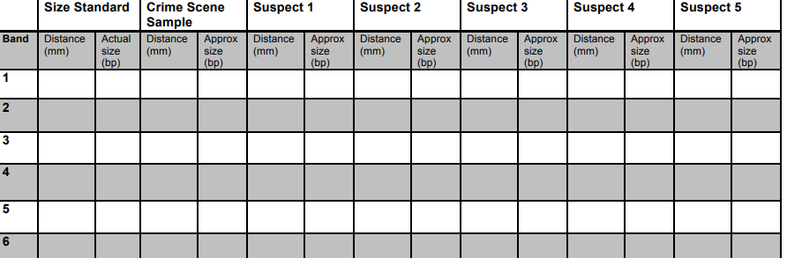

RESULTS
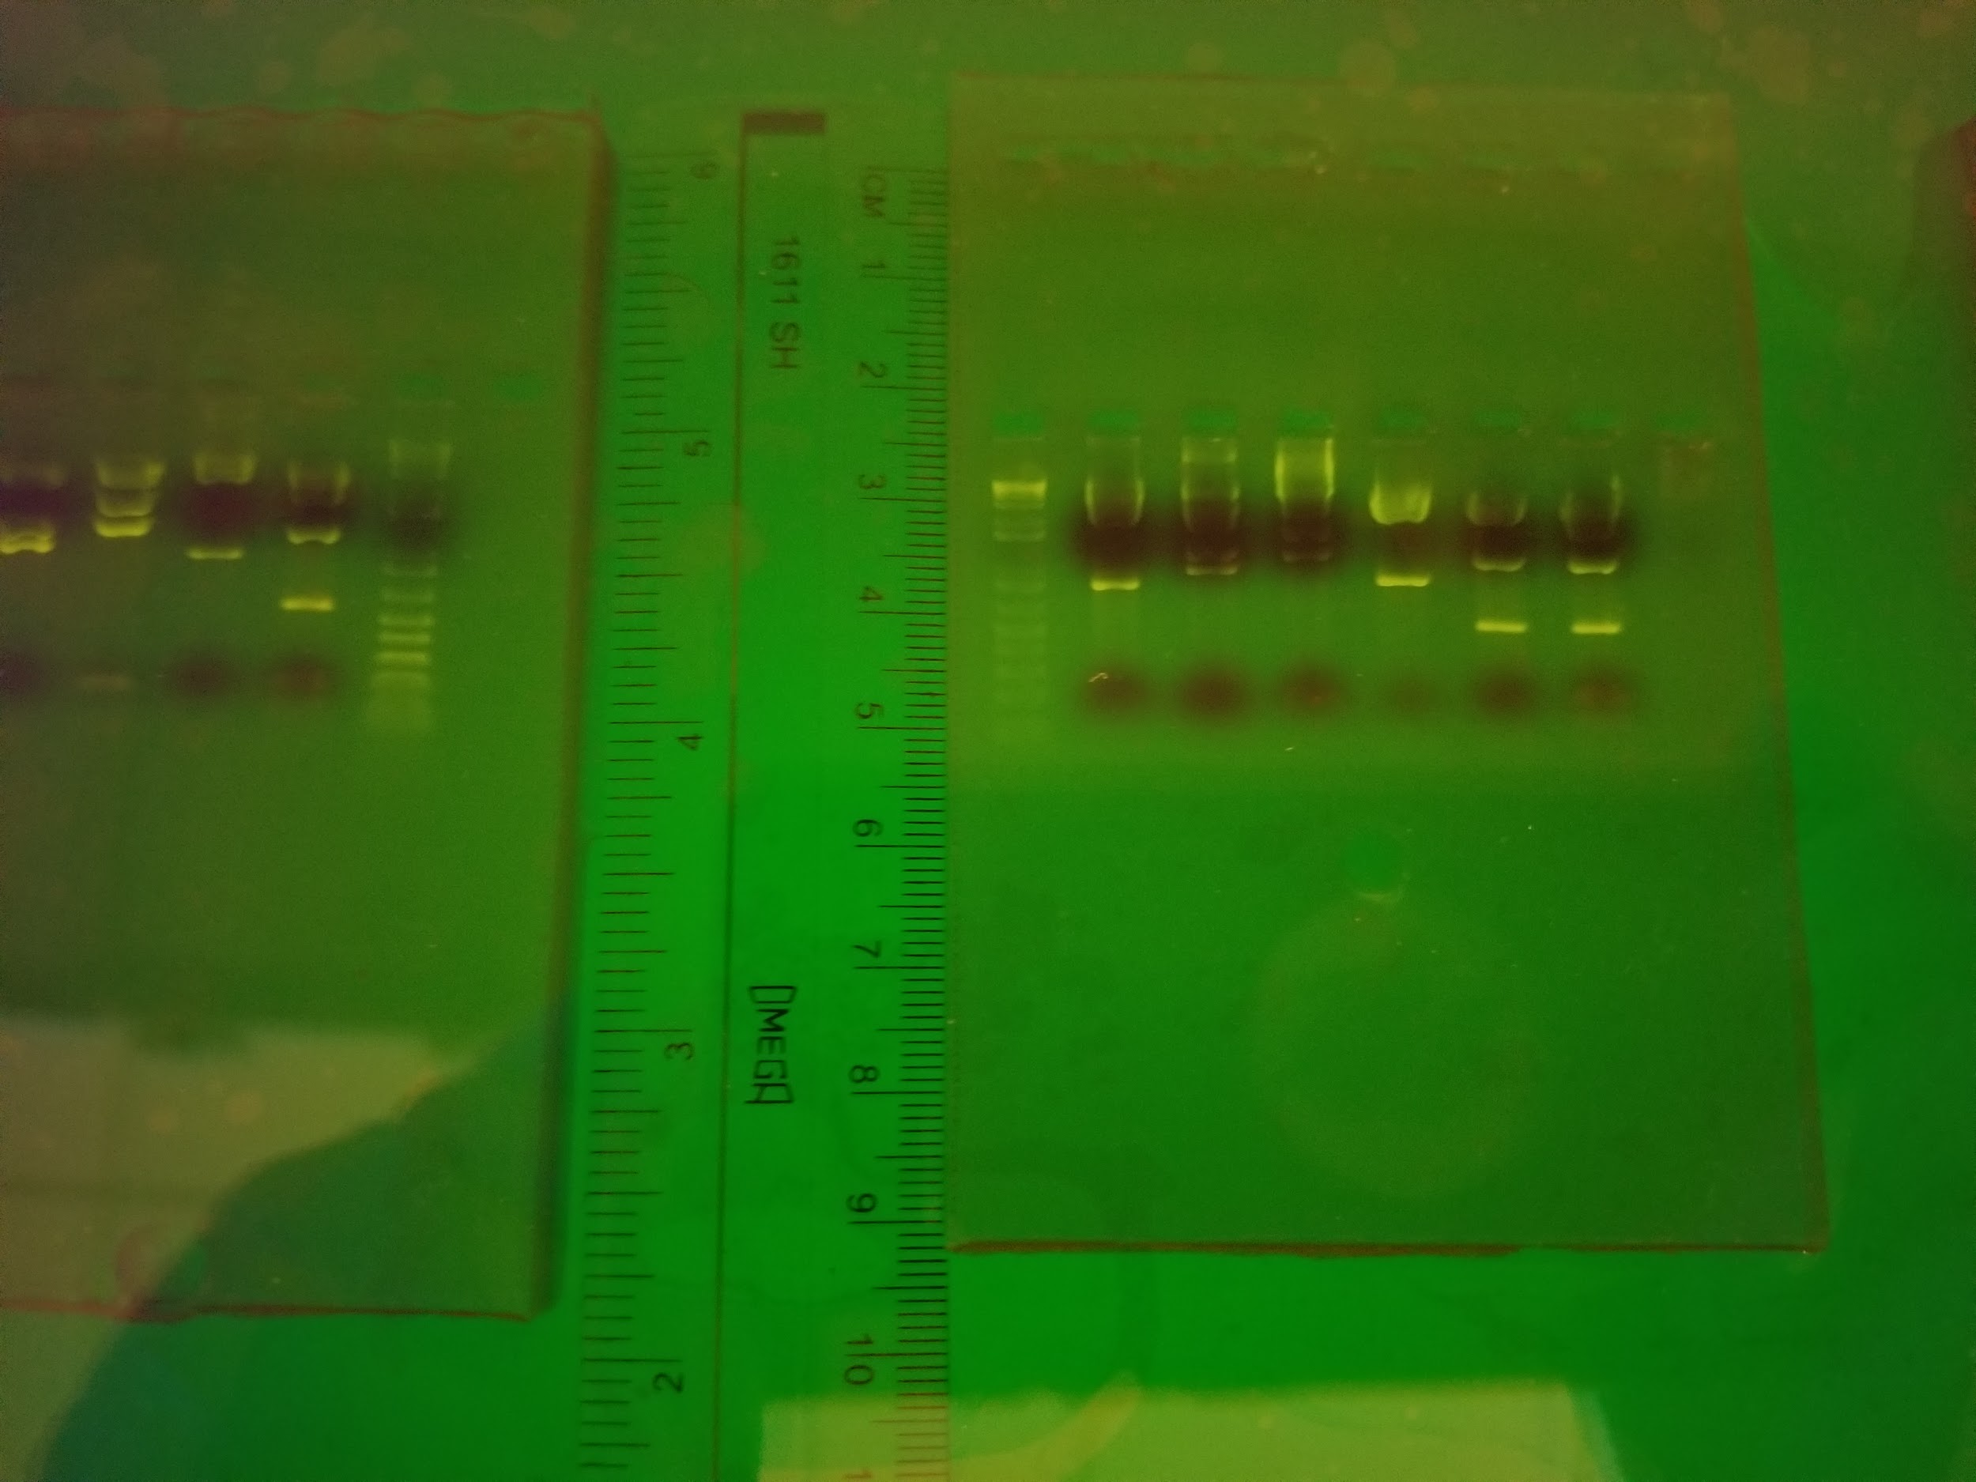
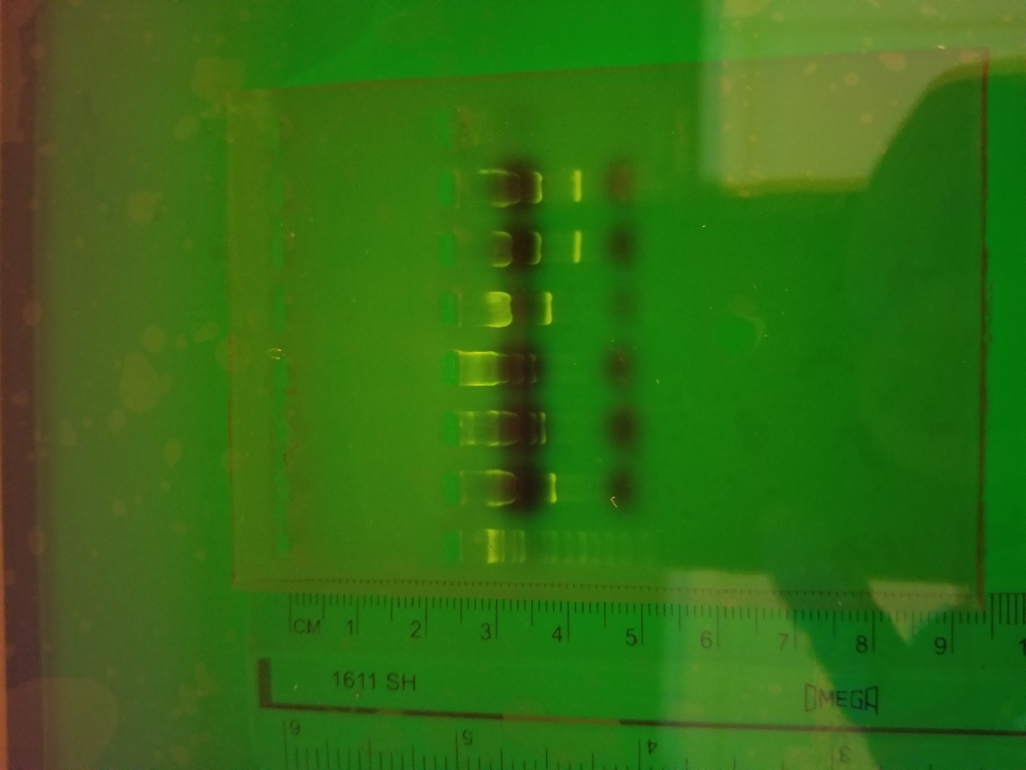
The samples from suspect 3 match the crime scene meaning there could be possible that suspect 3 committed the crime. Suspect 2 DNA samples seem to have the largest fragment and suspect 4 and 5 seem to have the smallest fragments. Suspects 4 and 5 have the same banding pattern which means they could be related.

CONCLUSION
When a restriction enzyme digested a linear piece of DNA in two places, it would have 3 fragments, but if the DNA is circular like bacterial DNA it would have 2 fragments instead of 3. Restriction enzymes in setting up a recombinant plasmid because the enzymes cut the DNA into small pieces and separated them for cloning. When cloning occurs the recombinant plasmid connects the strand back together. In gel electrophoresis, DNA is loaded near the negative end of the chamber because DNA is negatively charged so it would travel from negative to positive. restriction enzymes cut the DNA into pieces but in the gel would contain more than one band because it is been separated by size. The purpose of adding a negative control is to identify there are any loss strands of DNA. DNA bands in the negative control should not influence the conclusions because if there are not any loss strands of DNA, then nothing would show for negative control.

REFERENCES
- “Gel Electrophoresis.” Khan Academy, Khan Academy, www.khanacademy.org/science/biology/biotech-dna-technology/dna-sequencing-pcr-electrophoresis/a/gel-electrophoresis
- Genetics Manual
- Griffiths AJF, Miller JH, Suzuki DT, et al. An Introduction to Genetic Analysis. 7th edition. New York: W. H. Freeman; 2000. Making recombinant DNA. Available from: https://www.ncbi.nlm.nih.gov/books/NBK21881/

