GENETICS LAB REPORT
Drosophila melanogaster
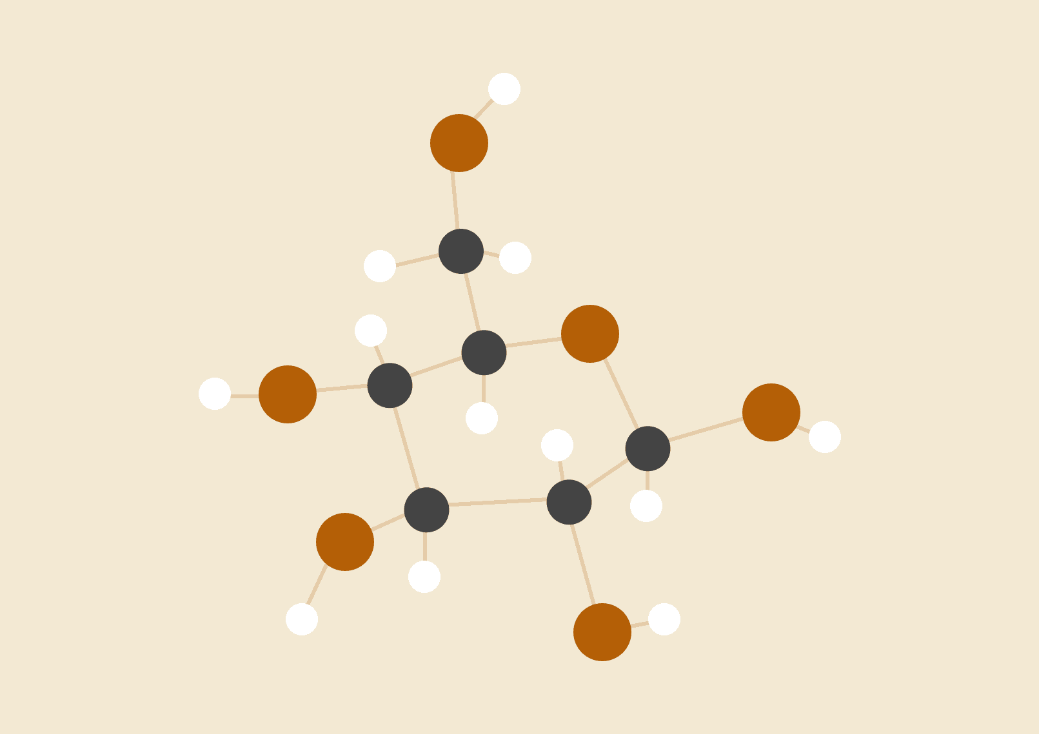
Nadia Gordon
03.28.2019

ABSTRACT
Drosophila melanogaster, which is commonly known as a fruit fly is a model organism used to study genetics because it is easy to manipulate. Also, they are pregnant for a short time. Fruit flies produce a large number of offspring. With these flies, it is easy to realize the sex and phenotypes which can be useful for testing for Mendelian inheritance. In the lab, we perform crosses of different strains to examine inheritance patterns. After examining the inheritance patterns use chi-square analyses to compare observed data to Mendelian expectations also test to determine its eye color is X-Linked Inheritance. I would leave F1 in a vial for a week and they would begin to leave their larvae in your vials. Remove F1 from the vial and wait a week for P1. Record the phenotypes of the P1 flies that originated from your F1 crosses. Determine both the sex of each fly and the relevant phenotype. In this lab, I observe the wild type; red eye, with cherry eyes, which I called sepia. With 1 degree of freedom and P = 0.05, a chi-square value of 33 is higher than that expected by chance. Thus, we can conclude that the observed results are significantly different from expectations.

HYPOTHESIS
Wild Type vs. Sepia
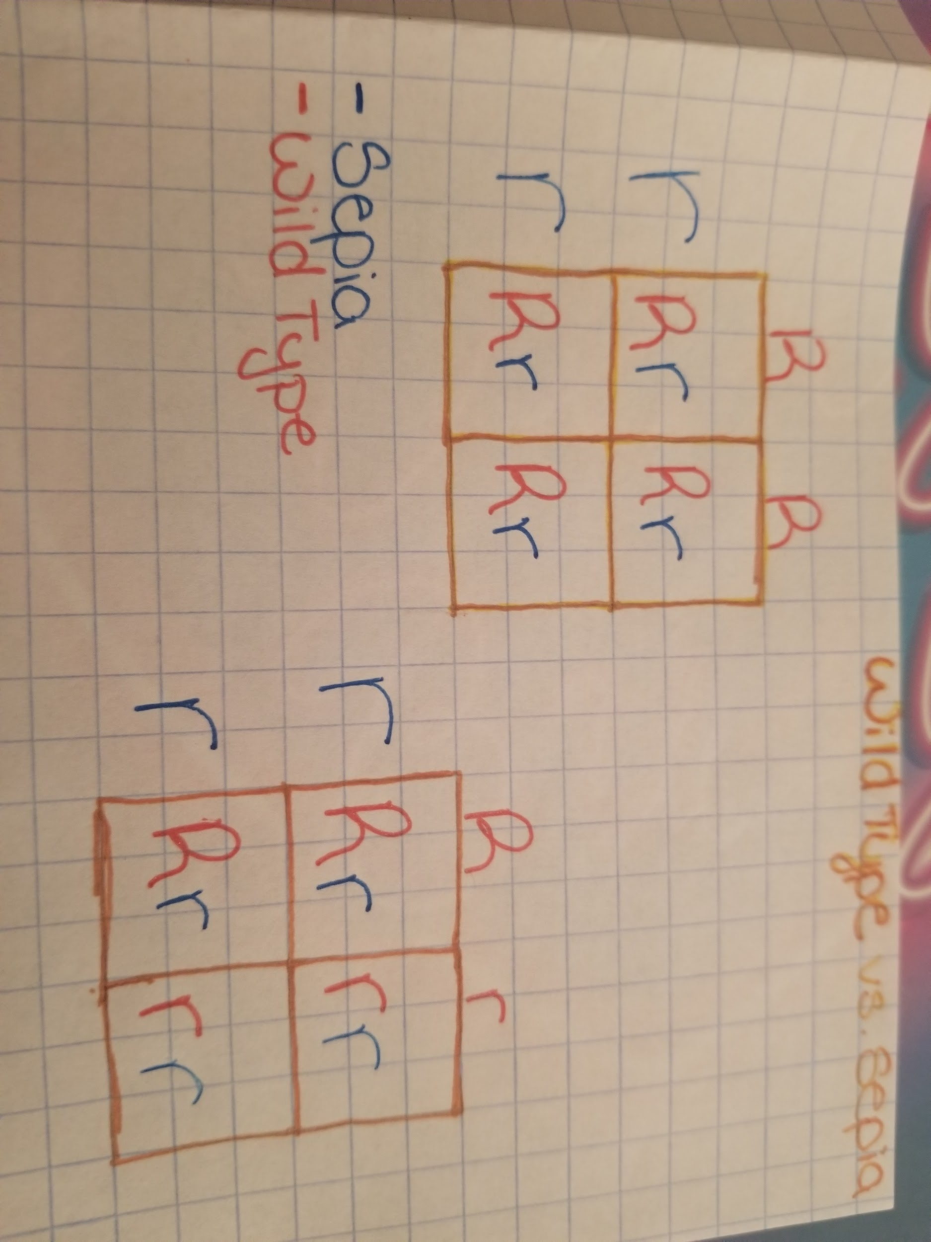 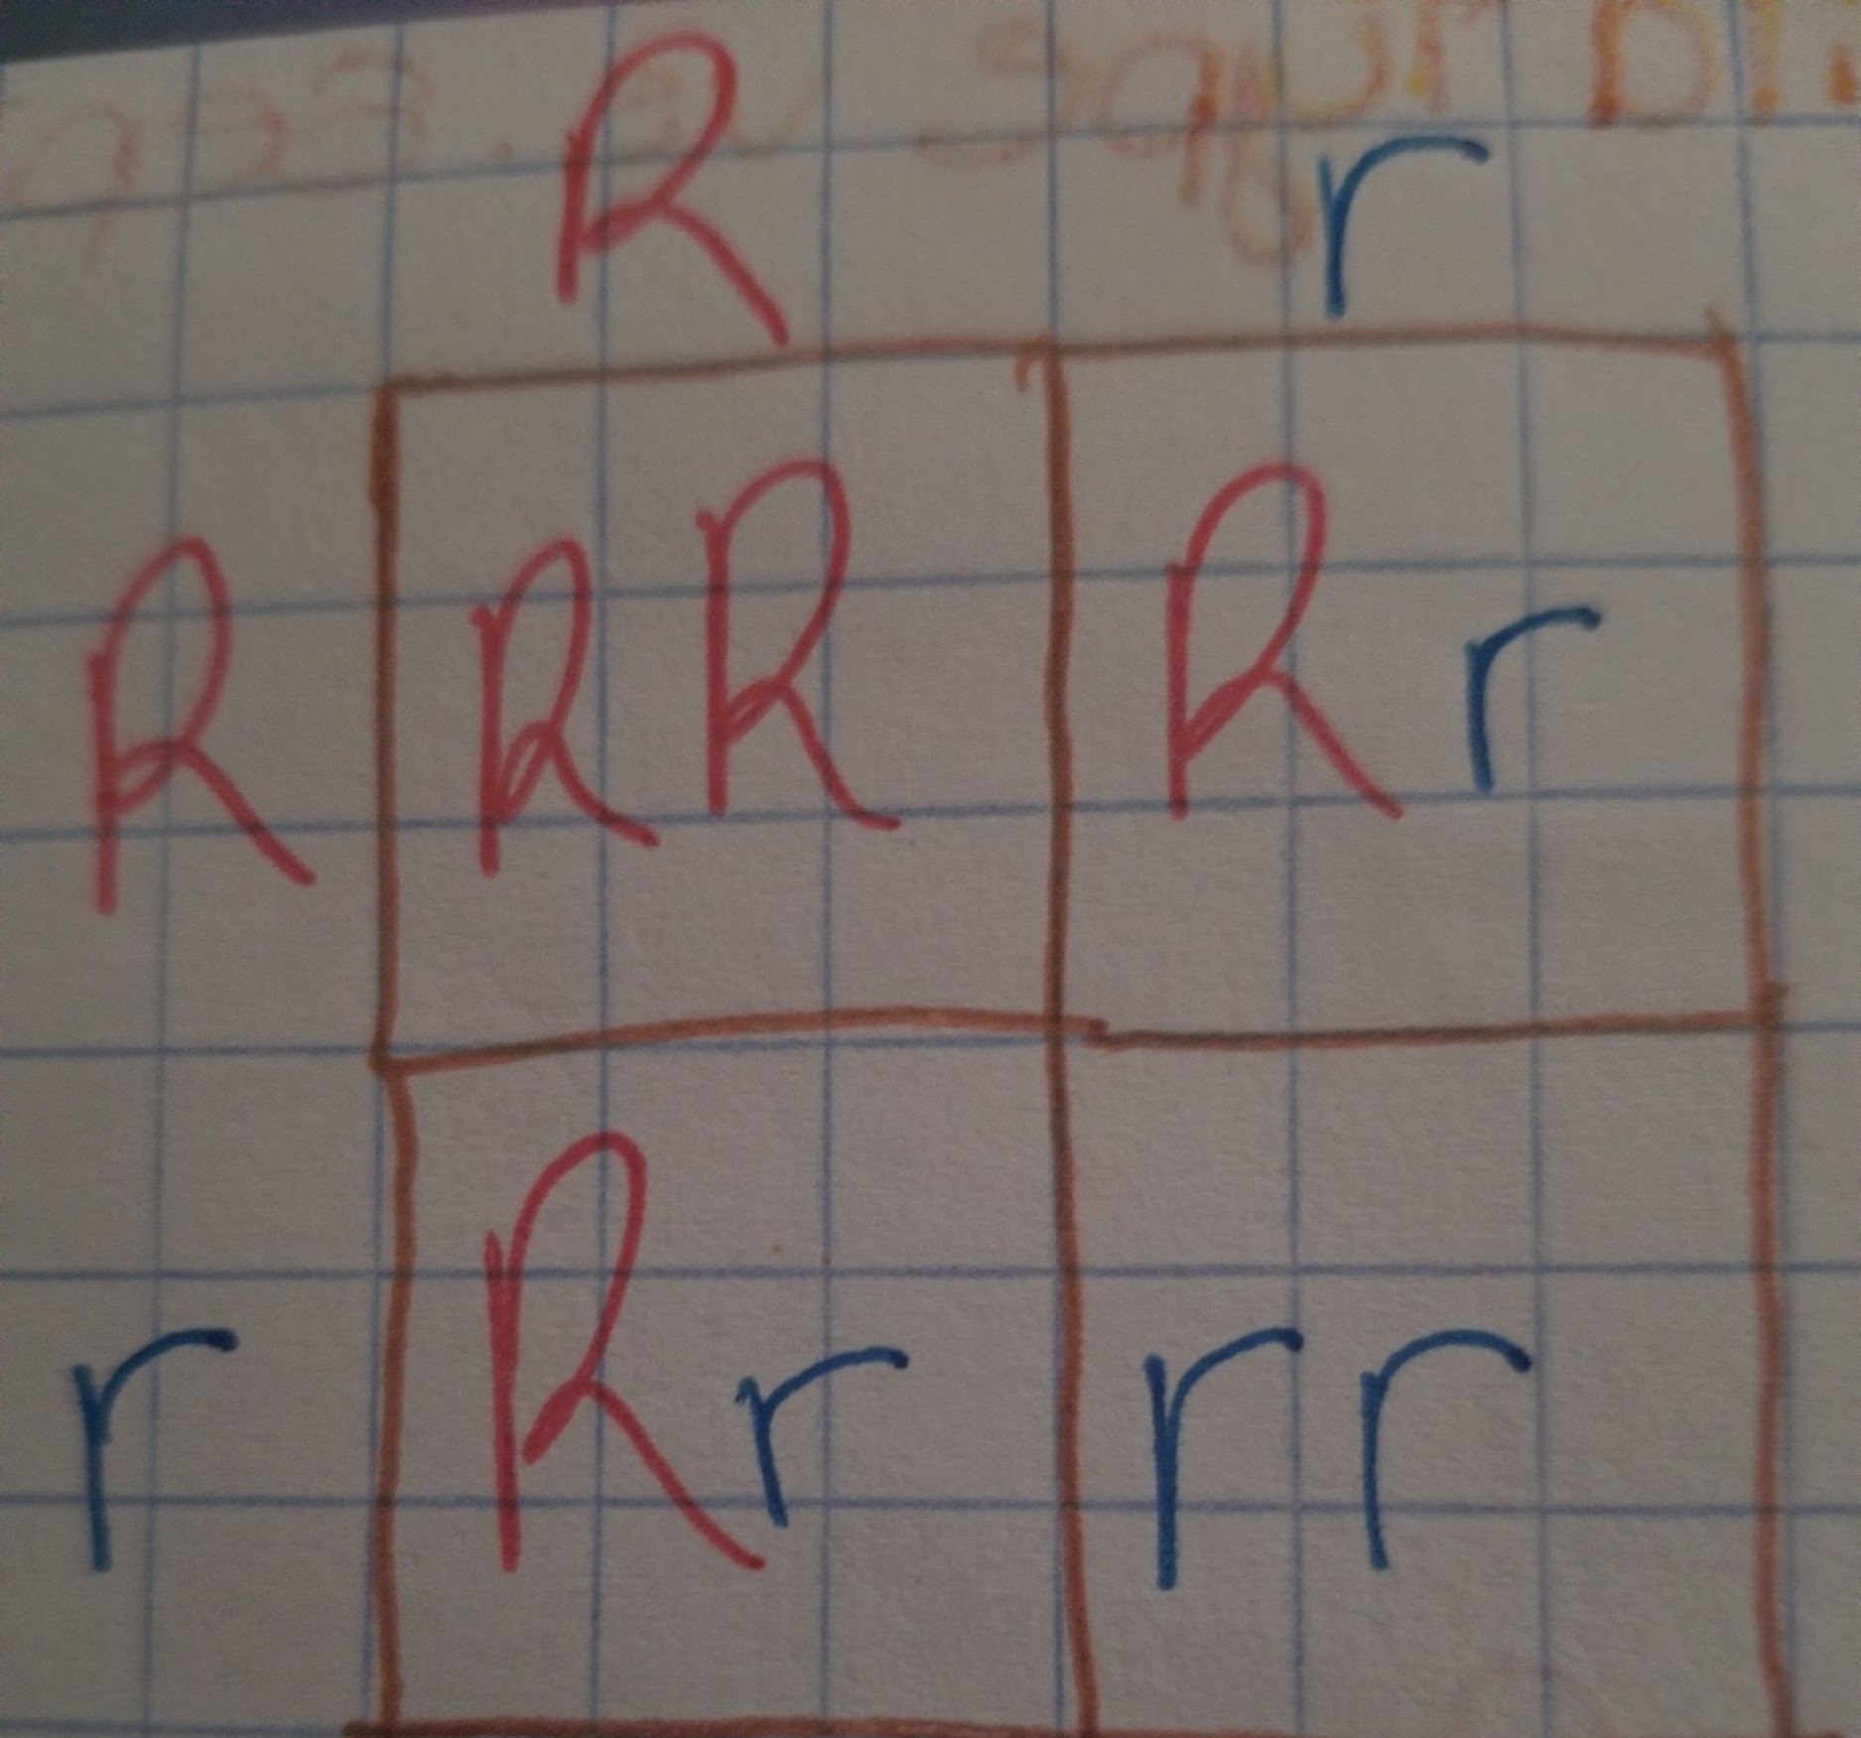 If the wild type is homozygous dominant paired with homozygous recessive all of the flies would have red eyes. If the wild type is heterozygous paired with homozygous recessive 50 percent of the flies would have red eyes and 50 percent would have cherry eyes. If both flies are heterozygous then there is a 75 percent would have red eyes and 25 percent would have cherry eyes.

MATERIALS
In this lab, I used Drosophila melanogaster and observe the sex and phenotype in Petri dishes and used a magnifying glass. Also, used Fly nap to put the flies to sleep to observe the sex and phenotype. Vials to keep the flies in. Using Instant Drosophila Medium and yeast to create food for the flies.

PROCEDURE
Determine the sex of your flies by using a magnifying glass, observe the different phenotypes present in mutant and wild-type varieties. Some of the mutants are eye color and wing shape. Put anesthetized flies in Petri dishes to observe the phenotypes. Fill in the table with the phenotypes and the sexes. To set up your culture vials, add one cup of the Instant Drosophila Medium and one cups of water to the vial. When the solution solidifies, add a little bit of yeast to the culture media. Add three male and female pairs of anesthetized flies into your culture vial. Be sure to label the vial with ‘F1 cross’, which means the parental strains crossed, the date, and your names. After all the F1 flies data is recorded, and the crosses set, dispose of any remaining anesthetized F1 flies into the vial with alcohol. Form a hypothesis for how your trait(s) are inherited then create two Punnett squares showing the results of both your P and F1 crosses. After a week remove the F1 flies from your crossing vials because you want to prevent mating between F1 and F2 flies, which will bias the results. Within you should begin to see F2 larvae in your vials. Record the phenotypes of the P1 flies that originated from your F1 crosses. Determine both the sex of each fly and the relevant phenotype. Anesthetize the adults and transfer them to a petri dish for scoring. Use the magnifying glass to aid in data collection. Record as many flies as possible and fill out the table.

DATA
Phenotype and sex | Total
Wild Female | 16
Wild Male | 9
Sepia Female | 17
Sepia Male | 17

 | Sepia | Wild Type
Female | 17 | 16
Male | 17 | 9
Total | 34 | 25

RESULTS
Total=59
Expecting a 3:1 ratio
Wild type expected= 45
$\frac{75}{100}$=$\frac{x}{59}$
x=44.25
Sepia expected=15
$\frac{15}{100}$=$\frac{x}{59}$
x=14.75
Applying the chi-square formula:
𝛘${}^{2}$ = $\frac{(25-45){}^{2}}{45}$+$\frac{(34-15){}^{2}}{15}$
𝛘${}^{2}$=8.8 + 24
𝛘${}^{2}$$≈$33
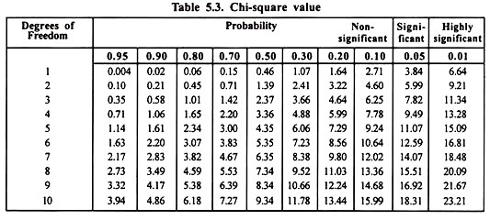
With 1 degree of freedom and P = 0.05, a chi-square value of 33 is higher than that expected by chance. Thus, we can conclude that the observed results are significantly different from expectations.

CONCLUSION
With 1 degree of freedom and P = 0.05, a chi-square value of 33 is higher than that expected by chance. Thus, we can conclude that the observed results are significantly different from expectations. Base on my data it is safe to say sepia is not X- linked because if it was the male would have it the most. The x-linked disease shows more in males because males have only one X, but it could show in females but is very rare. Female has two X and one gets turned off making one trait express. X-chromosome inactivation is a process of X chromosome inactivation in females compensates for the single X chromosome found in the male. The inactivated X chromosome is called a Barr Body. this process can lead to variegated phenotype.
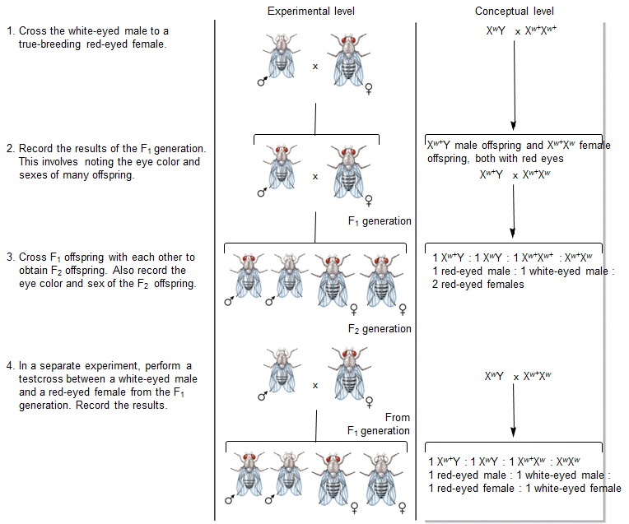In the early 1900s, Thomas Morgan did an experiment with flies which confirmed the Chromosome Theory of Inheritance, that certain genes are located to a chromosome. Morgan induces eye color in Drosophila melanogaster by obtaining a white-eyed fly and crossing it with a red eye. A true-breeding line of red-eyed fruit flies plus one white-eyed male fly that was discovered in Morgan’s collection of flies. In Morgan’s experiments, a key observation of the F2 generation that suggested an X-linked pattern of inheritance was the only white-eyed flies were males. Morgan’s work showed that a gene affecting eye color in fruit flies is inherited on the X chromosome because only males had a white eye. In my experiment, if all the males in my F2 had cherry eyes then it would be safe to say it was X-linked but I had an equal amount of females with cherry eyes. An error that occurs is some of the flies died before they could produce larvae which could skew the data.1

