GENETIC LAB REPORT
Human Blood Types
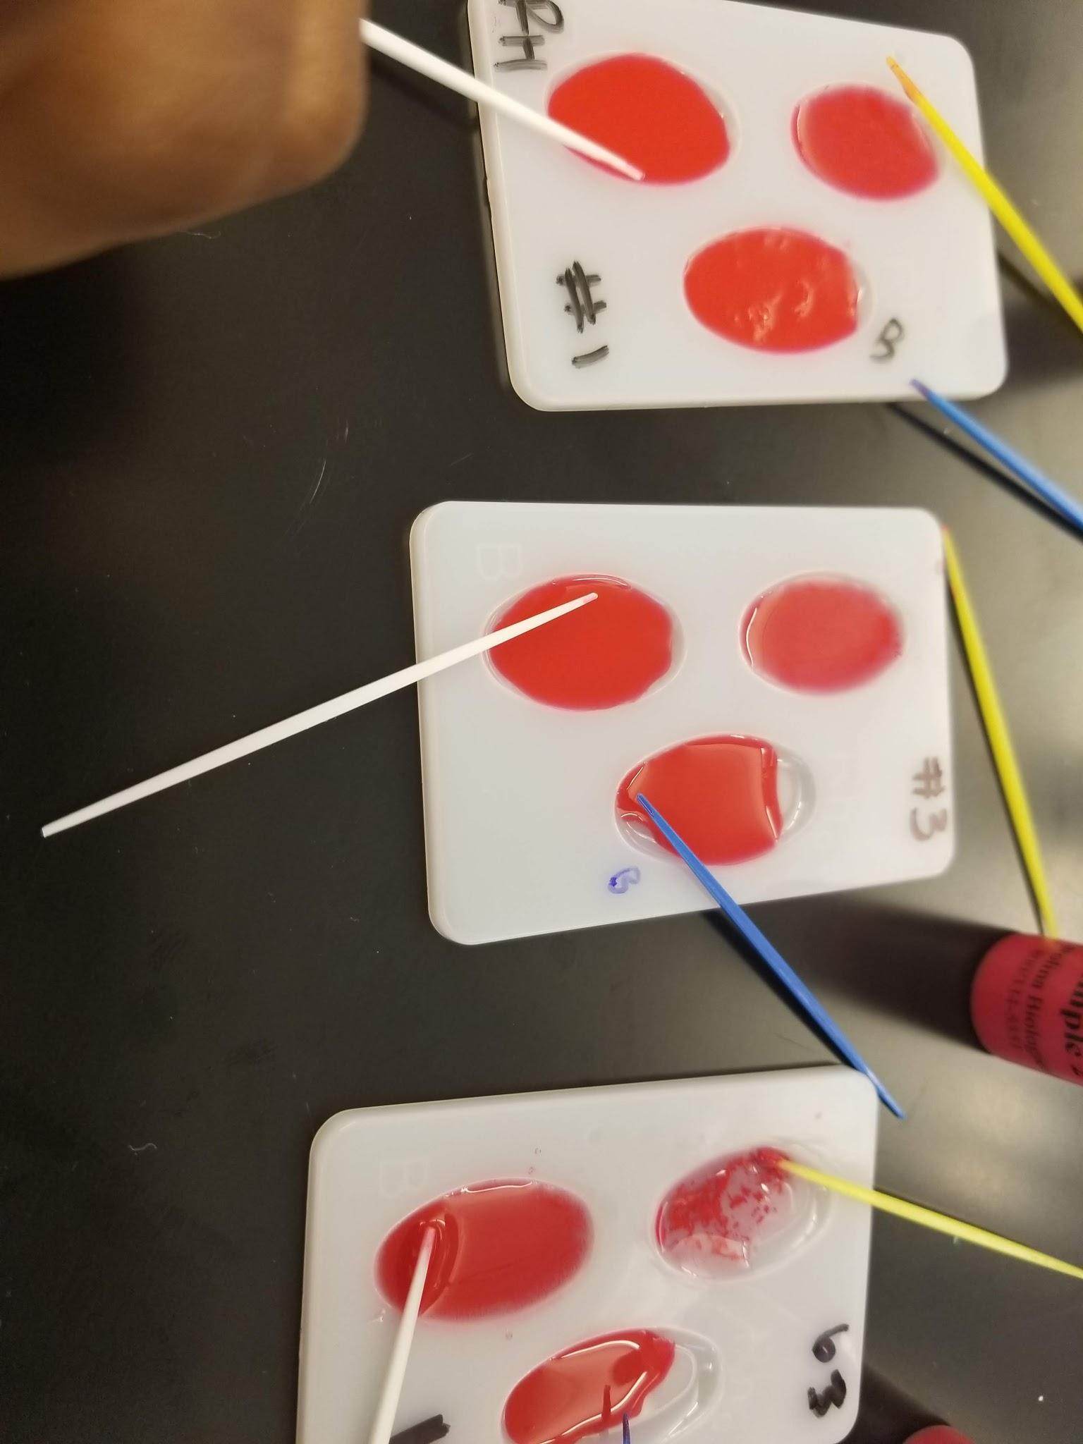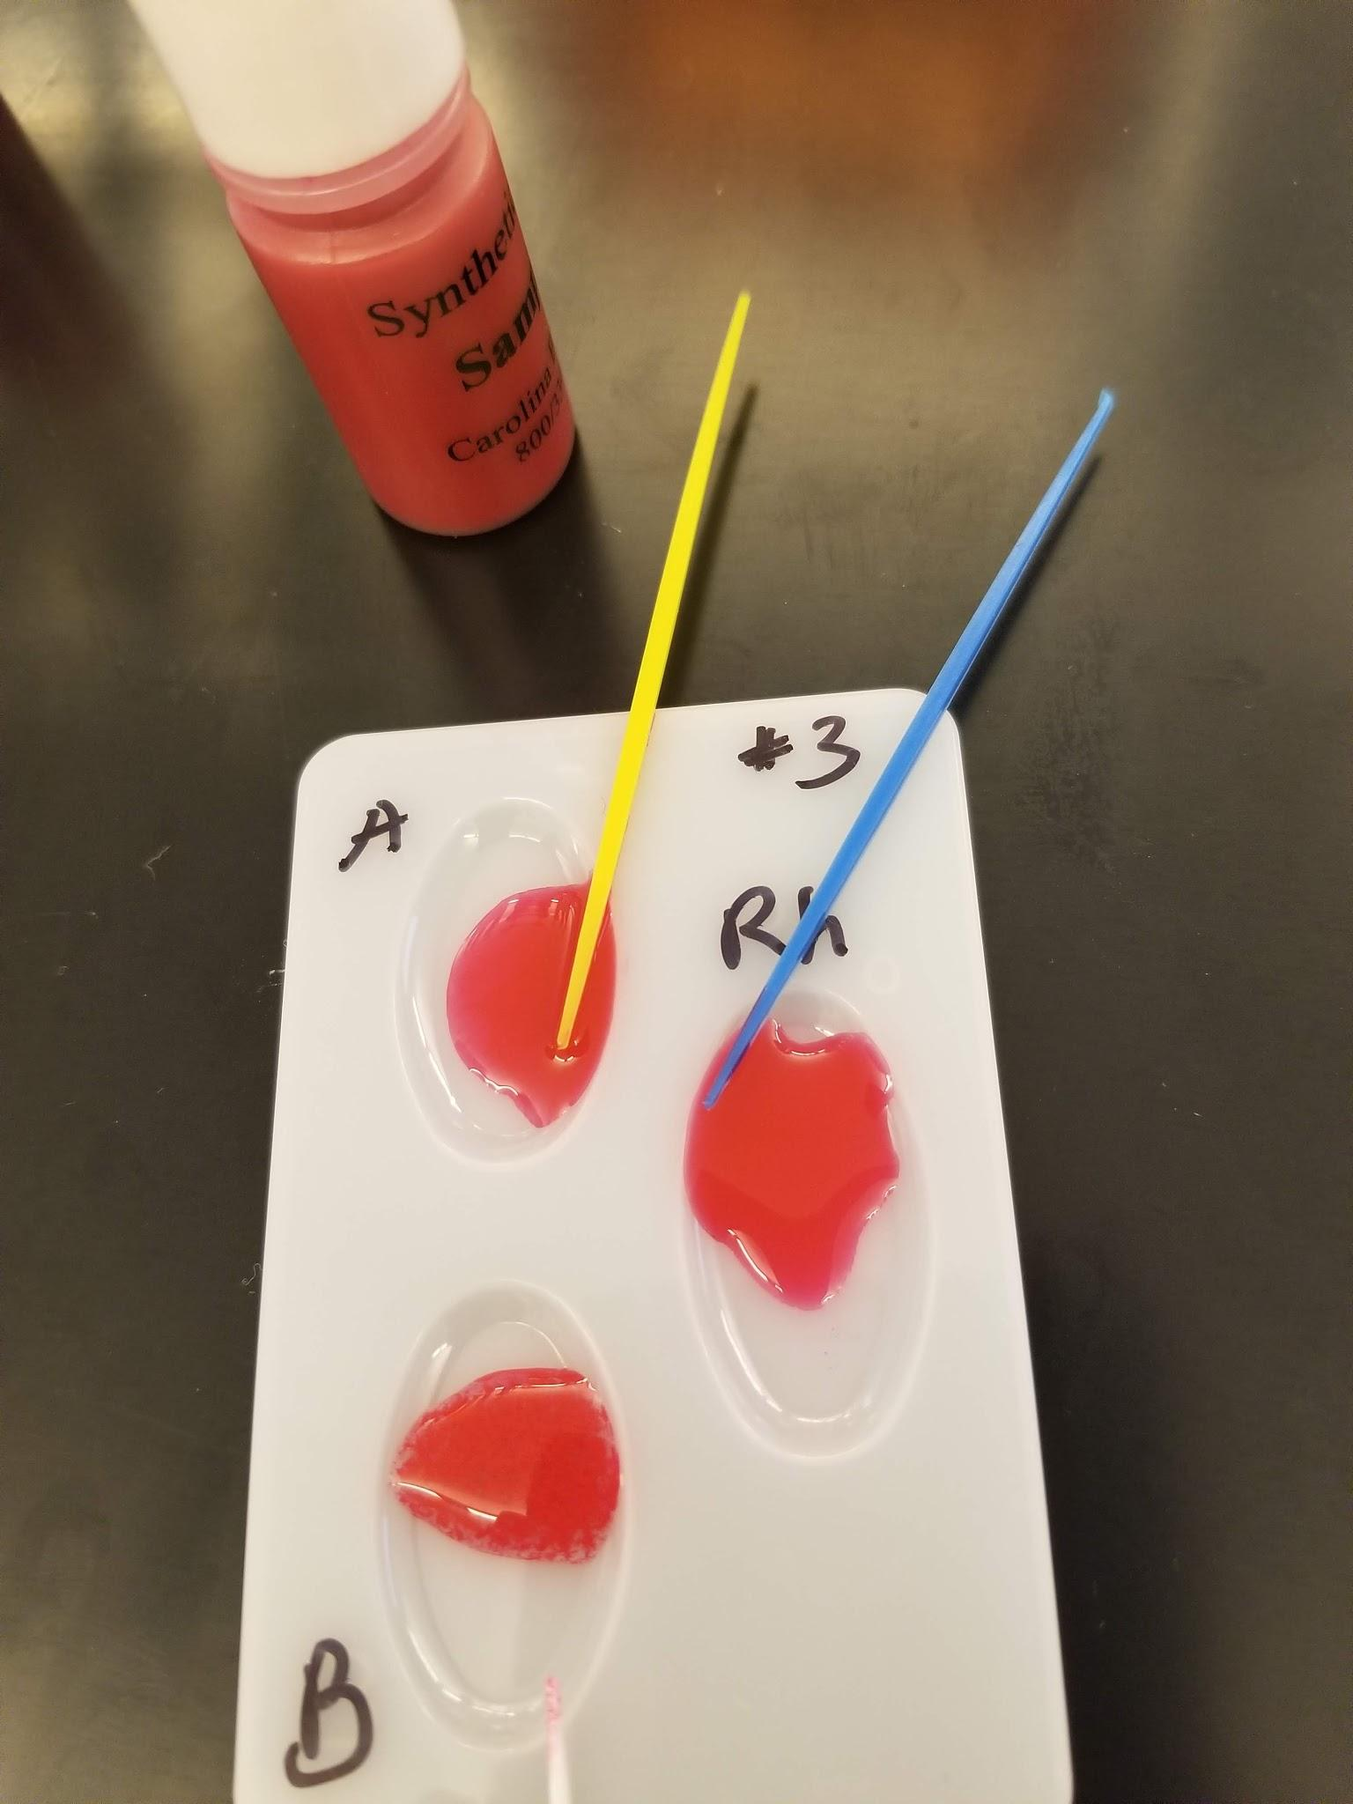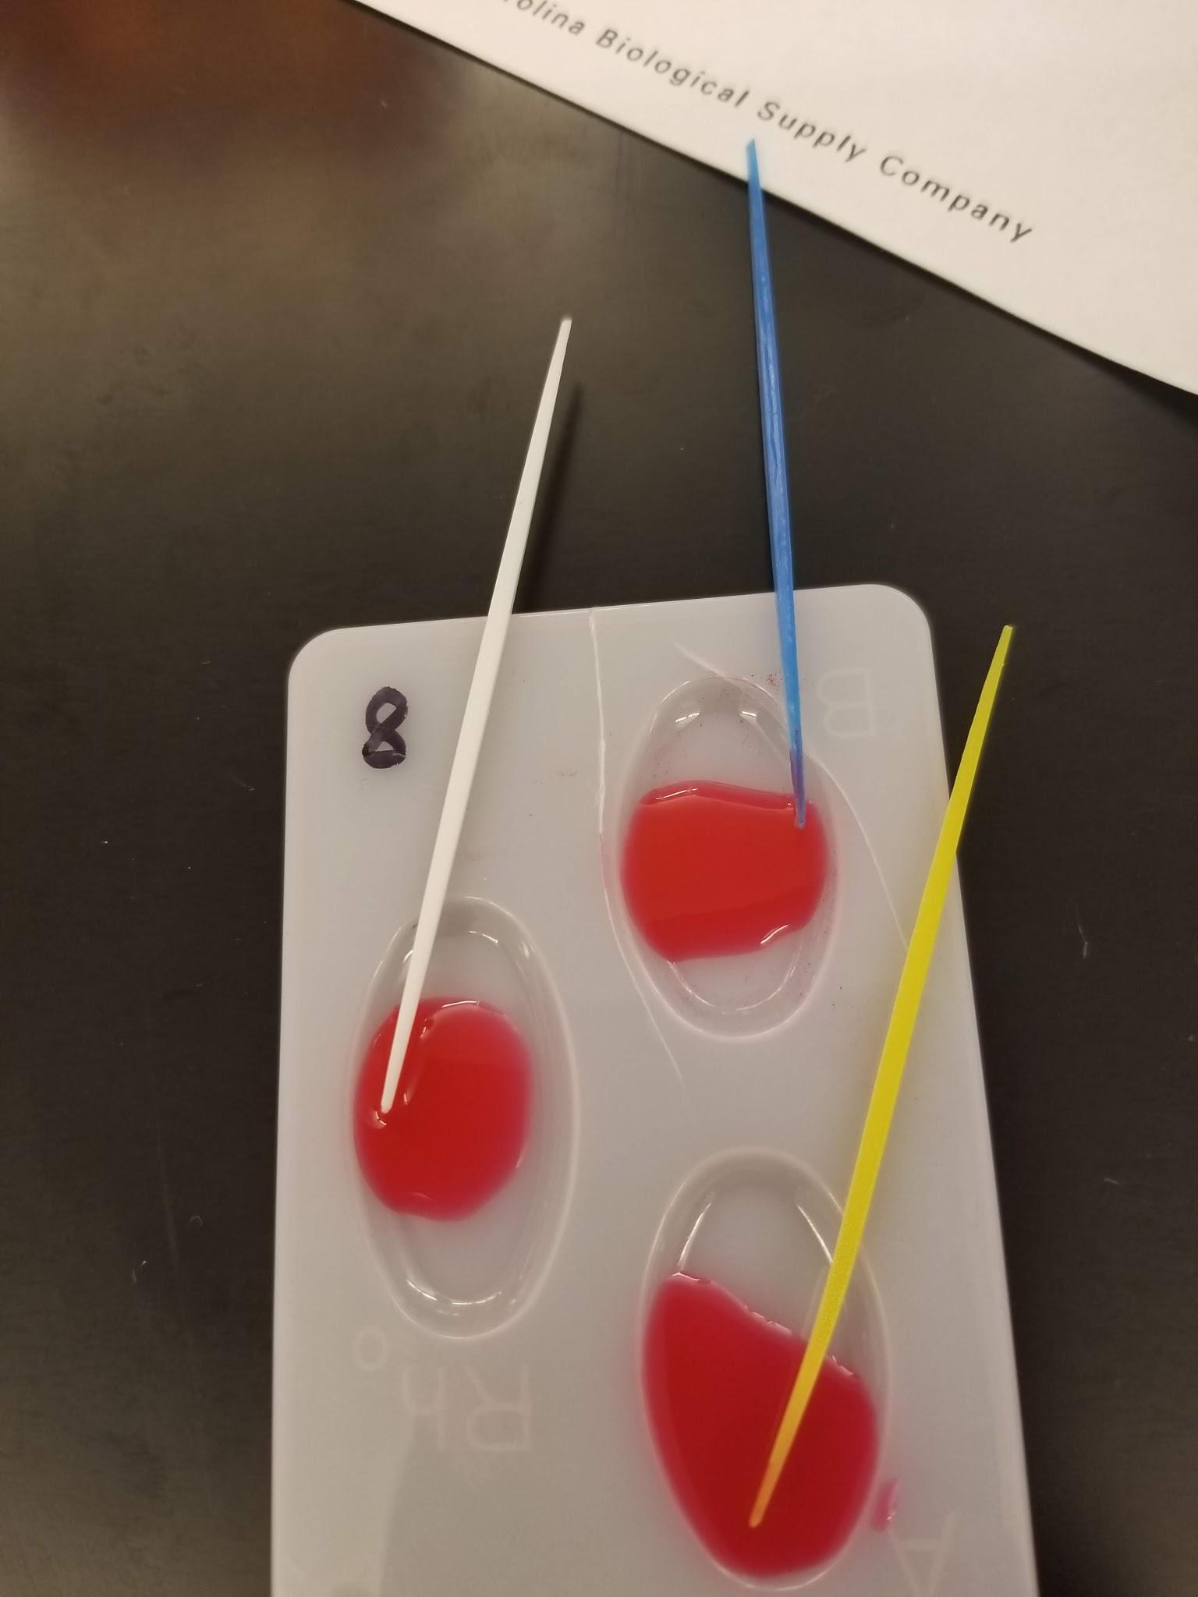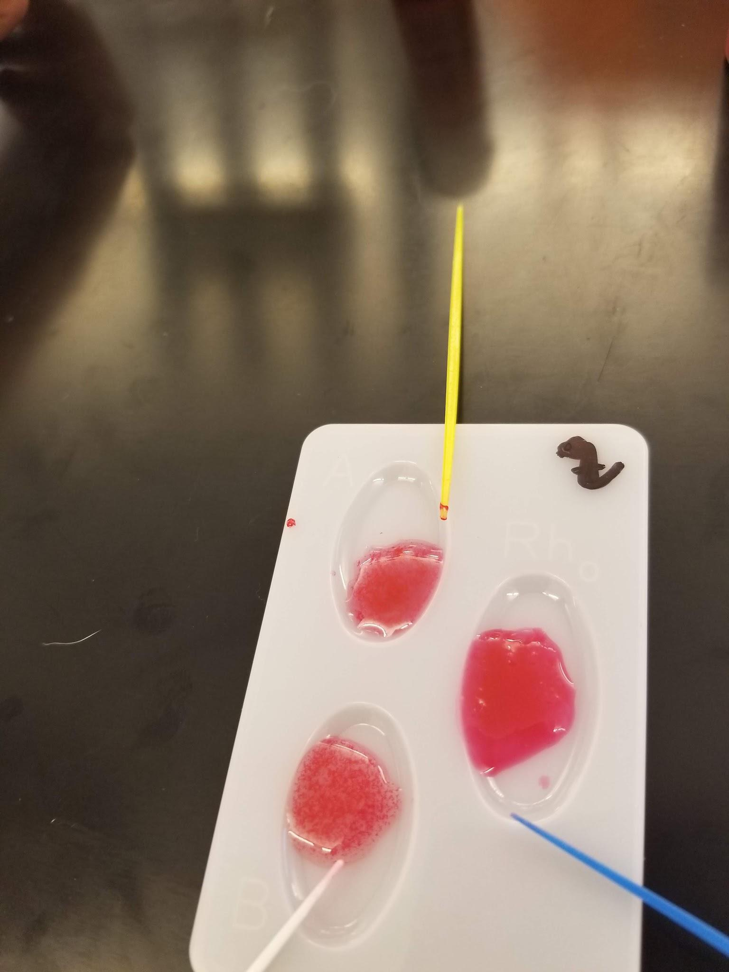
Nadia Gordon
03.21.2019

ABSTRACT
Humans have four different blood types which are A, B, AB, and O. Blood types are determined by antigen located in the person blood cell. Type A has an antigen that would accept only Type A and O and the same for the other blood type. People with an AB blood type expressing both A and B antigens because they are codominant. People with AB blood are considered the universal recipient. People with Type O blood do not have any antigens on their blood cell which allow them to be a universal donor. People with a specific blood types will have antibodies in their blood cell that will reject different blood types, like A would reject B. Also, when talking about blood type you would see + or – following the blood type, which tell if the blood is positive or negative for a second antigen called Rhesus which is controlled by different gene. In this lab, I tried to determine the blood type by place a drop of blood into each of the three wells in your dish. Add drop of Anti A in well labeled ‘A.’ Add drop of Anti B in well labeled ‘B.’ Add drop of Anti D in well labeled ‘Rh.’ Use the appropriately colored mixing stick to mix the blood sample with the serum. Look to determine if clumping occur. If clumping occurs when I know that is the blood type. For example, if I use a random sample and there is only clumping for Anti-A, then it is safe to say the person has blood type A.
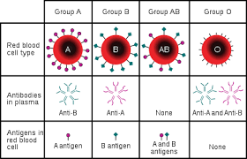

MATERIALS
In this lab I used Anti A, Anti B, and Anti Rh serum. Also, a three wells dish with sticks of different color, in this lab I used yellow, blue, and white sticks. This lab also need three synthetic blood sample.

PROCEDURE
Place a drop of blood into each of the three wells in your dish. Add drop of Anti A in well labeled ‘A.’ Add drop of Anti B in well labeled ‘B.’ Add drop of Anti D in well labeled ‘Rh.’ Use the appropriately colored mixing stick to mix the blood sample with the serum. Look to determine if clumping occur . Fill in the table below with a ‘yes’ or ‘no’ depending on whether or not clumping occurred. A positive reaction will indicate the blood type.

DATA
Test 1
 | Sample #5 | Sample #4 | Sample #8
Anti-A | Weak Clump | Weak Clump | No
Anti-B | Weak Clumping | No | No
Anti-Rh | Weak | No | No
Blood type | AB+ | A- | O-

Test 2
 | Sample #1 | Sample #2 | Sample #6
Anti-A | Clump | Clump | Clump
Anti-B | No | No | No
Anti-Rh | Clump | No | No
Blood type | A+ | A- | A-

RESULTS
Island 1
Blood Group | Total for Group | Blood Group Frequency
A+ | 3 | .18
A- | 5 | .29
B+ | 3 | .18
B- | 0 | 0
AB+ | 1 | .06
AB- | 0 | 0
O+ | 2 | .12
O- | 3 | .18
Island 2
Blood Group | Total for Group | Blood Group Frequency
A+ | 2 | .12
A- | 5 | .29
B+ | 2 | .12
B- | 3 | .18
AB+ | 1 | .06
AB- | 0 | 0
O+ | 2 | .12
O- | 2 | .12
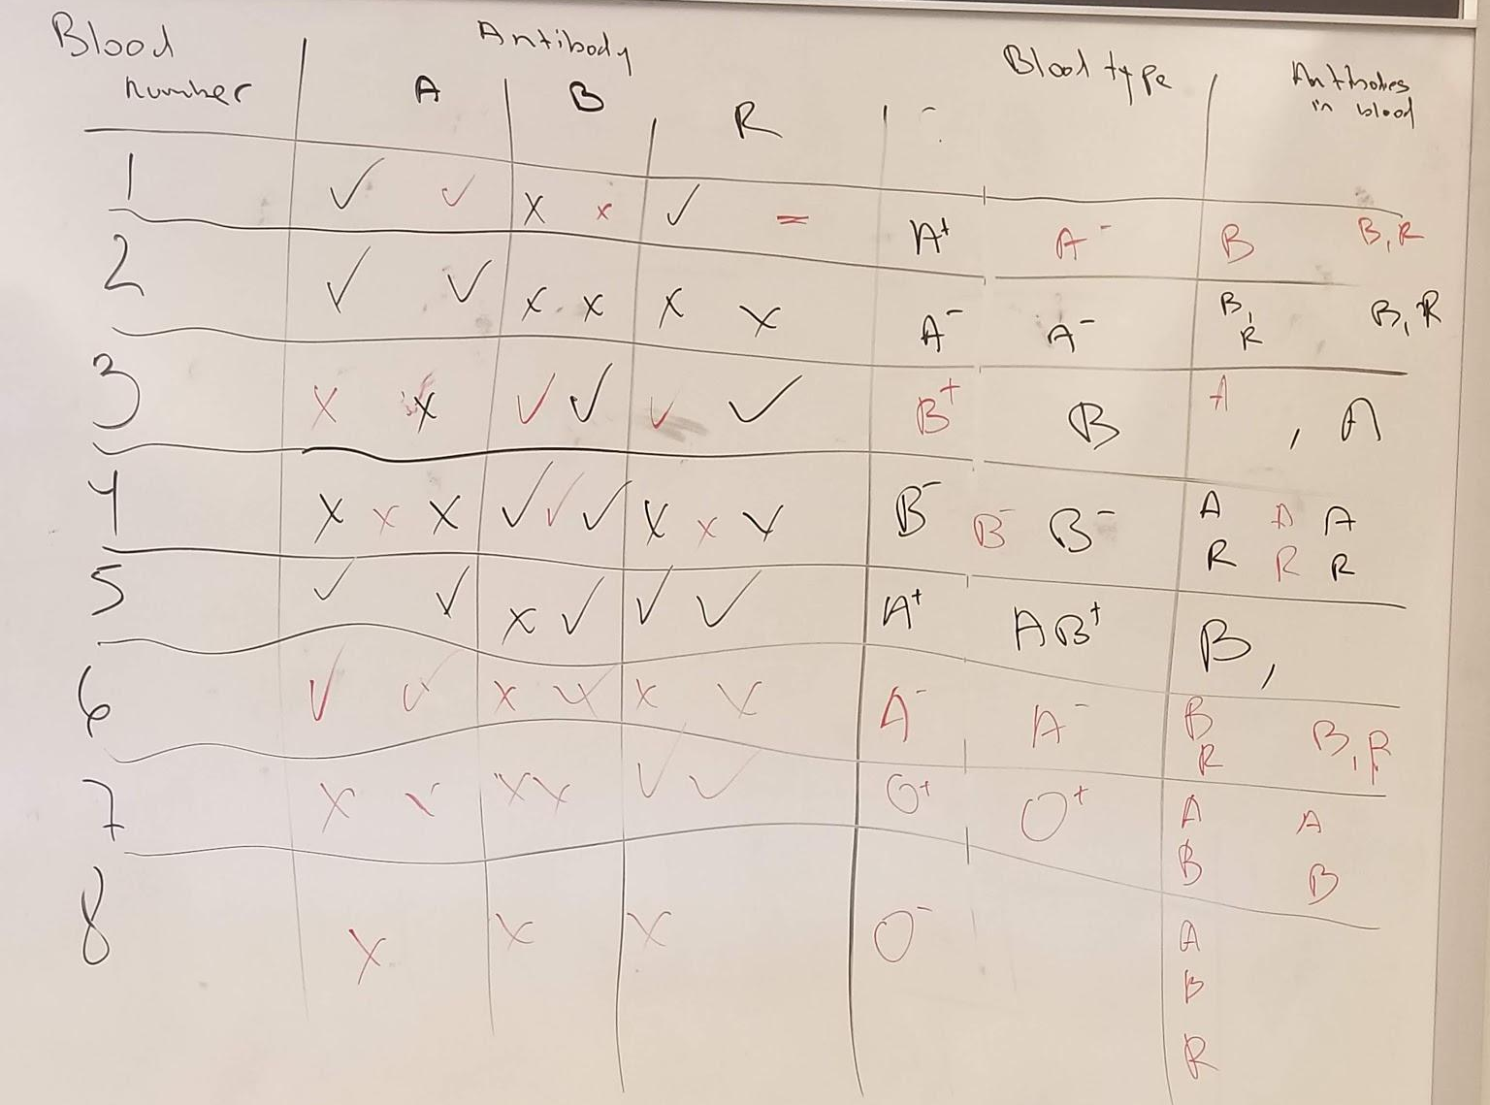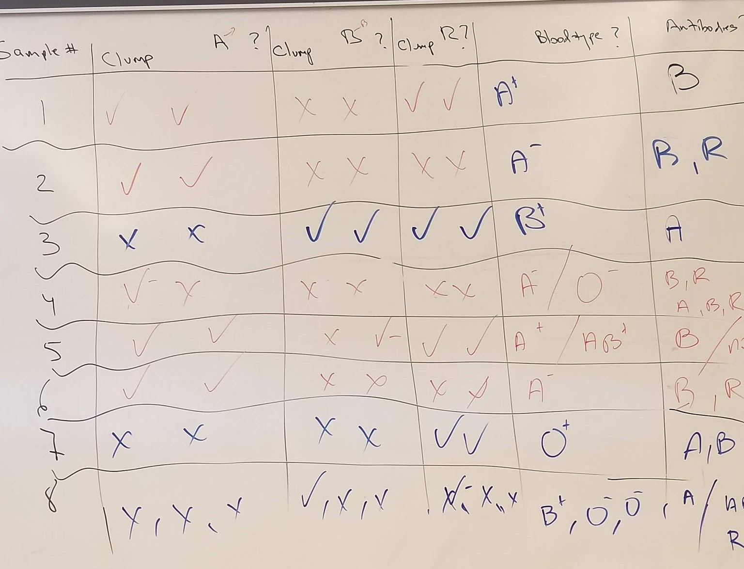
Island 1 and 2 are the total result of the class, and the shows how the class came to those calculation.

CONCLUSION
In this lab, I tried to determined the blood type by place a drop of blood into each of the three wells in your dish. Place a drop of blood into each of the three wells in your dish. Add drop of Anti A in well labeled ‘A.’ Add drop of Anti B in well labeled ‘B.’ Add drop of Anti D in well labeled ‘Rh.’ Use the appropriately colored mixing stick to mix the blood sample with the serum. Look to determine if clumping occur . Fill in the table below with a ‘yes’ or ‘no’ depending on whether or not clumping occurred. A positive reaction will indicate the blood type. If clumping occurs when I know that is the blood type. For example, if I use a random sample and there is only clumping for Anti-A, then it is safe to say the person has blood type A-. In the class, there was some disagreements on blood typing probably due to the wells not being cleaned properly. If I was able to do this lab again I would wash the three well dish so there would be any confession.

