Natalee Carela
DEN2315 – Pharmacology
June 30th - Summer 2020
Ginkgo Biloba
Ginkgo Biloba is one of the oldest living tree species existing today. These trees are indigenous to China but are widely cultivated in Asia, Europe, North America, New Zealand, and Argentina (Huh & Staba, 1992). The Ginkgo trees normally reach a height of 66 to 160 ft. and are resistant to wind and snow damage, which help them live for a very long time (Wikipedia, 2020). Male Ginkgo trees produce small pollen cones and female trees produce two ovules at the end of their stalk (Wikipedia, 2020). The leaves of the Ginkgo trees change color from green to saffron yellow in autumn and are considered unique because of their fan shaped leaf ranging from 5 to 10 cm long (CGTN, 2019).
The Ginkgo leaves undergo an extraction process before being manufactured into its final form. This extract has been standardized to 24% ginkgo flavonoid glycosides and 6% terpenoids (ginkgolides, bilobalide) (Salvador, 1995). This herb is known by a lot of different names, “ Fossil tree, Yinhsing, Kew tree, Bai guo ye, silver apricot,” and the most common one, “Maidenhair tree” (MSKCC, 2018). Gingko Biloba is marketed as an herbal supplement available without a prescription through distribution channels like drug stores, supermarkets, vitamin shops and nutrition centers (Heller, 1997). According to the California drug bank, the many formulations of dosages available are tablets, gels, powder, lotions, liquids, granules, capsules and extracts for both an oral and topical route of application (DBCA, 2020).
Findings have suggested that Ginkgo Biloba has been effective for improving mental functions including symptoms of Alzheimer’s and motoric and cognitive impairments (Diamond, et al., 2000). Aside from those listed above, additional off label uses for this leaf exist. Consumers have faith in Gingko Biloba as a remedy for anxiety, pre-menstrual syndrome, multiple sclerosis and tinnitus (Omudhome, 2019). Studies have found Gingko Biloba to be popular for treating vertigo, nausea, dizziness (Unger, 2013) and even erectile dysfunction (McKay, 2004).
According to Lexicomp’s Drug Information Handbook for Dentistry, possible adverse effects of consuming Ginkgo Biloba include headaches, dizziness, palpitations and dermatologic and gastrointestinal reactions (Wynn, et al., 2017). This reference indicates spontaneous bleeding is also a concerning side effect; stating chronic use inhibits platelet aggregation and prolongs bleeding. No oral manifestations involving the use of Ginkgo have been reported. The CA drug bank reports a list of over 500 drugs interactions where if used in combination with Ginkgo Biloba, the drug’s therapeutic efficacy and metabolism may be affected (DBCA, 2020). No potential contraindications have been established but because there’s not enough evidence on how safe this supplement is, it is advised to not consume it during pregnancy and lactation (Wynn, et al., 2017).
Ginkgo Biloba is attractive to the consumer because of all the advertised benefits and because its marketed as “natural” but the FDA has approved two types of medications to treat similar conditions. Cholinesterase inhibitors and memantine can both treat the cognitive symptoms of Alzheimer's disease (AA, 2020). Ginkgo can be bought OTC at almost any vitamin shop, which is easier than going to an actual doctor and getting a prescribed medication. Many consumers believe in its benefits because they already know someone who claimed their symptoms were relieved or because their own symptoms were relieved after trying the herb for the first time.
Everyday society is choosing to consume more “organic” and “natural” products. This means that as a health educator I should have a greater understanding on supplements, their effects and contraindications and verify my information with a dentistry drug information handbook. I should be comfortable reading my patient’s medical history and discussing possible risks because after all, that is part of my job, to educate my patients and guide them the right way. Since I learned Ginkgo Biloba’s consumption might affect the efficacy of various drugs, I would verify if the drug incorporated in my treatment plan could have a bad reaction with the herb. If it does, I would try to find another drug with the same therapeutic effect but with no interaction to Ginkgo Biloba.
Bibliography

- Alzheimer’s Association. (2020). Medications for Memory. Retrieved from https://www.alz.org/alzheimers-dementia/treatments/medications-for-memory
- Bruce J. Diamond, Samuel C. Shiflett, Nancy Feiwel, Robert J. Matheis, Olga Noskin, Jennifer A. Richards, Nancy E. Schoenberger. (2000). Ginkgo Biloba extract: Mechanisms and clinical indications. https://doi.org/10.1016/S0003-9993(00)90052-2.
- CGTN News. (2019, March 12). The beautiful trees native to China. Retrieved from https://news.cgtn.com/news/3d3d514d35676a4d33457a6333566d54/index.html
- Drug Bank of California. Ginkgo Biloba. (2020, June 12). Retrieved from https://www.drugbank.ca/drugs/DB01381
- Heller, A. (1997) Vitamins. Drug Store News (May 19), 51. Retrieved from: https://ntp.niehs.nih.gov/ntp/htdocs/chem_background/exsumpdf/ginkgo_gbe_508.pdf
- Hoon Huh & E. John Staba (1992) The Botany and Chemistry of Ginkgo biloba L., Journal of Herbs, Spices & Medicinal Plants, 1:1-2, 91-124, DOI: 10.1300/J044v01n01_10
- McKay D. (2004). Nutrients and botanicals for erectile dysfunction: examining the evidence. Alternative medicine review : a journal of clinical therapeutic, 9(1), 4–16. https://pubmed.ncbi.nlm.nih.gov/15005641/
- Memorial Sloan Kettering Cancer Center. (2018, April 3). Ginkgo. Retrieved from https://www.mskcc.org/cancer-care/integrative-medicine/herbs/ginkgo
- Omudhome Ogbru, P. (2019, March 05). Ginkgo Biloba Supplement Benefits, Side Effects & Dosage. Retrieved from https://www.medicinenet.com/ginkgo_ginkgo_biloba-oral/article.htm
- Salvador, R.L. (1995) Herbal medicine - Ginkgo. CPJ/RPC, (July-August), 39-41, 52. Retrieved from: https://ntp.niehs.nih.gov/ntp/htdocs/chem_background/exsumpdf/ginkgo_gbe_508.pdf
- Unger M. (2013). Pharmacokinetic drug interactions involving Ginkgo biloba. Drug metabolism reviews, 45(3), 353–385. https://doi.org/10.3109/03602532.2013.815200
- Wikipedia contributors. (2020, June 27). Ginkgo Biloba. In Wikipedia, The Free Encyclopedia. Retrieved from https://en.wikipedia.org/w/index.php?title=Ginkgo_biloba&oldid=964850650
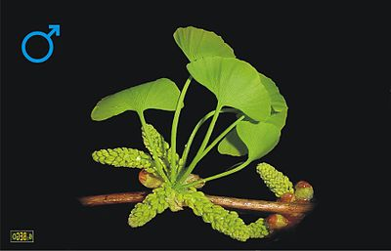
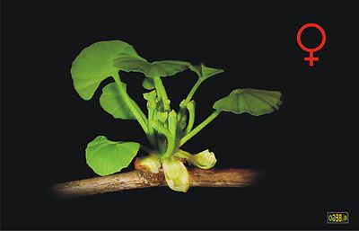
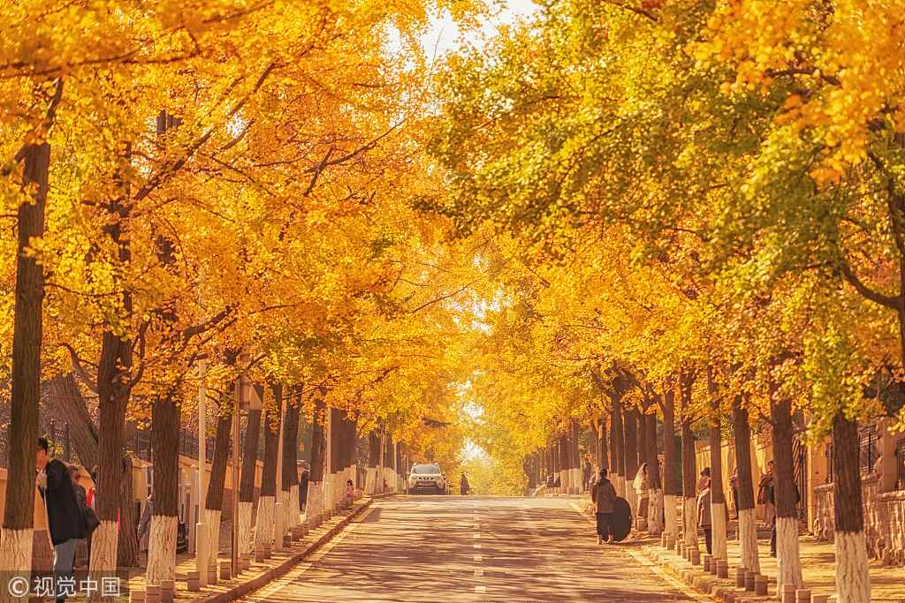
- Wynn, R. L., Meiller, T. F., & Crossley, H. L. (2017). Drug information handbook for dentistry: Including oral medicine for medically compromised patients & specific oral conditions (23rd ed.). Hudson, OH: Wolters Kluwer.
Pollen cones from male tree.
Photo from Wikipedia.
Ovules from female tree.
Photo from Wikipedia.
Ginkgo Tree in autumn.
Photo from CGTN News.

