COMD 3711 Vector Art Editing Professor Neuringer

Lo Poly Self-portrait Midterm Project

Your Photo

The first aspect of this assignment includes gathering or taking a photography of yourself.

The photograph should include the following:
- Image should be taken side view or ¾ view. Gazing from ¾ to camera looks engaging.
- Light should be high contrast coming from one side of your face. You can use a light source or go near a window to get natural light on one side of your face.
- The photo should have the highest resolution you can capture (more megapixels from camera or phone) in a jpg format.

Here is an idea of what your image might look like.

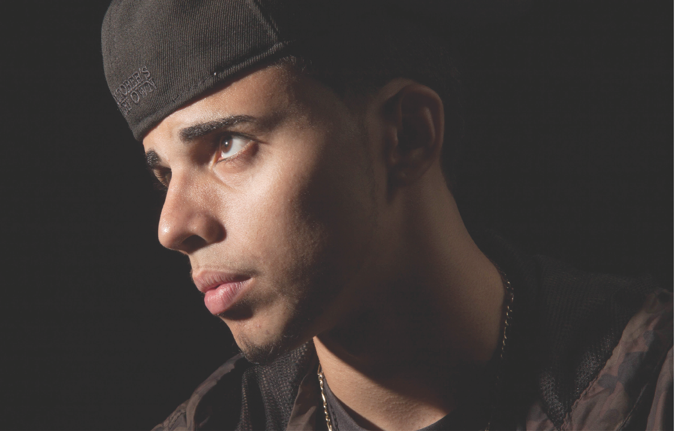

Save the photo to your desktop.
- Drag the image into the PS icon on your dock so that it will open in Photoshop. (or double click it).
- In the Tool Panel, select the Crop Tool (C) and set the Options Bar to look like the following:
10 in x 16 in by 300 dpi (portrait) or if you choose 16 in x 10 in by 300dpi (landscape).
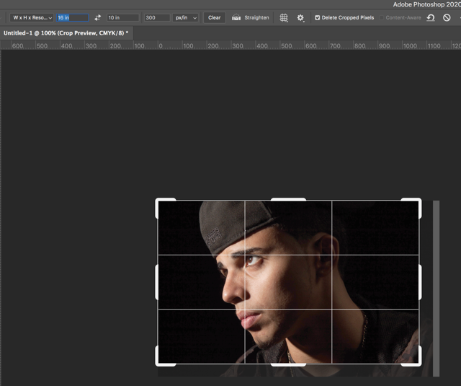
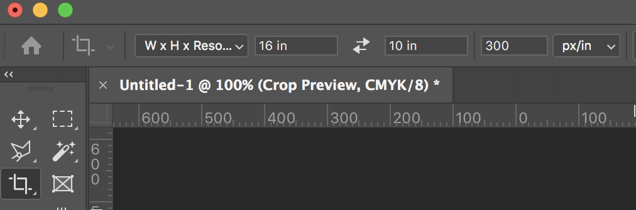

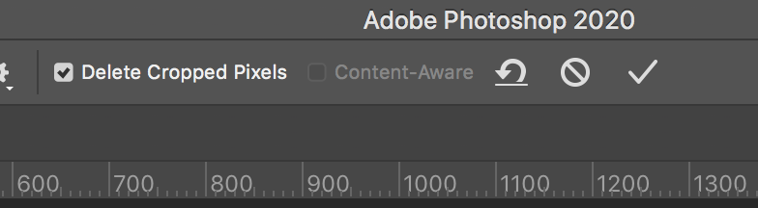
- After you crop the photo as you wish (the image should be head and shoulders only) click the check box on the options bar.

- Save your cropped image as : MidtermImage_LastName.jpg in the quality 12 Maximum setting and click OK and close the file. Save it on your desktop or somewhere where you can find it.
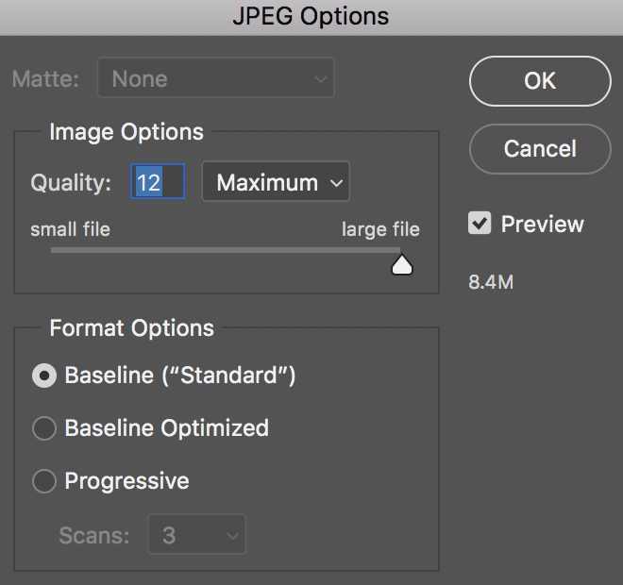

Open Adobe Illustrator and create a new Print File.
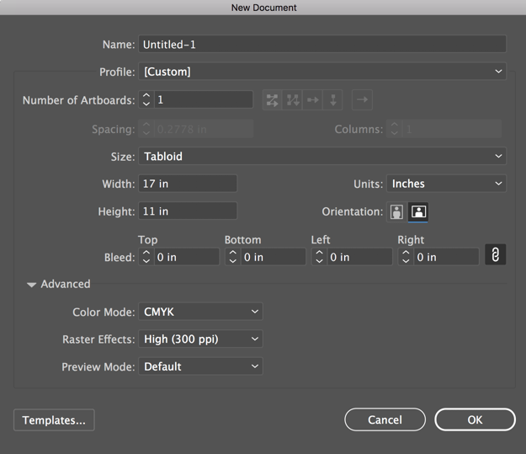
- Size Tabloid (17 x 11 or 11 x 17), no bleed
- Units - Inches
- Color Mode - CMYK
- Raster Effects High (300 dpi)
- Click OK

- Go to Window > Workspace > Essentials Classic.

- Go to View > Rulers > Show Rulers. The rulers will appear on the top of your document and also on the left side.
- With the Selection Tool drag guide from the top ruler to the top of your file at the 1/2 inch spot (horizontally).
- Now drag a Guide from top ruler to the bottom of your page to the 10 ½ inch spot.
- Now Drag a Guide from the left ruler to the ½ inch spot (vertically).
- Drag the last Guide from the left ruler to the right side of your page ½ inch from the edge.

- We are now going to place our cropped .jpg into this file. File > Place (navigate to the desktop or where you have stored your photo) and place it into the Illustrator File.
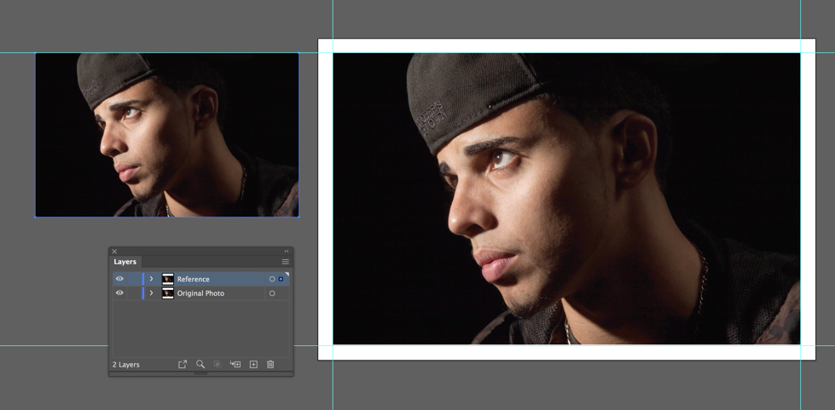
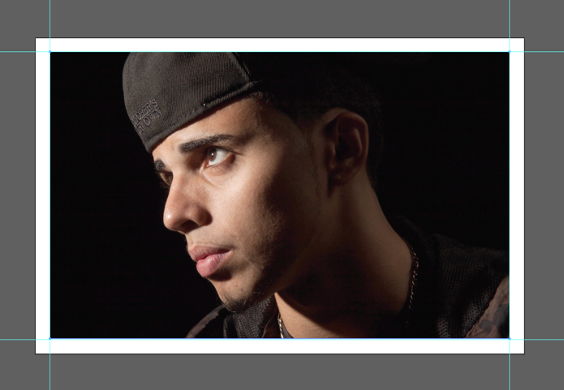
- The cursor will load the image. Move it to the left top where the guides intersect. Drag a box down and to the right and the image will fill the Print Area. If you cropped it correctly it will fit perfectly in the print area.

- Open the Layers Panel. Window > Layers.
- Duplicate the Original Photo Layer by dragging it to the bottom of the Layers Palette (by adding a New Layer + plus sign next to trash can) and then rename it Reference.
- Drag the reference layer to the left and make it smaller.
- Now Target the Original Photo layer and Click on the Hamburger Lines on the top Right of the Layers Palette.
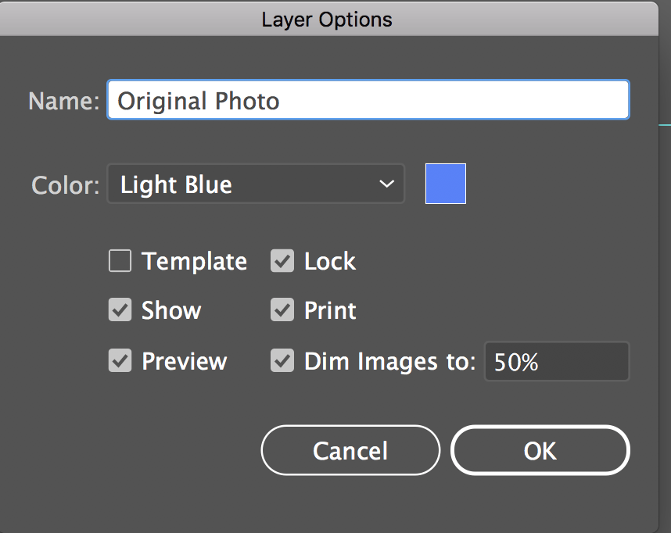
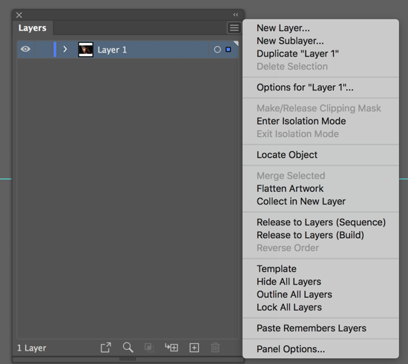
- Go down to Options for “Layer 1”.

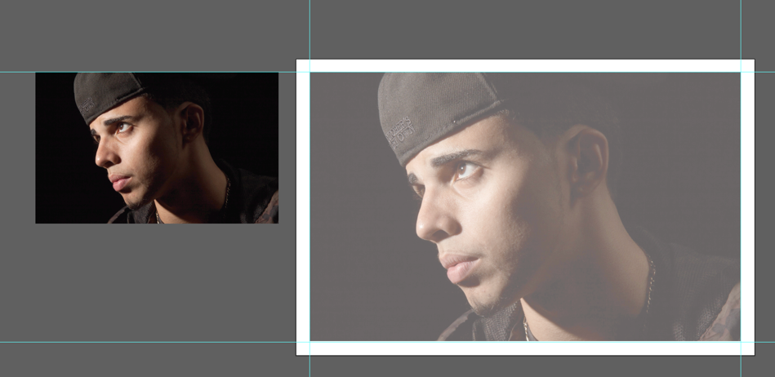
- In the Layer Options Type Name: Original Photo. Check the Lock box and set Dim Images to: 50%. Click OK. If 50% is too much or too little you can always go back and change it to a different amount. This is what it will look like.

Starting the drawing
- Create a new layer (+ sign again) for drawing your triangle shapes in the Layers Palette (+ sign). All shapes must be triangles. Draw with the pen it should have a 1pt black stroke and NO FILL.

Things to consider. Each triangle you draw should define the facets of your face. Think about highlights and shadows. Go to Pinterest.com and follow me Maureen Neuringer. Then search for my folder Lo Poly. There are many examples of what you can do. Ultimately, we will make two versions with different colors. Version 1 will use the eyedropper and Version 2 will have your own choice of color. Send the line drawing for approval.

Save this file as 3711_07_LastnameMidterm1.ai and bring it to next class Thursday, March 16th. Your final file (after next week) may be too big to send so you can use Wetransfer.com at no charge after you set up a free account.

Any questions just email me. You may want to send me the photo before you begin for feedback.

