N. Douglas / Section D305 / Homework #1 (Logo Research)
Most people can paint the perfect image of Shell’s logo in their minds the second they hear the company’s name. This is a productive method of design because of how easily it grasps the audiences’ attention. The logo has developed by a significant amount despite the remarkably simple logo concept that most people remember the company for. Before the company was thought of, the founder Marcus Samuel sold antiques and eventually oriental shells for interior design. Marcus Samuel Junior eventually found interest in oil due to the increase in demand and with Shells featuring as a newly founded export in his business the idea of using one to brand a logo sparked. The company is still in business after 50 years of work.
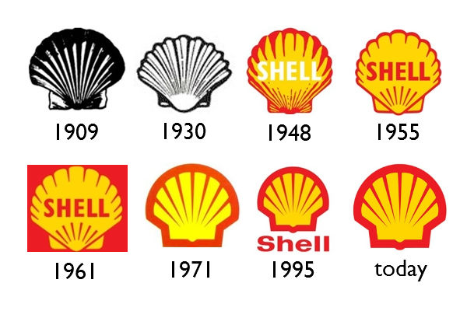
The first logo was created in 1900 and featured a 3-D image of a mussel shell. The font of the logo is Eurostile Black. Four years later the logo changed to a photo of an upright shell which began the process of creating the essentially minimalistic logo design we know and love today. Seeing as the black and white logos were merely photographs of shells and hardly appealed to an audience, the Shell Company built in California in 1915 decided to use the colors Red and Yellow to appeal to the Hispanic states. In terms of influence, the Shell logo is an inspiration to designers who are seeking to create a logo that leaves an imprint in the consumers mind. Attention grabbing, simple, and easily referring to the company’s brand is the ideal formation of logo design and the primary goal of all designers. It is noticeable that the Shell logos follow shifts in the style of design as the year’s progress.
Raymond Loewy is the designer of the Shell logo created in 1971 and it is said to be one his best works. It is also found that Loewy designed logos for Exxon and BP. Despite his varying works outside of logo design it is apparent that Loewy creates immensely simple concepts that work as time-honored and traditional inscriptions on the world. On the 1971 Shell logo that he created it is hard to miss that the text has been removed. This was with the intention of creating a logo to last inside the minds of consumers. It works because the consumers have known Shell by their logo featuring its text even though the updated redesign is simpler than it was before.
The 1955 design of the logo has a font that contains no serifs. This is an effective way to brand their company simply because of the field that they are maintaining. Type that does not contain serifs is usually more eye-catching and has the intent of grasping attention much easier than of those that do contain serifs. For example, road signs are placed without the use of serifs so that drivers can easily read the message without the distraction of a serif. Gasoline consumers are also on the road and hardly have the time to stop and focus on any one text other than road signs. It is much easier for a driver to notice bold the bold red text of the Shell logo with an all-capital Sans serif typeface. The chosen colors are what grabs attention the most and are also points of success on the designers’ behalf.
In conclusion, the Shell logo is a highly effective concept due its simplicity, colors, and partially choice of text. Raymond Loewy’s idea has surely inspired many other designers including myself to try to create a logo worth remembering simply by the company’s title. The history of this design began with very minor but complex attachments to the Shell and eventually became an easily understood 2d abstract idea. It is said that logos that are branded without text are the products of a large budget. This proves to be true with Shell’s design as they have maintained their business for over 50 years and counting.
Citations:
- http://www.shell.us/about-us/who-we-are/the-history-of-shell-oil-company.html
- http://images4.wikia.nocookie.net/__cb20120831084645/logopedia/images/b/b4/Shell_1955.png
- http://www.logodesignlove.com/shell-logo-design-evolution
- http://www.shell.in/aboutshell/who-we-are/history/history-logo.html
- http://blog.logomyway.com/history-famous-logos-1-shell/
- http://blog.logomyway.com/wp-content/uploads/2011/12/shelllogo.jpg

