Michael Valentin

CDMG 1112

Professor Bauer

**Field Trip Report**

The overall presentation at the “United Federation of Teachers” was very well explained, they went into lots of detail on what they do there and how the machines work. The facility was well organized and well equipped with many machines, the building itself was very clean and modern. I learned a lot about the production of printing and “I” as a graphic designer can work well with printing companies.

Web offset is a form of offset printing in which a continuous roll of paper is fed through the printing press. Pages are separated and cut to size after they have been printed. Web offset printing is used for high-volume publications such as mass-market books, magazines, newspapers, catalogs and brochures.

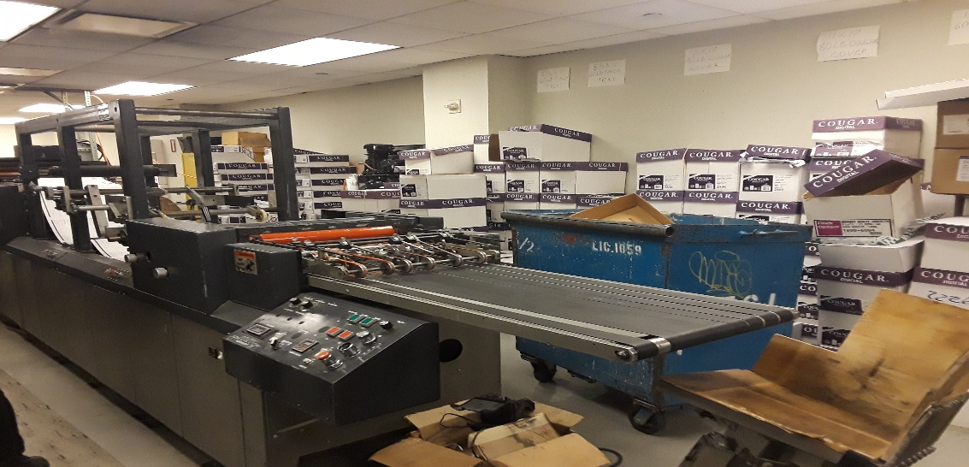

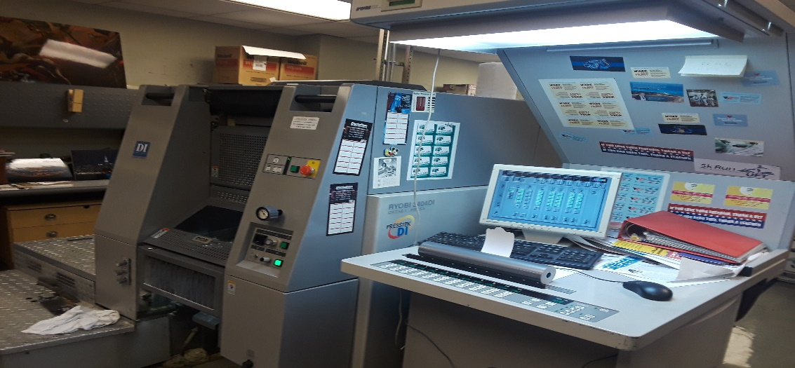

Digital printing is the process of printing digital-based images directly onto a variety of media substrates. There is no need for a printing plate, unlike with offset printing. Digital files such as PDFs or desktop publishing files can be sent directly to the digital printing press to print on paper, photo paper, canvas, fabric, synthetics, cardstock and other substrates.

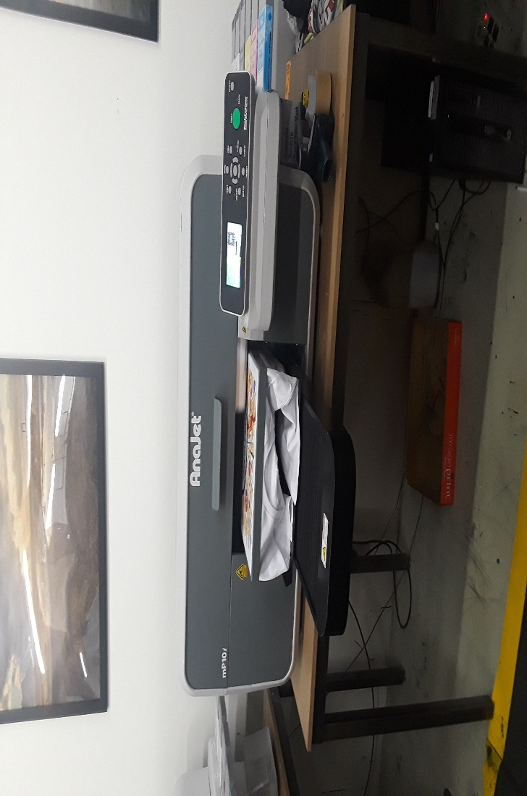

The most common form of commercial T-shirt decoration is screen-printing. In screen-printing, a design is separated into individual colors. Plastisol or water based inks are applied to the shirt through mesh screens which limits the areas where ink is deposited. In most commercial T-shirt printing, the specific colors in the design are used.