The Neuro Linker

The Neuro Linker was first shown on the Japanese Light Novel, Accel World, which was written by Reki Kawahara, on february 10th 2009, before getting it’s own anime adaption on April 6th 2012. The Neuro Linker is a portable computer that uses virtual and augmented reality for each user to use. It attaches to your neck like a collar would and connects to your nerves to trick your senses.
In turn, through your actual eyes, you see floating transparent windows which are similar to those you see on a computer. These are made by the Neuro Linker, and since your senses are being tricked, you can actually touch them and feel your finger touching some sort of screen that’s not only there, that only you can see. The way you interact with these flying transparent windows are sent back to the Neuro Linker, making all these actions valid, so if you want to send an e-mail, instead of going to a computer or sending one via cell phone, you can simply open a window and type out an e-mail via virtual keyboard.

All of this considered, the Neuro Linker truly is a portable computer that you can use anytime, anywhere, while also not disturbing any one else who uses it. However, keep in mind only you can see the windows so you may appear like a crazy person randomly tapping the air for the first few years.

Although the idea of the Neuro Linker has obviously been made, since it’s shown on the anime, Accel World, it has not been exactly sought out. For example, the Neuro Linker in Accel World was simply to show how the world depends on it and it’s interactions on it every day, but was not the main focus of the show.
What’s currently out today that is similar would have to be other goodies that are well known like Google glasses. Other inventions that are pretty similar are also the emotive headset and even the nekomimi.
The google glass is basically a wearable PC that you can bring everywhere with you. Instead of tricking the brain’s signals into seeing windows of the computer however, the user wears glasses which brings an augmented view of what you want to see on your field of view. It also takes advantage of voice commands, which I’m personally not a big fan of since most computers can’t accurately know what you’re saying, but with how far technology goes every day, maybe it might be a little reliable on the google glass.

http://www.google.com/glass/start/
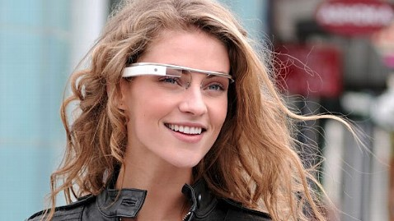

The necomimi is basically a headset with cat ears on it. However, it is not just for looks. Using your brain waves, the headset reads your emotions, moving the cat ears. What pose the cat ears are currently are dependent on your emotions. However, the necomimi isn’t exactly accurate when it comes to reading and in turn, unrealiable at it’s current state.
http://neurowear.com/projects_detail/necomimi.html#ShopList

http://www.youtube.com/watch?feature=player_embedded&v=w06zvM2x_lw

The emotive headset is basically another headset which reads your brain waves. However it’s a lot more accurate then the necomimi and has a lot more options other then simply reading your emotions. Options include being able to control the computer via emotiv headset. It works by using a training system where you train the program on how to read certain thoughts. For example, you can program the idea of “push” onto anything you want, rabbits or anything. When you activate the mouse mode of the emotiv, you can set push to the mouse button and interact with the computer using the mouse as your mind.
Minor set backs with this program however include putting the sensors properly on your head, getting the sensors to read your brain wave signals correctly and finally, training the program. When training, you can only think of one thing for each action. One thing may not seem that hard to do but trying to do so is actually extremely hard to do.

http://www.emotiv.com/
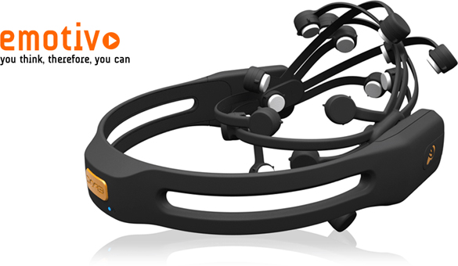
There are of course newer works that are similar to that of the neuro linker. For one, brain implant chips are being worked on which will be used as a way to have a computer with you wherever you go. This was first worked on upon by IBM, but not much info has been given out to the public. There are some cool features that seems to be planned for implement, such as controlling the volume of certain objects. In other words, if I’m in a noisy train but some guy is making a speech, I can increase the volume I hear from him, while decreasing the sounds of others so that my priority focus would be on him. Though there are some negatives with this, seeing as how it can make you unaware of your surroundings. If you’re talking with a friend and you have thsi chip installed, you’d naturally keep his volume up louder than the rest and in turn hinder your ability to react with your surroundings. Either way, not much info is released about the brain chip, nor would I like the user of the Neuro Linker to have any implants to use his device, but this is a step further to a possible neuro linker.

Augmented Reality
http://www.cgw.com/Publications/CGW/2001/Volume-24-Issue-11-November-2001-/Showcasing-Augmented-Reality.aspx#.UUifJeizJk0

This article talks about HMD’s(Head mount displays) and how they can be used for Augmented reality or AR. The HMD’s are to be worn on the users head. The HMD’s simply just show images in front of the users eye. What ends up happening is the the user sees an image projected onto another object that only he can see. They also state the optics used for the heads mount display can be changed. It states that the goal of their project is to make it so that the computer acts in the background and makes it easy for the user to use. They want to make it so that the user only has to focus on the task they are suppose to be doing rather then the actual computer itself as it operates in the background.
In the end, Bimber, one of the people working on the project to increase augmented reality, states that there are still many things that haven’t looked into yet which could increase it’s usefulness over time. According to Bimber, those in the military have also shown interest in this field of technology and looks forward to it’s evolution as time goes by.

www.cs.unc.edu’s PDF article on virtual reality

This article basically explains what VR, or Virtual Reality is. I personally learned a lot form this article, finding out that in 1994, VR was already being worked on. VR apparently doesn’t work completely and still is evolving today.
The article then talks about how VR works, mainly about modeling, engineering, it’s tracking system, the egonomics and other stuff. Interesting enough, CAD files can apparently also be used to enhance one’s VR experience. Well, I guess that isn’t that much of a surprise since it is basically modeling.

http://www.guardian.co.uk/science/2013/feb/28/brains-rats-connected-share-information

This article is probably one of the most impressive experiments I’ve seen regarding that of the brain. The experiment was pretty simple. The two rats are connected via the internet, sharing information with each other in real time. In turn, they were able to work together to try and figure out how to gain rewards for their efforts. These rewards were like getting some food or getting some water for them to drink. The two rats however were separated by about a thousand miles, but since their brains were connected directly through the internet, their thoughts were shared with each other and had an easier time finding out how to unlock the rewards that they desired.

The Neuro Linker is a portable computer that uses virtual and augmented reality for each user to use. It attaches to your neck like a collar would and connects to your nerves to trick your senses.
The way this works is that it uses the factor of your nervous system which works by having your brain send signals to other parts of your body. Like if you want to punch somebody in your face, your brain waves would send signals throughout your body to make the punch. What the Neuro Linker does exactly is send signals to your sense of touch and sight.

In turn, through your actual eyes, you see floating transparent windows which are similar to those you see on a computer. These are made by the Neuro Linker, and since your senses are being tricked, you can actually touch them and feel your finger touching some sort of screen that’s not only there, that only you can see. The way you interact with these flying transparent windows are sent back to the Neuro Linker, making all these actions valid, so if you want to send an e-mail, instead of going to a computer or sending one via cell phone, you can simply open a window and type out an e-mail via virtual keyboard.
One other fun possibility would be some sort of web cam chat. You can call somebody on Neuro Linker via the internet. It’s shown possible to do a video chat on an I-phone over skype so something similar with the Neuro Linker should also be possible. Using your brain waves, the Neuro Linker simply has to read the structure of your body and send it to another persons Neuro Linker through a network.

Being a computer, one thing that is of a big concern is hacking. Hacking data of the Neuro Linker which is connected to your brain may in turn seem dangerous. However, a virus sent into the Neoro Linker will not be able to kill a person. All can do is trick your sense of touch around your finger tips and possibly change your field of vision. Changing a person’s field of vision drastically however will be noticeable and all a person would have to do is turn the Neuro linker off, or even take it off.

Still, hacking a Neuro Linker should still be possible. No matter what kind of defense a person puts on a computer, a good hacker should still be able to crack through it so the Neuro Linker is still no exception. What they can exactly do to the user via signals however should be extremely limited and anything obviously unnatural to the user should be a sure-sign to take it off. Once again, since the Neuro Linkers only tricks what the user can feel by “touching the virtual screen,” a program written to kill the user should not be possible to make.
All of this considered, the Neuro Linker truly is a portable computer that you can use anytime, anywhere, while also not disturbing any one else who uses it. However, keep in mind only you can see the windows so you may appear like a crazy person randomly tapping the air for the first few years.

Timeline:

Throughout the weeks that happened, it was basically just constant research to see what was possible. My project however focused on three entirely different subjects of research and combining all of them together. The three topics were: Augmented reality, Virtual Reality and what was currently available with technologies revolving around the brain. The three topics also overlapped each other at times, which made my research tend to go all over the place some days. However, I was able to find some interesting parts of information within my research. One thing that really bugged me though was what I’d do for my deliverables. Planning them out and working on them took over the last two weeks of my project.

Deliverables:
My planned deliverables at first for this project, which may or may not change at any time would include a video clip on how the neuro linker works as well as an object that is suppose to represent the neuro linker. At first, I believed that was all I’d possibly need, however as time went on I found that wasn’t really the case.

My main concern was the video and I thought simple masking was all I really needed. What I shortly encountered instead however was a video of my arm trying to touch a button, but it obviously wasn’t even touching it. Instead it seemed more like my arm was already through the overlay of the “holographic window,” so it didn’t even look a bit at all realistic.

What I ended up doing was picking up after effects and looking at some tutorials but they don’t go well in depth for something I’d like to do, which would be holographic windows. I am however trying to get it to work so it’d be cool to see how that turns out, though after effects is a very complex program. All in all, this will be my main deliverable and it’ll attempt to show how the neuro linker will work if it were to exist now.

As for the other two deliverables, I’m planning on doing a two dimensional sketch of it and it’s concept on how it works. The two dimensional sketch will just show how the device would look like. As for the concept, or more accurately a system diagram, it’ll go in depth on how it works. It’ll also say what part of the device will do what. For example, like how the neurol linker will detect that the user interacts with the virtual windows that the user sees through their eyes, or how it connects with the users brains so that the neuro linker can trick the senses of the user.

I believe all of this information I should put forth to the people with my deliverables will be enough to get them curious about my product, which will follow with them funding it right away. Hopefully with enough funds to get this project out to the general public within a decade, or ten years, so that the general public will be able to enjoy an augmented and virtual reality experience that controls a computer on their neck with their brain. In a way, the people themselves will become the computer.

