Title: The Mobile Grub
Keywords: Nutrients, Food Emulator, Delicious, Healthy, Electronic Cooking, Replicator.
Abstract:
The majority of the time, people all around the world are rushing to get from point A to point B and do not have enough time to grab anything to bite or drink. Every time anyone is busy or stuck in a location where they cannot move for another few more hours, people usually have a craving for any small bite for the moment. With the invention of the Mobile Grub, people will be able to put their stomach on silence for the few extra hours they need to get through. Without having to spend little by little on the nearest vending machines, the Mobile Grub will have people saving much more money, giving the person to not only fill up their stomachs in the current moment, but also have the person save their money for a meal the Mobile Grub cannot dish out.
The Mobile Grub will be able to fit in your purse and/or pocket no matter where you travel. This device can create any breakfast ingredient you desire to go. It will have the ability to not only create your favorite breakfast, lunch or dinner meals, but also have the ability to fill up your stomach with just the size of a pill. The only external requirement is water in order to fully grasp the flavor in your mouth.

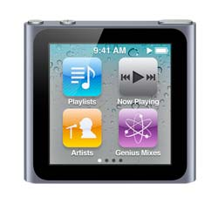
Tangible:
The way the Mobile Grub is to be used, is simply the same way an iPod Nano of the 6th generation is. The same way the widgets appear on the screen is the same format the Mobile Grub will have. For each of the screen displays, the selections are just categories that explain more within. For example, if you are in the dairy screen and hit the category of “ice cream”, another screen of flavor selections will appear. The selections end when there are no more to be selected.
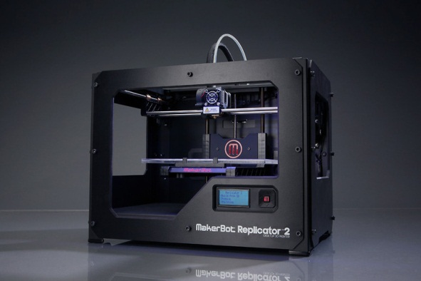
Much like the Makerbot, the Mobile Grub will prepare a meal in a small device; the only real difference is what prepared and size difference is. With the Makerbot, you can make any model with a limit size inside; whereas with the Mobile Grub, you can make any full course meal in the size of a pill and get full for 2 hours max.

The way the pills will be created is with a technology that is being created and researched by scientist today. Even though there aren’t any food pills that have full amount of calories, the Mobile Grub will create a chewable pill that has no taste. In order to taste it the pill will have to be mixed with water to get the full flavor and feel as if you are full in the stomach. We already mix water with protein shakes so why not continue that technology to get the satisfactory you get when eating a real full course meal. Just like in the military had portable pill meals for on the go, this is the same idea, but with more technology involve such as creating your own meal.
Philosophical Research:
With the gradual change in technology, people have been known to change along with change. The majority of the time people prefer to have a “choice” in life. When the time comes to choose anything, they feel the empowerment of being powerful by having the authority to choose and by having the final choice. From the past times people had no choice given, but because times change, society began to expand in having decisions of either the Right or the Wrong.
Much like Nietzsche stating about being deceived, we all deceive ourselves in one way but with anything deceiving us will pretty much lead us to being skeptical about life itself.
For the most part, society tends to be attracted to new things that are put in their surroundings. Much like a computer, a smartphone and even the iPod, has people acting in ways they’ve never imagined to act. Listening to music or moving things with their fingers and having things done at the touch of a screen makes a person lose their thought process and continue working on whatever is in front of them. Just like walking and texting, people went from waiting for a phone call once they get home or waiting for a hand written letter by someone far away, now with technology devices being portable and easy to use, people multitask more outdoors than indoors mainly because most activities that are about to occur have to do with meeting another somewhere.

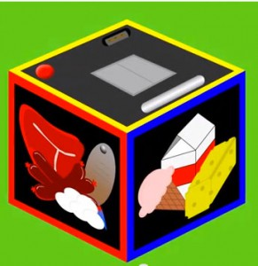
Description:
The Mobile Grub is a device that has much interactivity with all food types. You can get the taste of any food in the food pyramid. You also get the satisfaction of creating your own dish without having to get in front of a stove. You can create your own dish and in just under 3 seconds you can fill up your stomach for a good 2 hour extension.
Every time you are in a meeting or at school and cannot seem to get any meal in time and have the loud growl, you can always use a preset or create a dish of your choosing. A pill is created with the exact tasting that you crave.
Deliverables:
For my deliverable, I will create two animations. One is explaining the device and another selling the device as a commercial, showing a number of events in which the Mobile Grub will be useful for anyone. In the animation there will be a description of size, how to use the device, and what the device is mainly about and showing the interactivity within. I will also create a brochure to show that the device is worth being used and sold to the public. The user can read around the entire brochure about the device and they will all see what good can bring to owning a Mobile Grub. And a final deliverable will be a script on a commercial to selling this device where actors will portray a scene in getting hungry and wanting to have the Mobile Grub in the right moment and the right time. These deliverables will make much more sense to what the Mobile Grub will be about.
WARNING: THIS INVENTION MAY GET YOU HUNGRY!

