Name: ___________________________________ Points: ______

1. Change to radians 2. Change to degrees



a. 330° b. 225° c. -160° a. b. c.

3. A line passing through point . Find the six trigonometric functions.



4. A line passing through point . Find the six trigonometric functions.



Origins of the Coordinate Plane

René Descartes was a noted French Philosopher of the 17th Century who thoughtfully doubted accepted knowledge. It was in Part II of his book “Discours de la methode pour bien conduire sa raison et chercher la verite dans la sciences,” published in 1637 (which translates as “Discourse on the method of rightly conducting the reason and seeking truth in science”) that he considered how to systematically doubt knowledge. Descartes’ re-examination of accepted knowledge was in part a re-examination of geometry. In his search for precision and logic he related components of a geometry figure to two (2) straight lines, what today are called the x and y axes, or the x and y coordinates. This two-dimensional plane is known as the Cartesian plane (Anglin, 1994).

While Descartes’ name is associated with the Cartesian plane, the development of a co-ordinate system can be traced back to ancient Egypt, where the idea of a coordinate system was used in the laying out of towns and lands by Egyptian surveyors. From these the Romans acquired the concept of organizing districts. These districts were designated in hieroglyphics by a symbol derived from a grid still used in surveying land today (Smith, 1958).

C:\Users\Janet\AppData\Local\Microsoft\Windows\Temporary Internet Files\Low\Content.IE5\Z9OVSVGG\MC900389446[1].WMF

5. Given  and find the value of the other ratios.

6. Given  and find the value of the other ratios.

7. Find the coordinates for all the angles in the unit circle:

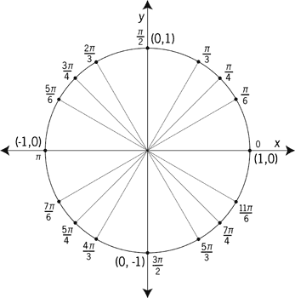

8. Find the reference angle associated with each rotation and then find the associated point  on the unit circle.

1.  b. 
2.  d. 

References

Anglin. W.S. (1994). *Mathematics: A concise history and philosophy.* New York, NY: Springer Verlag.

Smith. D.E. (1958).  *History of mathematics, Vol. II.* New York, NY: Dover Publications.