Name: ___________________________________ Points: ______

1. Solve the system.

a) 

b) 

2 . Find the tension in each cord TA, TB, TC in the figure if the weight of the suspended object is 250 Newton

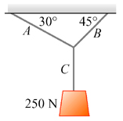 

3. Using Kirchhoff’s rules, find the currents (I1, I2, I3) in the circuit shown.

+

_

15V

9V

100Ω

100Ω

100Ω

Loop 1

Loop 2

I1

I2

I2

I1

I3

A

B