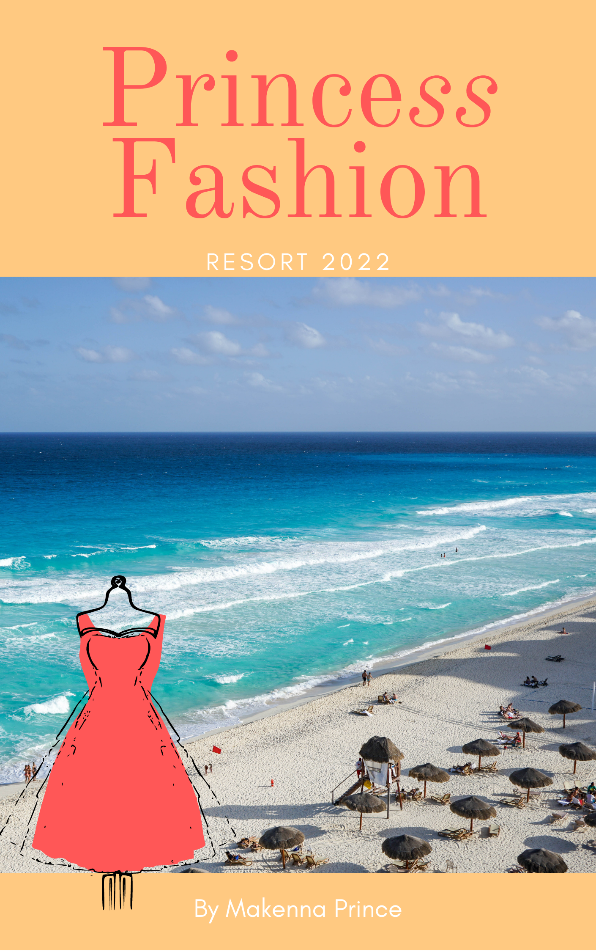
At Princess Fashion our mission is to provide elegant clothing to our clients and to achieve our goal of exceeding customer expectations in all facets of the customer experience. Our brand name Princess Fashion is based on our creators last name with the added “ss” to show femininity and elegancy of the brand. Princess Fashion will be releasing our debut line for resort 2022. Our debut line will be a ready to wear line. We chose resort 2022 for our debut line because everyone should look elegant on vacation.
At Princess Fashion our target demographic is working middle class women with a college education. These women would be in the age group of 25 – 40 years old and lives in any major city around the world. Their psychographics would be that of a fashionable woman that lives in the city and is looking for a tropical getaway. They are interested in fashion and traveling and have a strong value in friendships and family.
Our competitors include the likes of Fe Noel, The Reformation and Pampelone. These three brands have a similar aesthetic to that of Princess Fashion. Princess Fashion is a mid-range brand that creates sustainable clothing that creates a feeling of royalty in the wearer.
For our resort 2022 line we will have four different styles of dresses, three skirts, and three tops. We are also taking color inspiration from WGSN & Coloro spring/summer 2022 color forecast. The colors include Orchid Flower (Coloro: 150-38-31), Olive Oil (Coloro: 044-52-13), Butter (Coloro: 040-86-20), Mango Sorbet (Coloro: 030-67-34), and Atlantic Blue (Coloro: 115-35-20) (Trendsetter, 2020). Our clothing will be made from cotton, viscose/rayon, silk, and linen.
Clothing will be sent out to fashionable influencers with a following of 100,000 or more. Princess Fashion will also buy advertising spots on social media and magazines online/hard copy. We will also aim to collect email addresses from interested consumer for internal marketing. With all three sources of advertising, we are sure to have a large outreach to create interest in our brand.

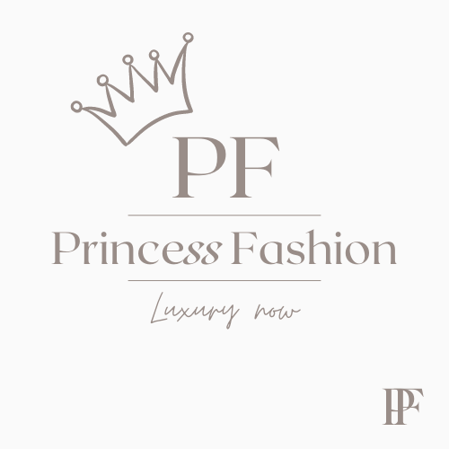

Citation

Trendsetter. (2020, May 6). WGSN x Coloro Announce Key Colors for Spring/Summer 2022. Retrieved from https://www.fashiontrendsetter.com/v2/2020/05/06/wgsn-x-coloro-announce-key-colors-for-spring-summer-2022/

