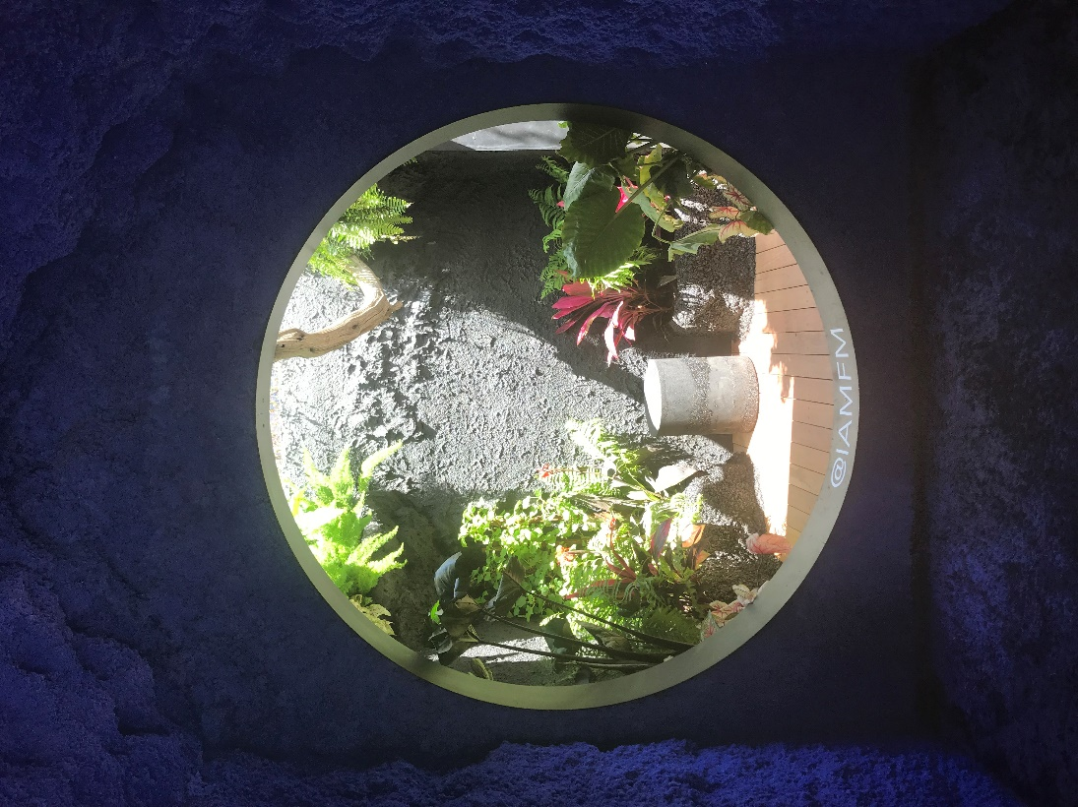
Faiza Hussain
Museum visit
For my museum visit I went to the design week event in time square. I found this installation where you can step inside this small house like building where there is this blue rock formation with a garden inside that you can step in. I pick this piece because of this piece being an ambiguous piece. There is no telling with is in the background verse what is in the foreground. The flowers take up 50% of the image and the blue rock cover takes up 50% of the image. Then there is the light source that create multiple tones of color making for there to be a sense of motion and there tones of greys within the garden.
Exhibit: Iamfm
Artist Fernando Mastrangelo
Where: Design Week- Time Square 45th street & Broadway
Date:5/22/19 Date of photo: 5/15/19

