Derek Tolentino
5/21/19
Museum Visit

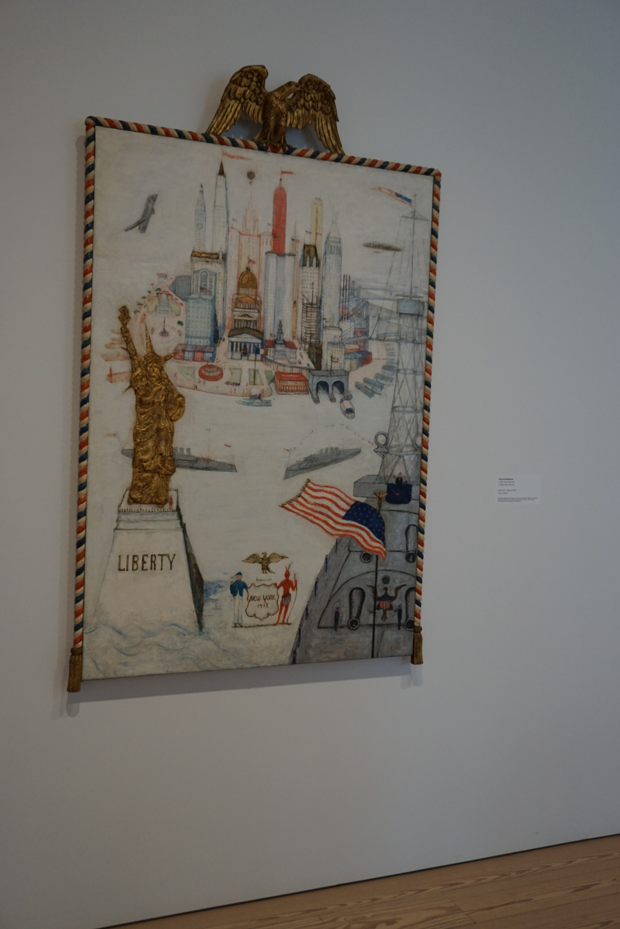

While on my museum visit to the Whitney I found that this art piece by Florine Stettheimer was the most interesting it depicted early New york with a modernistic vibe to it. So this work of art defiantly has and obvious aspect to it because of its clear depicted imagery of iconic new york structures such as the statue of liberty and the over all architecture of the buildings the ships not to mention the native American and the solder welcoming those to the new home land. As far as textures and patterns its an oil based painting with a 3 dimensional aesthetic to the piece its self capturing the essence of an industrialized economy. When it comes to motion this piece defiantly has it but how so? The planes, the bouts, the mini people even the buildings the self’s have a little bit of shakiness to it bringing it to life in a sense which shows the illusion of movement. Last but not least color when it comes to color this image has color of industrialization and an empire that’s full of power with colors that pop and say I’m here but mean business which what new york is all about and I believe that this artist captured it exceptionally.

To conclude taking all the essential elements of color, contrast, movement, tone and prospective we can summarize that art and design can best be put out by the way the viewer wants interpret what the artist or designer put out and if it makes sense.

