Spencer Emile
A Car’s Timing belt Assembly

A Car’s timing belt assembly is a series of connected parts (Timing belt, Camshaft, crankshaft, and water pump) that are apart of a car engine assembly. A timing belt synchronizes the camshaft to the crankshaft, and water pump position, so the valves will open and close at the proper timing in relation to the position of the pistons. The camshaft rotates at exactly 1/2 speed of the crankshaft; meaning two revolutions of the crankshaft are equal to one revolution of the camshaft. (Information taken from http://www.samarins.com/glossary/timing_belt.html)

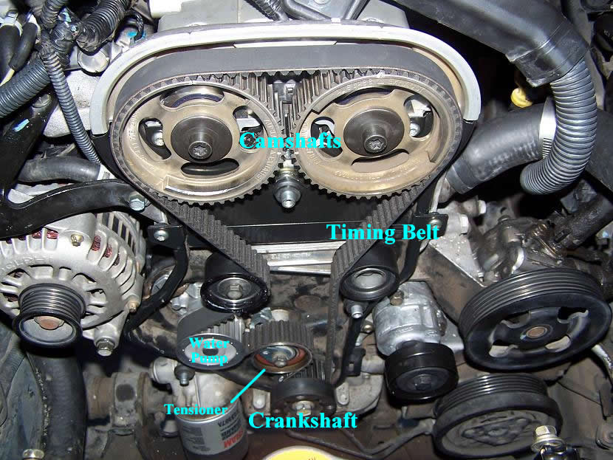
I think this is cool because if the math or part is off by a little bit or not made or fixed correctly it can mess up your whole timing belt assembly, possibly leaving you stranded on the side of the road. Lets just put it this way if your timing belt assembly brakes your car won’t move.

Simple machines in design
-Pulleys.
-Gears (on some systems).
-Wheel and axle.

Work Cites
-"Timing Belts and Timing Chains on Cars and Trucks." Timing Belt,Chain,repair,replace,change,symptoms,bad,bend Valve. N.p., n.d. Web. 09 Sept. 2015. <http://www.econofix.com/tbelt.html>.

-"Belting Out the Pros and Cons of an Engine Timing Belt." The Blog to Rule the Road Belting Out the Pros and Cons of an Engine Timing Belt Comments. N.p., 27 Sept. 2014. Web. 09 Sept. 2015. <http://www.carpartkings.com/blog/2014/09/belting-pros-cons-engine-timing-belt.html>.

-"Timing Belt." - Automotive Illustrated Glossary. N.p., n.d. Web. 09 Sept. 2015. <http://www.samarins.com/glossary/timing_belt.html>.

