Michelle Olmo

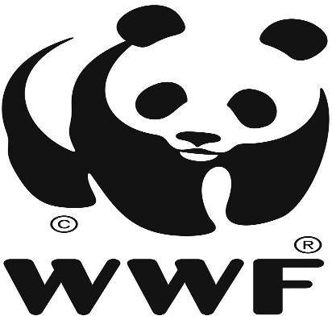

The World Wildlife, Inc. (WWF) was originated in 1961. It’s an organization that works in more than 100 countries. The organization collaborates with people around the world to develop and deliver solutions that protect communities, wildlife, and the places where they live.

The WWF logo began from a panda named Chi-Chi, and was living at the London Zoo in 1961.

Gerald Watterson played a role in the initial sketches and the logo was designed by Sir Peter Scott, who also found the company, in 1961.

The color of the logo is black and white. According to Peter Scott he stated, “We wanted an animal that is beautiful, is endangered, and one loved by many

people in the world for its appealing qualities. We also wanted an animal that had an impact in black and white to save money on printing costs.”

The logo uses a sans serif font, which is close to Zar Brush Gothic Regular.





