Michelle Olmo
Professor: Trofimova
February 21, 2020
WWF Logo

The World Wildlife, Inc. (WWF) had become the second national organization to be

formed in 1961. Gerald Watterson played a role in the initial sketches and the logo was designed

by Sir Peter Scott, who also found the company, in 1961. The WWF was established through a

set of worldwide conservationists to elevate funds in aid of global efforts.

The wonderful panda logo of WWF began from a panda named Chi that turned into

moved from the Beijing Zoo to the London Zoo across the equal time of the foundation of

WWF. The World Wildlife for Nature, referred to as WWF (it was once referred to as the world

wildlife Fund and still is within the US and Canada) has an all around perceived logo which

remains an effective image for the important focal point of the WWF's work: the protection,

conservation and reclamation of indigenous habitats around the world. “Our iconic logo is at the

heart of all our communications and used on every piece of our brand identity,” says Georgie

Bridge, WWF-UK’s head of design management. “We strive to ensure that [it] is always applied

with respect and in its pure form.”

The logo is a panda bear, one of the most endangered species on earth and also one of the

most caring species. The organization also needs an animal that would have an impact in black

and white painting. When Sir Peter Scott drew the panda logo for the first time he stated, “We

wanted an animal that is beautiful, is endangered, and one loved by many people in the world for

its appealing qualities. We also wanted an animal that had an impact in black and white to save

money on printing costs.”

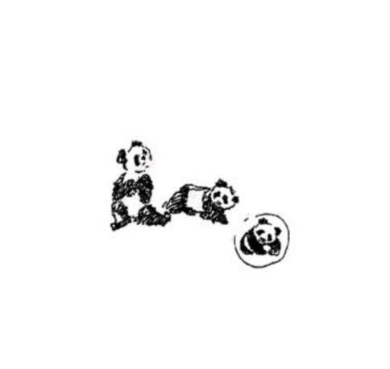

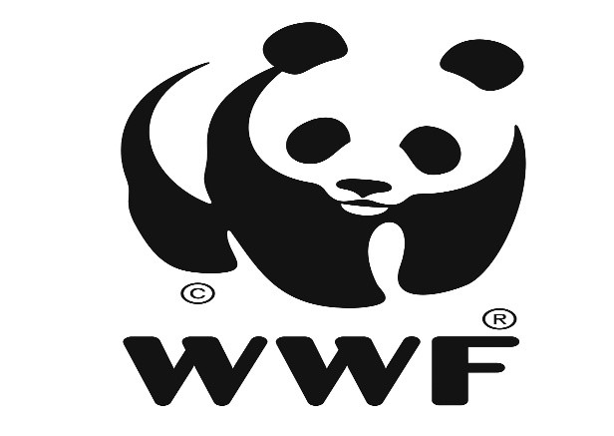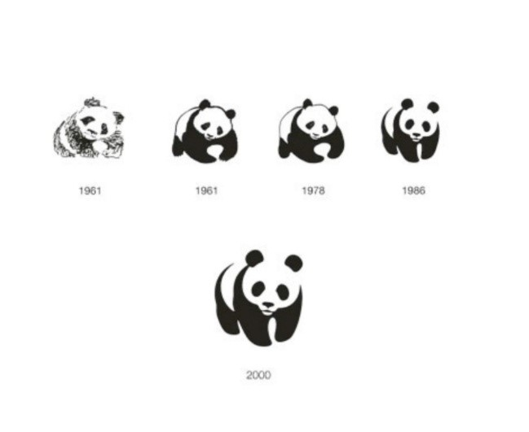

Work cited

History.” WWF, World Wildlife Fund, www.worldwildlife.org/about/history

“How the World Wildlife Fund Logo Was Designed.” Creative Review, 6 Nov. 2018, www.creativereview.co.uk/world-wildlife-fund-logo/.

“The Story behind the Panda Logo of WWF?” History of the WWF Logo - The World Wide Fund for Nature, www.dewebsite.org/logo/wwf/wwf.html.

