Introduction to Mapping Exercise
ARCH 0000 Information Design ²

This week think about a map you would create of your department and places you like at the college for new students. These places can include locations for socializing, studying, club activities, or resources you’ve found helpful—and so extend beyond the classrooms and labs.
Often maps are considered exact representations of physical space. For this work though, consider not just the space on campus but also your own experiences – so the map will include these personal encounters and knowledge, as well as physical space. See the attached maps from the children’s tales, Winnie the Pooh by A.A. Milne, 1922 and Cantino Planisphere by a Portuguese mapmaker in 1502.
For next week, go to the college and walk around the department and the places you would include. Take notes and make a very rough map as you walk through the spaces. Next, create a sketch map – one that shows your department, it’s and the college’s resources that you would highlight, and that includes your lived knowledge.
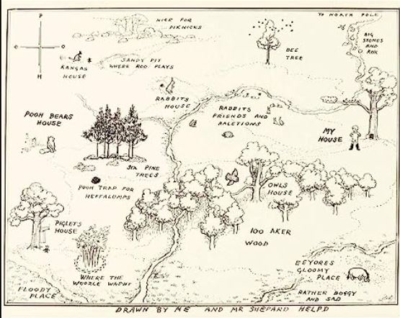

Figure 1. A.A. Milne, 100 Acre Wood Map, 1922.
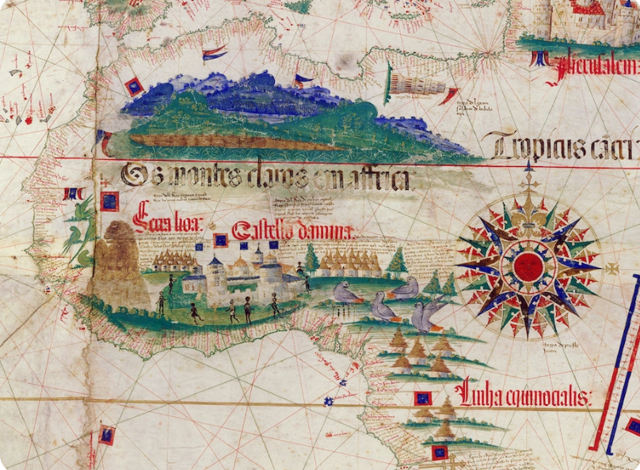

Figure 2. Cantino planisphiere, 1502, Portugal

