Digital Control

Lab #11

4-bit Up-Counter

Professor: Patrick

05/17/13

Marlon Myers

Bryam Valencia

Objective:

* To design a 4-bit up-counter circuit using the Quartus II, while constructing the circuit on a bread-board, before testing the up-counter on the Digital trainer.

Abstract:

 The 74ls76a is a Jk flip flop with set and clear.that was used in the lab experiment as a up counter. A counter that can change state in either direction, due to an up or down chosen input, is known as an up or down counter. When the selected input is in the up state, the counter increases its value. When the selected input is in the down state, the counter decreases the count. The circuit in this experiment is constructed on both virtually on the Quartus II software and physically on the bread board that’s connected and powered by the digital trainer. The circuit is constructed on Quartus II and then built on the bread board. A 4-bit counter counts to 8, and has a mod of 9. A vector wave file is created and display all waveforms of “Clock”,”Led0”,”Led1”,”Led2”, “Led3”. The Q’s of the circuit are connected to their corresponding outputs. The circuit is then tested on the digital trainer and all results are outputted from the Led lights on the Digital trainers,

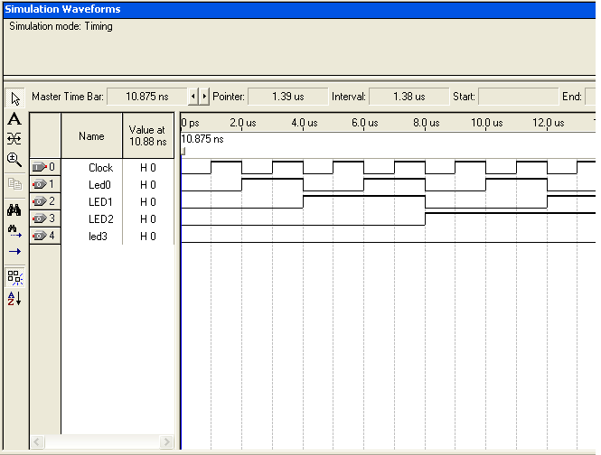

Wave Form

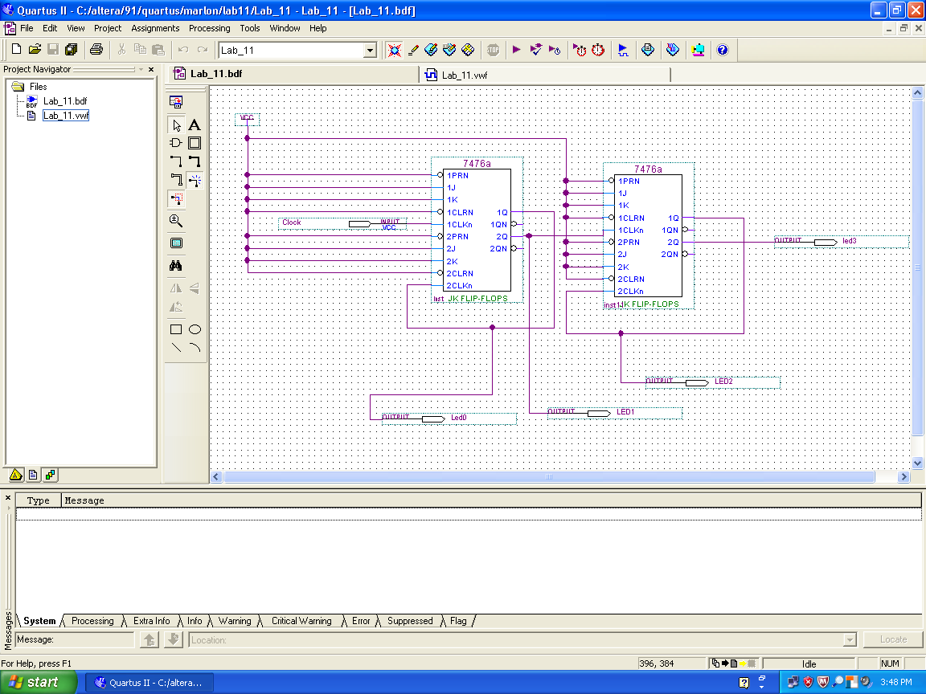

Circuit(vitual)

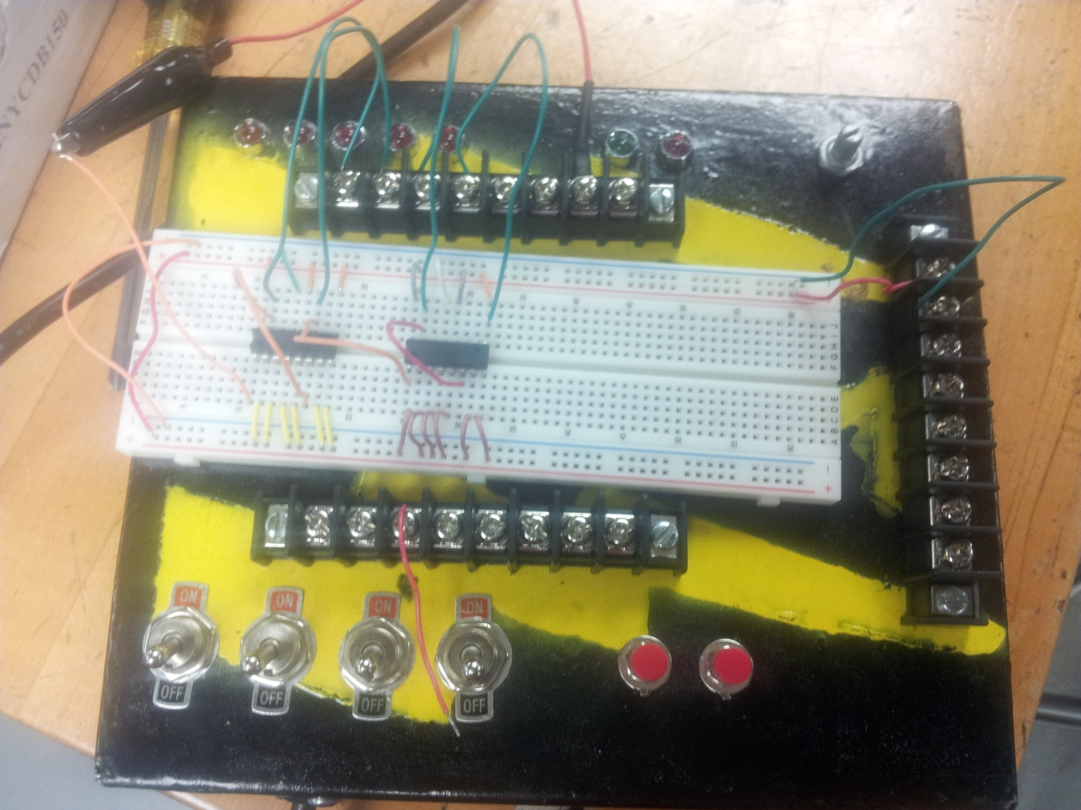

Circuit(physical)