Experiment: #3:


NAND and NOR Gates

Marlon Myers
Digital Control
EMT1250
Professor: Prof. Patrick

Table of Contents:

Objective | 3
Equipment | 3
Discussion | 3
Schematic | 4
Questions | 6
Charts | 7
Conclusion | 9

Objective:

• To investigate the operation of the NAND and NOR Gates.
•To form other basic gates using the NAND and NOR Gates

Equipment:
- 5V DC Power Supply
- Digital Trainer (Logic Probe)
- Breadboard
- DIP Switch
- 7400 (NAND gate)
- 7402 (NOR gate)

Discussion:

- NAND and NOR gates are two important gates because they are considered universal gates. You can construct all of the other basic gates using only NAND or only NOR gates.

- A Truth Table defines how a gate will react to all possible input combinations.

- A Logic Probe is a piece of test equipment which displays the logic level at a point in the circuit. 0 to 0.8V = Logic 0 and lights the L indicator. 2.0V to 5.0V = Logic 1 and lights the H indicator. Invalid logic voltage levels light neither indicator.

Schematics:
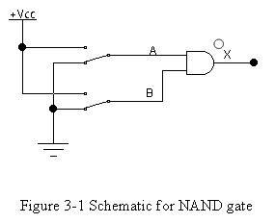

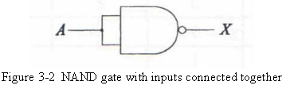

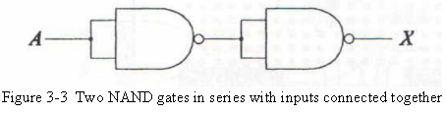

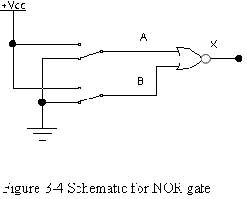

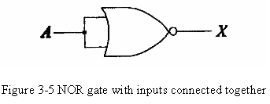

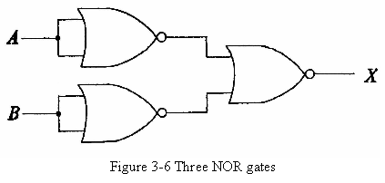

Questions:
- What are the Boolean expressions for the NAND and NOR gates?

- Answer: NAND = AB
NOR = A + B

- How does a NAND gate differ from an AND gate?

- Answer: a NAND gate is an inverted AND gate

- How does a NOR gate differ from an OR gate?

- Answer: a NOR gate is an inverted OR gate

- Under what input conditions is the output of a 2 input NOR gate LOW? Under what input conditions is the output of a 2 input NAND gate HIGH?

- Answer: The output of a two input NOR gate is low, when either one or both inputs are “High”. In Comparison, The output of a two input NAND gate is high, when either one or both inputs are “LOW”

- From the data in the experiment, how can you configure a NAND or NOR gate to function like an inverter?

- Answer: To configure a NAND or NOR gate to function like an inverter, connect the inputs together.

Chart:
Truth Table |  |  | Volts Measured
A | B | X | A(volt) | B (volts) | X(volt)
0 | 0 | 1 | 0 | 0 | 3.47
0 | 1 | 1 | 0 | 5.07 | 3.47
1 | 0 | 1 | 5.09 | 0 | 3.47
1 | 1 | 0 | 5.09 | 5.06 | 0.45
Table 3-1 Truth table and volts measured for input/output for Figure 3-1

Truth Table |  | Volts Measured
A | X | A(volt) | X(volt)
0 | 1 | 0 | 3.46
1 | 0 | 5.06 | 0.45
Table 3-2 Truth table and volts measured for input/output for Figure 3-2

Truth Table |  | Volts Measured
A | X | A(volt) | X(volt)
0 | 1 | 0 | 0.45
1 | 0 | 5.06 | 3.47
Table 3-3 Truth table and volts measured for input/output for Figure 3-3
Truth Table |  |  | Volts Measured
A | B | X | A(volt) | B (volts) | X(volt)
0 | 0 | 1 | 0 | 0 | 3.01
0 | 1 | 0 | 0 | 5.06 | 0.43
1 | 0 | 0 | 5.06 | 0 | 0.43
1 | 1 | 0 | 5.06 | 5.06 | 0.41
Table 3-4 Truth table and volts measured for input/output for Figure 3-4
Truth Table |  | Volts Measured
A | X | A(volt) | X(volt)
0 | 1 | 0 | 3.47
1 | 0 | 5.06 | 0.41
Table 3-5 Truth table and volts measured for input/output for Figure 3-5
Truth Table |  |  | Volts Measured
A | B | X | A(volt) | B (volts) | X(volt)
0 | 0 | 0 | 0 | 0 | 0.40
0 | 1 | 0 | 0 | 5.06 | 0.42
1 | 0 | 0 | 5.06 | 0 | 0.42
1 | 1 | 1 | 5.06 | 5.06 | 3.47
Table 3-6 Truth table and volts measured for input/output for Figure 3-6
Conclusion:
In conclusion, a NAND gate is an inverted AND gate, and a NOR gate is an inverted OR gate. The output of a two input NOR gate is low, when either one or both inputs are “High”. In Comparison, The output of a two input NAND gate is high, when either one or both inputs are “LOW”. To configure a NAND or NOR gate to function like an inverter, connect the inputs together.

