Experiment: #9:

 Magnitude Comparator

Marlon Myers

Digital Control

EMT1250

Professor: Prof. Patrick

Table of Contents:

|  |  |
| --- | --- |
| Objective | 3 |
| Abstract | 3 |
| Schematic | 4 |
| VHDL code | 5 |
| |  |  | | --- | --- | | Waveform |  | | 9 |
| Data Results | 10 |
|  |  |

Objective:

* To build 1 - bit and 2 - bit Magnitude Comparator circuit s using the Quartus II development software with the DE - 2 board.
* To test the design by downloading the file into the DE - 2 board, exercising the inputs with toggle switches and observing 3 individual LED’s.

Abstract:

A Magnitude Comparator compares one and two binary numbers and indicates whether the numbers are equal or which number is larger. The Comparator will take inputs from 4 toggle switches ( SW[ 0] ~SW[3] ) representing two 2 bit binary numbers and activate LED G[ 0] ~LEDG[ 3 ] in the DE - 2 board . The input numbers will be labeled A0, A1 and B0, B1 and the outputs will be labeled AeqB, AltB, and AgtB. The LED’s are activated under the following condition.

|  |  |  |  |
| --- | --- | --- | --- |
| Input | AgtB | AeqB | AltB |
| A>B | On | Off | Off |
| A=B | Off | On | Off |
| A<B | Off | Off | On |

|  |  |  |
| --- | --- | --- |
| Name | Pin Number | Switches |
| A1 | Pin_AE14 | SW[3] |
| A0 | PIN_P25 | SW[2] |
| B1 | PIN_N26 | SW[1] |
| B0 | PIN_N25 | SW[0] |

|  |  |  |
| --- | --- | --- |
| Name | Pin Number | LED |
| AgtB | Pin_W19 | LEDG[2] |
| AeqB | Pin_AF22 | LEDG[1] |
| AltB | Pin_AE22 | LEDG[0] |

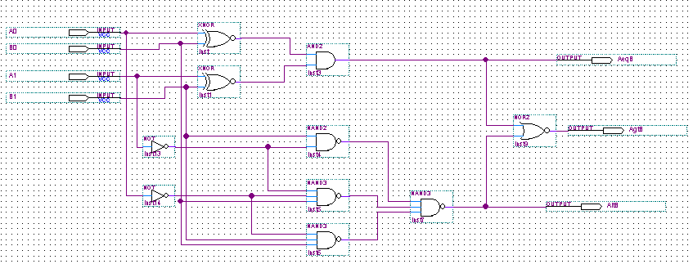Schematic:

VHDL Code:

Library ieee;

Use ieee.std_logic_1164.All;

Entity XNORckt is

Port(

A,B : In std_logic;

AXnorB : out std_logic);

End XNORckt;

ARCHITECTURE behavior OF XNORckt IS

Begin Process(A ,B )

Begin

AXnorB <= A XNOR B;

END PROCESS;

End Behavior;

------------------------------------------------------------------

Library ieee;

Use ieee.std_logic_1164.All;

Entity andckt IS

Port(

X,Y: IN std_logic;

XandY : OUT std_logic);

END andckt;

ARCHITECTURE behavior OF andckt IS

BEGIN

PROCESS(X,Y)

BEGIN

XandY <= X AND Y; --and gate operation

END PROCESS;

END behavior;

---------------------------------------------------------------------

Library ieee;

Use ieee.std_logic_1164.All;

Entity Notckt IS

Port(

A1 : IN std_logic;

A1Not : Out std_logic);

End Notckt;

ARCHITECTURE behavior of Notckt IS

Begin Process(A1)

Begin

A1Not <= Not A1;

End Process;

End Behavior;

--------------------------------------------------------------------------

Library ieee;

Use ieee.std_logic_1164.All;

Entity NANDckt Is

Port(

A,B : IN std_logic;

ANANDB : Out std_logic);

End NANDckt;

ARCHITECTURE behavior of NANDckt IS

Begin Process(A,B)

Begin

ANANDB <= A NAND B;

End Process;

End Behavior;

---------------------------------------------------------------------------

Library ieee;

Use ieee.std_logic_1164.All;

Entity NANDckt2 IS

Port(

A,B,C : IN std_logic;

ANANDBNANDC4 : OUT std_logic);

End NANDckt2;

ARCHITECTURE behavior of NANDckt2 IS

Begin Process(A,B,C)

Begin

ANANDBNANDC4 <= (A NAND B) NAND C;

End Process;

End Behavior;

----------------------------------------------------------------------------

Library ieee;

Use ieee.std_logic_1164.All;

Entity NotNotckt IS

Port(

A1 : IN std_logic;

A1NotNot : Out std_logic);

End NotNotckt;

ARCHITECTURE behavior of NotNotckt IS

Begin Process(A1)

Begin

A1NotNot <= Not (Not A1);

End Process;

End Behavior;

----------------------------------------------------------------------------

Library ieee;

Use ieee.std_logic_1164.All;

Entity NORCKTOUT IS

Port(

D, E : IN std_logic;

DNORE : OUT std_logic);

End NORCKTOUT;

ARCHITECTURE behavior of NORCKTOUT IS

Begin Process(D,E)

Begin

DNORE <= D NOR E;

End Process;

End Behavior;

------------------------------------------------------------------------------

Library ieee;

Use ieee.Std_logic_1164.All;

USE Work.All; -- Top level Entity

ENTITY Lab9_3 IS

Port(

Input_A0, Input_B0, Input_A1, Input_B1 : IN std_logic;

GtOutput,LtOutput,EqOutput : Out std_logic);

END Lab9_3;

ARCHITECTURE struct OF Lab9_3 IS

-----------------------------------------------------

COMPONENT XNORckt IS

Port(

A,B : In std_logic;

AXnorB : out std_logic);

End COMPONENT;

----------------------------------------------------

COMPONENT andckt IS

Port(

X,Y : IN std_logic;

XandY : OUT std_logic);

END COMPONENT;

----------------------------------------------------

COMPONENT Notckt IS

Port(

A1 : IN std_logic;

A1Not : Out std_logic);

End COMPONENT;

------------------------------------------------------

COMPONENT NANDckt Is

Port(

A,B : IN std_logic;

ANANDB : Out std_logic);

End COMPONENT;

------------------------------------------------------

COMPONENT NANDckt2 IS

Port(

A,B,C : IN std_logic;

ANANDBNANDC4 : OUT std_logic);

End COMPONENT;

-------------------------------------------------------

COMPONENT NotNotckt IS

Port(

A1 : IN std_logic;

A1NotNot : OUT std_logic);

End COMPONENT;

-------------------------------------------------------

COMPONENT NORCKTOUT IS

Port(

D,E : IN std_logic;

DNORE : OUT std_logic);

End COMPONENT;

-------------------------------------------------------

SIGNAL wire_1, wire_2, wire_4, wire_5: std_logic;

SIGNAL wire_6, wire_7, wire_8: std_logic;

SIGNAL wire_A, wire_B : std_logic;

-------------------------------------------------------

Begin

Gate1: XNORckt port map (A => Input_A0, B => Input_B0, AXnorB => wire_1);

Gate2: XNORckt port map (A => Input_A1, B => Input_B1, AXnorB => wire_2);

Gate3: andckt port map (X => wire_1, Y => wire_2, XandY => wire_A);

Gate4: NotNotckt port map (A1 => wire_A, A1NotNot => EqOutput);

Gate5: Notckt port map (A1 => Input_A1, A1Not => wire_4);

Gate6: Notckt port map (A1 => Input_A0, A1Not => wire_5);

Gate7: NANDckt port map (A => Input_B1, B => wire_4, ANANDB => wire_6);

Gate8: NANDckt2 port map (A => wire_4, B => wire_5, C => Input_B0, ANANDBNANDC4 => wire_7);

Gate9: NANDckt2 port map (A => wire_5, B => Input_B1, C => Input_B0, ANANDBNANDC4 => wire_8);

Gate10: NANDckt2 port map (A => wire_6, B => wire_7, C => wire_8, ANANDBNANDC4 => wire_B);

Gate11: NotNotckt port map (A1 => wire_A, A1NotNot => LtOutput);

Gate12: NORCKTOUT port map (D => wire_A, E => wire_B, DnorE => GtOutput);

END Architecture struct

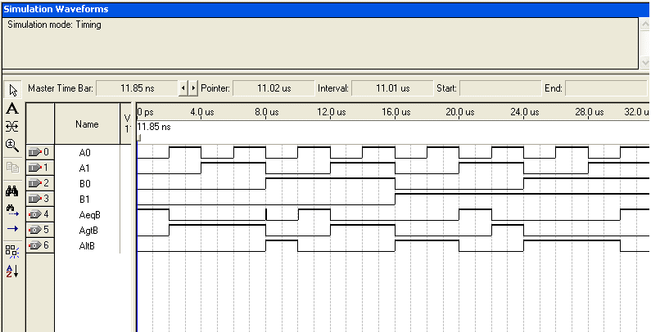Wave Form:

Data Results:

|  |  |  |  |  |  |  |
| --- | --- | --- | --- | --- | --- | --- |
| Input | | | | Output | | |
| A1 | A0 | B1 | B0 | AgtB | AeqB | AltB |
| Off | Off | Off | Off | 0 | 1 | 0 |
| Off | Off | Off | On | 0 | 0 | 1 |
| Off | Off | On | Off | 0 | 0 | 1 |
| Off | Off | On | On | 0 | 0 | 1 |
| Off | On | Off | Off | 1 | 0 | 0 |
| Off | On | Off | On | 0 | 1 | 0 |
| Off | On | On | Off | 0 | 0 | 1 |
| Off | On | On | On | 0 | 0 | 1 |
| On | Off | Off | Off | 1 | 0 | 0 |
| On | Off | Off | On | 1 | 0 | 0 |
| On | Off | On | Off | 0 | 1 | 0 |
| On | Off | On | On | 0 | 0 | 1 |
| On | On | Off | Off | 1 | 0 | 0 |
| On | On | Off | On | 1 | 0 | 0 |
| On | On | On | Off | 1 | 0 | 0 |
| On | On | On | On | 0 | 1 | 0 |