EXPERIMENT #1:

Logic Probe
And
Oscilloscope

Marlon Myers
Digital Control
EMT1250
Professor: Prof. Patrick

Table of Contents:

Objective | 3
Equipment | 3
Discussion | 3
Schematic | 4
Questions | 5
Charts | 6
Conclusion | 7

Objective:

• To become familiar with constructing a circuit from a schematic diagram.

•To use the Oscilloscope to measure the parameters of Periodic waveforms.

Equipment:

- 5V DC Power Supply
- Logic Probe (from the Digital Trainer)
- Oscilloscope
- Function Generator
- EMT 1250L Parts Kit

Discussion:

•The DIP Toggle switch will be used to connect +5V and GND to a LED and Resistor network.

•The Function Generator will be set to various settings and then measured on the Oscilloscope.

Schematic:

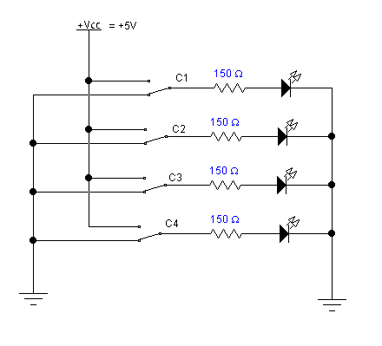

Question:
- Compare using a, Logic probe VS an Oscilloscope in debugging a circuit. State the advantages of each.

- Logic probe:
- Logic probe advantages :
- Low cost: A logic probe does not contain much circuitry, and the display is very rudimentary. Therefore the cost of manufacture is very low.
- Ease of use : To use a logic probe typically requires the connection of power leads and then connecting the probe to the required point on the circuit.
- Logic probe disadvantages -
- Very rough measurement: The nature of the logic probe means that only an indication of the presence of a logic signal can be detected.
- Poor display: A logic probe only uses a few LEDs to indicate the nature of the logic signal. As a result, little information can eb displayed about the nature of the logic signal that is detected.
- Oscilloscope:

- Oscilloscope disadvantages:

- One disadvantage is that oscilloscopes cost many times more than other types of electronic measuring instruments

- Oscilloscope advantages:
- When you connect an oscilloscope's probe to a power source, the device immediately displays its waveform on the screen. The waveform is a visual representation of the signal's peaks and valleys.

- Calculate the Duty Cycle for the 3 Function Generator settings in Part 2 of the experiment. Use the Oscilloscope readings to calculate Duty Cycle. Do the calculated values agree with the Function Generator settings?

Chart:

Oscilloscope Measurements
V High (V) | V Low(V) | Thi Secs | Period (secs) | Frequency (HZ)
4 | 2 | 500 | 1.00 ms | 1.00 KHZ
Frequency = 1 kHz, Amplitude = 2VPP, Offset = 2V, Duty Cycle = 50%

Oscilloscope Measurements
V High (V) | V Low(V) | Thi Secs | Period (secs) | Frequency (HZ)
3.8 | 1.5 | 20 us | 99.95 | 10.01KHZ
Frequency = 10 kHz, Amplitude = 2.5VPP, Offset = 2.5V, Duty Cycle = 20%

Oscilloscope Measurements
V High (V) | V Low(V) | Thi Secs | Period (secs) | Frequency (HZ)
3.8 | 2 | 40 us | 50us | 20 KHZ
Frequency = 20 kHz, Amplitude = 2VPP, Offset = 2V, Duty Cycle = 80%

Conclusion:

